
Last Call at Leatherback’s

A New Jedi Order Mini-adventure converted to Saga Edition by Darth_Scorpion

DESIGN
CORY J. HERNDON
EDITING
RAY AND VALERIE VALLESE
TYPESETTING
SUE WEINLEIN COOK
WEB PRODUCTION
DANIEL STAHL
WEB DEVELOPMENT
THOM BECKMAN
ART DIRECTION
SEAN GLENN
LUCAS LICENSING EDITORS
MICHELLE VUCKOVICK AND LELAND CHEE
STAR WARS RPG CREATIVE DIRECTOR
CHRIS PERKINS
VICE PRESIDENT AND DIRECTOR OF RPG R&D
BILL SLAVICSEK
Based on the Star Wars Roleplaying Game by Andy Collins, Bill Slavicsek, and JD Wiker, utilising mechanics developed for the new DUNGEONS & DRAGONS® game by Jonathan Tweet, Monte Cook, Skip Williams, Richard Baker, and Peter Adkison.
©2002 Lucasfilm Ltd. & ™ All rights reserved. Used under authorisation. Made in the U.S.A.
DUNGEONS & DRAGONS, AMAZING, DRAGON, TOPDECK, DUELIST, MAGIC: THE GATHERING, and the Wizards of the Coast logo are registered trademarks owned by Wizards of the Coast, Inc. The d20 logo is a trademark owned by Wizards of the Coast, Inc.
This Wizard’s of the Coast game product contains no Open Game Content originally. No portion of this work has been reproduced with written permission and is unauthorized. To learn more about the Open Gaming License and the d20 System License, please visit www.wizards.com/d20.
This material is protected under the copyright laws of the United States of America. Any reproduction or unauthorized use of the material contained herein is prohibited without the express written permission of Wizards of the Coast, Inc. This product is a work of fiction. Any similarity to actual people, organizations, places, or events is purely coincidental.
As part of this conversion from the Original Core Rulebook to Saga Edition, anything I have changed due to mechanical constraints is noted in red text and additions I have made are written in blue text. Stat blocks of creatures and characters are as close as I feel can be made in both flavour and intent to the original versions.
The original version of this adventure can be found at: http://wizards.com/default.asp?x=starwars/article/sw20020221a2
Any material used from books other than the Saga Edition Core Rulebook is noted using the superscript initials of that book. If you don’t have the relevant sourcebook, use your own discretion as to what replacements are needed.
Material from the Legacy Era Campaign Guide and Starships of the Galaxy / Galaxy of Intrigue has been used in remaking this adventure for Saga Edition.

“Last Call at Leatherback’s” allows the players’ characters to experience firsthand the Yuuzhan Vong invasion of Sriluur – an important hub on the Sisar Run. Though the planet is doomed to fall, the heroes will have the opportunity to foil the plans of the Peace Brigade, battle the Yuuzhan Vong’s vicious reptoid ground troops, duel Yuuzhan Vong warriors, and save an important underworld dignitary in the process.
How to Use This Adventure
If you will be playing a hero in “Last Call at Leatherback’s”, read no further unless you want to spoil the surprise. The following information is intended for Gamemasters only.
The Sriluur Experience
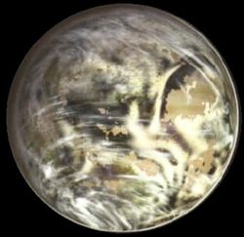
Sriluur, found in the Outer Rim Territories near Hutt Space, is the fifth world of the Sriluur system and rivals Tatooine for harsh, dry, desert conditions. At first glance, the planets seem quite similar and Merim City might be mistaken for Mos Eisley to the untrained eye. Unlike Tatooine, however, Sriluur is particularly rich in base metals, especially copper. The sands of the deserts themselves are quite copper-rich and coppery-green oxidised dust settles over every exposed surface on the planet.
If a character leaves the city and enters the desert, thirst, dehydration, and eventually death may result. For more information, consult the rules on Thirst in Chapter IV of the Star Wars Roleplaying Game Saga Edition Core Rulebook, page 66.
The adventure is intended for a party of four heroes, all at level 3. It’s assumed that the heroes are interested in opposing the Yuuzhan Vong in order to save their own skins, make a little money, do a little good, or all three. “Last Call at Leatherback’s” is presented here as a stand-alone adventure, but with a little tweaking can fit nicely into your New Jedi Order era campaign. It might also serve as a good starting point for such a campaign.
Why Are the Heroes Here?
Sriluur, the homeworld of the Weequay people, is a key location on the Sisar Run. The heroes might be here for a number of reasons, including:
- They might be smugglers or freelance lawbenders lying low after a recent successful job.
- They could live on Sriluur and operate out of Leatherback’s bar.
- They might be New Republic / Imperial Remnant agents sent to check on the planet and see if the Yuuzhan Vong have actually made it that far.
- They could be allies of the Jedi – and more than one might be Jedi themselves. In this case, they’re probably with Kyp Durron’s faction.
However the heroes end up in Leatherback’s bar, the important thing is that the group is prepared to work together, whether for the common good, survival, or money.
And one more thing: they do not have a ship... yet.

Scene I: Drink Up
As the curtain rises on our story, the heroes sit around a table in a dingy dive known as Leatherback’s. Like many spaceport watering holes in Merim City – one of two large cities on the surface of hot, dry Sriluur – Leatherback’s is owned and operated by a Weequay (named Leatherback, naturally). He stands behind the bar, pouring drinks, while a lone, middle-aged Twi’lek female twirls on a small stage that’s almost as run-down as she is. A few other scattered aliens hang around the bar and some darkened tables, while an extremely drunken Weequay sits unsteadily at the edge of the stage, staring up longingly at the used-up dancing ‘girl’.
Everywhere, conversations are about the Yuuzhan Vong invasion and the exodus of people leaving Sriluur in an attempt to head off the inevitable. Leatherback is annoyed at the drop in business and the fact that he had to get rid of his bartender droid. The Trandoshan in the corner grumbles that his most recent smuggling job flew the coop before he was paid. Whole clans of Weequay are forming militia armies to fight the invasion that everyone on the planet soon expects.
As the heroes enjoy a drink, lunch, cards, or whatever strikes their fancy, they hear a commotion outside. It seems to be moving down the street, heading this way.
The Droid Riot (Challenge Level 2)
If the heroes investigate, they see a gang of six Humans forcing a small group of droids down the street. The Humans shout epithets and anti-droid, anti-Jedi slogans, hurl chunks of metal and garbage, and generally do everything in their power to batter the droids, driving them forward. Several other aliens have noticed what’s going on, but they seem more interested in their own business – except a lone, well-dressed Rodian, who seems intent on protecting the droids (any character who succeeds at a DC 15 Knowledge (Tactics) check notices that the Rodian seems intent on protecting one LOM-unit in particular). The Rodian calls for help to passersby and the open windows of buildings as he’s forced down the street, but no one responds. If the droids and the Rodian are going to survive, it will be up to the heroes to lend a hand.
The attacking humans are members of the Peace Brigade, the collaborationist movement that the Yuuzhan Vong began inciting years before the actual invasion. The Peace Brigadiers know that the Yuuzhan Vong are on the way and want to impress them by having Merim City cleared of droids by the time the invaders arrive. They are not high-ranking members of the Brigade, but just one of many such groups made up of low-ranking thugs that are doing the same thing elsewhere on the planet.
The Rodian continues to call for help, and if the heroes still don’t come to the rescue, he begins shouting that he’ll pay handsomely for some timely assistance.
Peace Brigadier Tactics
The Peace Brigadiers are not smart – they are bullies, plain and simple, and they believe that a bunch of helpless droids and a snivelling Rodian can’t possibly put up much of a fight. If the heroes challenge them (with violence, diplomacy, intimidation, etc.), the Brigadiers draw their blasters and begin firing right there on the street.
Peace Brigadiers (6) | CL 1
Medium Human Non-heroic 2
Dark-side 3
Init +6; Senses: Perception +5
Languages Basic
Defences Ref 10 (Flat-footed 10), Fort 11, Will 9
HP 10; Threshold 11
Speed 6 squares
Melee Unarmed +2 (1d4+1) or
Melee Baton +2 (1d6+1) or
Melee Baton +2 (2d6+1) with Mighty Swing or
Ranged Blaster Pistol +1 (3d6)
Base Atk +1; Grp +2
Atk Options Mighty Swing
Abilities Str 13, Dex 11, Con 12, Int 8, Wis 9, Cha 10
Feats Mighty Swing, Skill Training (Persuasion), Toughness, Weapon Proficiency (Pistols, Simple Weapons)
Skills Initiative +6, Perception +5, Persuasion +6
Possessions Baton, Blaster Pistol, Clothing

These Brigadiers are stubborn and determined, but they’re not ready to die for the Yuuzhan Vong just yet. Once two of the six have been incapacitated, the rest flee. If the heroes try to hunt them down, the Rodian shouts to them to return. He reminds them that chasing the thugs will do little good, and that leaving the planet should be their goal: he has inside information that the Yuuzhan Vong will be on Sriluur before the day is out.
Chazrach Species Modifiers
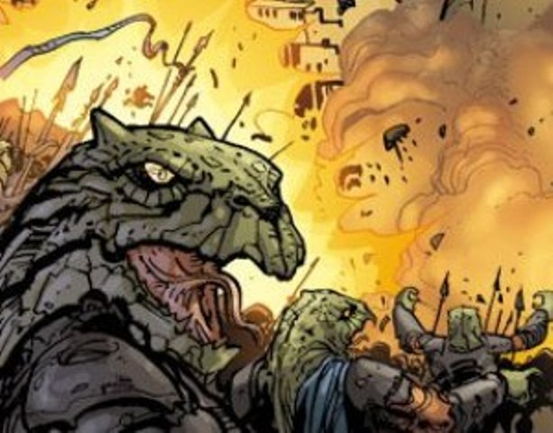
Ability Modifiers: +2 Strength, -2 Dexterity, -2 Intelligence.
Medium Size: As Medium creatures, Chazrach have no special bonuses or penalties due to their size.
Speed: Chazrach base speed is 6 squares.
Darkvision: Chazrach ignore concealment (including toal concealment) from darkness. However, they cannot perceive colours in total darkness.
Limited Weapon Familiarity: Chazrach treat amphistaves as simple weapons instead of exotic weapons, but only for the Quarterstaff and Spear forms. Chazrach cannot utilise the Whip form of the amphistaff without the Exotic Weapon Proficiency (Amphistaff) feat.
Natural Armour: Chazrach have thick scales that provide a +2 natural armour bonus to their Reflex Defence. A natural armour bonus stacks with an armour bonus.
Automatic Languages: Chazrach speak Yuuzhan Vong.

Scene II: A Round for All My Friends
The Rodian introduces himself as Falloon and makes an offer to the heroes: if they help him and his droid, 9T-LOM, reach their ship on the other side of town; he will get them off-planet personally. If that’s not payment enough for them, he offers them a thousand credits each once he arrives at his destination – that’s the best he can do, as he has no money on him. He reminds them, however, that rides off Sriluur are not easy to come by these days.
The droids that the heroes saved begin to gather around, offering their gratitude. Many also want to know what they should do. The heroes might recommend that they hide, shut down, or even run out into the desert, but unfortunately, there is really little they can do. Passenger space is going to be far too precious to evacuate mechanicals, and it’s probably only a matter of time before the Peace Brigade or their masters destroy the droids.
At that very moment, a sonic boom pierces the sky, and a group – or perhaps a squadron – of what looks like flying rocks the size of starfighters cuts across the greenish sky. They’re followed by larger yorik-trema landing craft. Falloon suggests that this would be a good time to run.
Chazrach Attack (Challenge Level 2)
As Falloon shouts directions and stays close to his LOM-unit, the heroes wind their way through the city to the starport on the other size. As they cut down a street, manoeuvring through a suddenly panicked (albeit thin) crowd, they are cut off by a Yorik-trema landing craft that settles to the ground directly in front of them. To their horror, a fleshy, oval hatch opens and disgorges a squad of twelve reptilian troops. They’re armed with amphistaves and have large, bony, dome-like protrusions on top of their heads. They scream with bloodcurdling fury and charge en masse.
These are the Chazrach, or ‘reptoids’, as the New Republic calls them. They are nothing more or less than mindless killing machines.
In battle, the Yuuzhan Vong use organic control vehicles to direct the Chazrach. While the control vehicle is present and operational, the Chazrach cannot retreat, surrender, or stop fighting. When the control vehicle is gone, however, the Chazrach go berserk, attacking anything in sight – including their Yuuzhan Vong masters and each other.
Chazrach are typically deployed in large squads to hunt down, flush out, or draw out their enemies. In battle against these killers, many over confident Jedi charge against what they think are weak shock troops – only to find more powerful foes waiting for them nearby.
Chazrach Shock Troopers (12) | CL 0
Medium Chazrach Non-heroic 1
Dark-side 2
Init +4; Senses: Darkvision; Perception +5
Languages Yuuzhan Vong
Defences Ref 12 (Natural armour +2, Flat-footed 12), Fort 12, Will 11
HP 4; Threshold 12
Speed 6 squares
Melee Unarmed +2 (1d4+2) or
Melee Amphistaff (quarterstaff form) +2 (1d6+2) or
Melee Amphistaff (spear form) +2 (1d8+2; if the attack roll also exceeds the targets Fortitude Defence, the target moves -1 persistent steps down the condition track) or
Ranged Amphistaff (spear form) -1 (1d8+2; if the attack roll also exceeds the targets Fortitude Defence, the target moves -1 persistent steps down the condition track)
Base Atk +0; Grp +2
Abilities Str 14, Dex 8, Con 12, Int 8, Wis 10, Cha 9
Special Qualities Darkvision, Limited Weapon Familiarity (Amphistaff)
Feats Improved Defences, Skill Training (Endurance), Skill Training (Perception), Weapon Proficiency (Simple Weapons)
Skills Endurance +6, Initiative +4, Perception +5
Possessions Amphistaff, Robeskin

Once the heroes plough through the Chazrach, Falloon points out his ship at the starport. It’s about 300 metres ahead, down a long alley. He leads them down the darkened street to the ship and freedom.
Any character who succeeds at a DC 20 Knowledge (Technology) check or a DC 15 Pilot check can tell Falloon’s ship is very, very expensive. Just who is this Rodian, anyway? And what’s so important about his LOM droid?
Wartime Medicine
Although they’ll no doubt do their best, some of the heroes may get hurt over the course of this adventure, possibly badly (especially if amphistaff poison is involved). Once the Yorik-trema begin landing, all normal societal functions in Merim City cease as sentients begin to run for their lives.
This means that medicine is there for the taking, if the heroes can find a hospital or doctor’s office. Allow the heroes a chance to find such a place if they are seriously hurt or wounded. Time (and Falloon) won’t allow bacta treatment, but a sufficient number of medpacs can be found.

Scene III: Closing Time
As the heroes move toward the spaceport down the narrow alley, Falloon tells them that they’ll be there in no time.
But just 20 metres before they reach the end of the alley, they see a half-dozen large, hulking silhouettes step in to block their egress. The misshapen, scarred, tattooed humanoids can only be Yuuzhan Vong warriors. They snarl and bark at the heroes in fractured basic: “Abomination! Death to the infidels!”
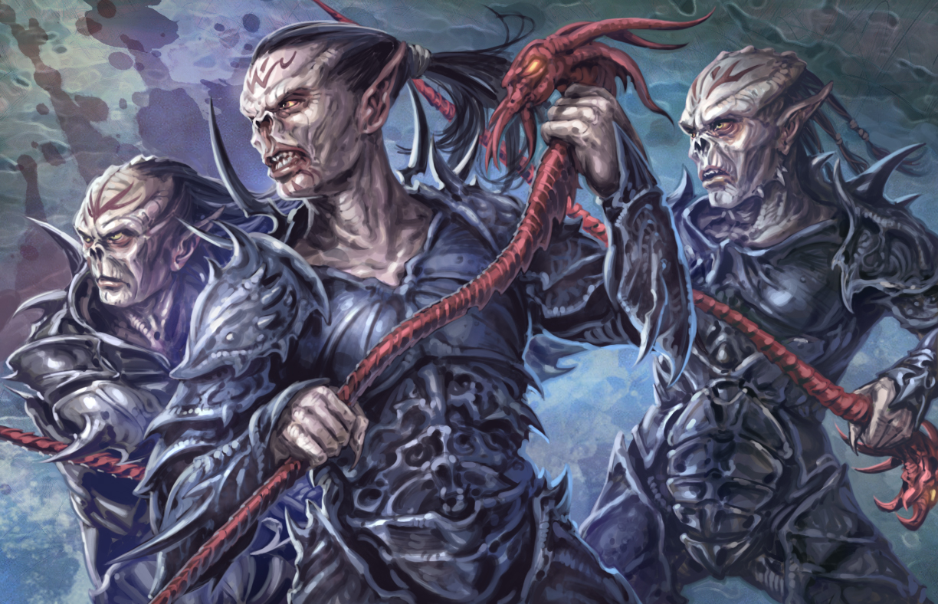
The heroes are going to have to earn that ride off world...
Face to Ugly Face with the Yuuzhan Vong (Challenge Level 2)
The sight of the LOM droid drives the Yuuzhan Vong warriors into a furious rage, and they immediately attack. They focus on the droid and anything between them and their target, such as the heroes. If the heroes manage to stay at a distance from their attackers, the Yuuzhan Vong will switch tactics and throw their nang hul (thud bugs)^{LECG}.
Yuuzhan Vong Warriors (6) | CL 1
Medium Yuuzhan Vong^{LECG} Soldier 1
Destiny: 0; Dark-side 5
Init +6; Senses: Perception +0
Languages Basic (tizowyrm), Yuuzhan Vong
Defences Ref 17 (Flat-footed 16), Fort 19, Will 11
HP 31; Threshold 24
Immune Force effects that target Will Defence
Speed 6 squares
Melee Unarmed +4 (1d4+3) or
Melee Coufee +4 (1d4+3) or
Melee Amphistaff (quarterstaff form) +4 (1d6+3) or
Melee Amphistaff (spear form) +4 (1d8+3; if the attack roll also exceeds the targets Fortitude Defence, the target moves -1 persistent steps down the condition track) or
Melee Amphistaff (whip form, reach 2 squares) +4 (1d4+3; if the attack roll also exceeds the targets Fortitude Defence, the target moves -1 persistent steps down the condition track) or
Ranged Coufee +2 (1d4+3) or
Ranged Nang hul +2 (2d8 or 2d8 stun) or
Ranged Amphistaff (spear form) +2 (1d8+3; if the attack roll also exceeds the targets Fortitude Defence, the target moves -1 persistent steps down the condition track)
Base Atk +1; Grp +4
Abilities Str 16, Dex 13, Con 12, Int 12, Wis 10, Cha 10
Special Qualities Force Immunity, Technophobic, Weapon Familiarity (Amphistaff)
Talents Armoured Defence
Feats Armour Proficiency (Light, Medium), Improved Damage Threshold, Weapon Proficiency (Simple Weapons)
Skills Initiative +6, Endurance +6, Knowledge (Galactic Lore) +6, Pilot +6
Possessions Amphistaff, Coufee, Nang hul (Thud bugs, 2), Tizowyrm (Basic), Warrior's Vonduun Skerr Kyrric (+5 Reflex Defence, +5 Fortitude Defence, Max Dex +4)

The Yuuzhan Vong are armed with both amphistaffs (melee weapons) and nang hul (ranged weapons), but the sight of a droid drives them so insane with disgust and hatred that they charge directly into melee. 9T-LOM is their target, of course, and as he interposes himself between the attackers and his protocol droid, Falloon instructs the heroes that the droid must make it off world, even if he does not. He has no weapon, but will die to protect the droid.
In Case of Broken Droids
9T-LOM – plucky, brave droid that he is – still might catch a stray amphistaff and get knocked down for the count. In such as case, all is not lost; the data can still be retrieved from the droid by an experienced technician. However, Falloon might have to let his true identity slip (as detailed in the Epilogue) to convince the heroes that he can find a tech capable of pulling that off.
As no stats were supplied for 9T-LOM originally, the following stat block has been supplied for use (see Rebellion Era Campaign Guide, page 55 for the base stats of the LOM-Series Protocol Droid):
9T-LOM | CL 1
Medium droid (3rd-degree) Non-heroic 3
Init +1; Senses: Perception +1
Languages Basic, Binary, Rodese
Defences Ref 10 (Flat-footed ), Fort 9, Will 10
HP 7; Threshold 9
Immune Droid Traits
Speed 6 squares (walking)
Melee Unarmed +1 (1d3-1)
Base Atk +2; Grp +1
Abilities Str 8, Dex 11, Con --, Int 13, Wis 11, Cha 15
Feats Linguist, Skill Focus (Knowledge [Bureaucracy]), Skill Focus (Use Computer), Skill Training (Knowledge [Bureaucracy]), Skill Training (Use Computer)
Skills Knowledge (Bureaucracy) +12, Knowledge (Social Sciences) +7, Persuasion +8, Use Computer +12
Systems Basic Processor, Hand Appendages (2), Locked Access, Translator Unit (DC 10), Walking Locomotion, Vocabulator
Possessions Audio Recorder

In Case of Broken Rodians
If Falloon is nearing death for any reason, he will pass the access codes to his private yacht, the Gilded Thranta, on to one of the heroes before he expires.
As no stats were supplied for Falloon originally, the following stat block has been supplied for use:
Falloon | CL 2
Medium Male Rodian Non-heroic 3/ Noble 1
Force 1; Dark-side 4
Init +4; Senses: Low-light Vision; Perception +8 (may reroll, must take second)
Languages Basic, Huttese, Rodese, +1
Defences Ref 14 (Flat-footed 12), Fort 11, Will 14
HP 11; Threshold 11
Speed 6 squares
Melee Unarmed +2 (1d4)
Base Atk +2; Grp +4
Abilities Str 10, Dex 14, Con 10, Int 14, Wis 12, Cha 11
Special Qualities Heightened Awareness, Low-light Vision
Talents Connections
Feats Skill Focus (Knowledge [Bureaucracy]), Skill Training (Knowledge [Bureaucracy]), Skill Training (Knowledge [Social Sciences]), Skill Training (Use Computer), Weapon Proficiency (Pistols, Simple Weapons)
Skills Knowledge (Bureaucracy) +14, Knowledge (Social Sciences) +9, Perception +8 (may reroll, must take second), Persuasion +7, Pilot +9, Use Computer +9
Possessions Credit Chip, Datapad (codes for the Gilded Thranta), Expensive Clothing

Once inside, the heroes will be able to launch the ship, then they can worry about where they’re going. However, whether the heroes defeat all of the Yuuzhan Vong, or simply manage to fight their way to Falloon’s vessel, they’re going to need luck and a little skill to get off planet.

Scene IV: One for the Road
Once inside the Gilded Thranta, Falloon asks the heroes whether any of them is a decent pilot. He can fly the ship himself, but he’d rather keep a close watch on 9T-LOM on the way to their destination – Coruscant (this information can be provided by coded datapad or by 9T-LOM himself, depending on how the previous fight went).
Parting Shots (Challenge Level 6)
As they enter the upper atmosphere, they see the wreckage of numerous ships that attempted to escape Sriluur’s fate. As they move through the debris, a flight of three Yorik-et coralskippers intercepts the yacht at point blank range (0-1 squares at Starship scale). Working as a pair and a single, the skips alternate tactics: the single attempts to strip the Gilded Thranta’s shields with their dovin basals, while the other two fire their yaret-kors (see Saga Edition Starships of the Galaxy, page 73 for official stats for the coralskipper. If you do not possess that book, coralskipper stats converted from the OCR New Jedi Order Sourcebook have been supplied below. The Legacy Era Campaign Guide, page 69 contains details on the effects of dovin basal weaponry/shielding).
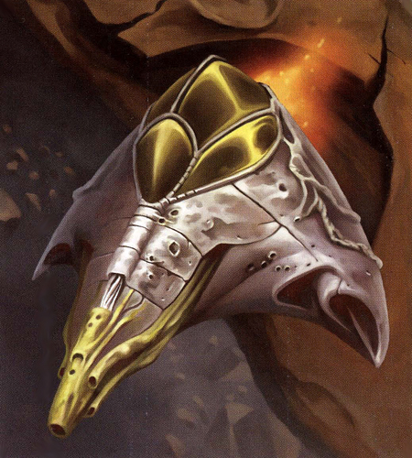
Yorik-et Coralskipper (3) | CL 6
Gargantuan living starfighter
Init +6; Senses: Perception +6
Defences Ref 17 (Flat-footed 12), Fort 24; +7 Armour, Vehicular Combat
HP 100; DR 10; SR 25; Threshold 44
Speed Fly 12 squares (Max. Velocity 400 km h⁻¹), Fly 4 squares (Starship scale)
Ranged Fire-linked (2) Light Yaret-kors +8 (see below) or
Ranged Dovin basal +8 (see below)
Fighting Space 4×4 or 1 square (Starship scale); Cover total
Base Atk +2; Grp +31
Atk Options Autofire (Light Yaret-kors), Fire-link (Light Yaret-kors)
Abilities Str 39, Dex 20, Con 39, Int 18
Skills Initiative +6, Perception +6, Pilot +6, Stealth -4, Treat Injury +6, Use Computer +10
Crew 1 (Skilled); Passengers None
Cargo 1.3 tons; Consumables 1 day; Carried Craft None
Availability Military; Cost Not available for sale
Fire-linked (2) Light Yaret-kors (Pilot)
Atk +8 (+3 autofire), Dmg 6d10×2
Dovin basal (Pilot)
Atk +8, Dmg 7d10×2 dovin basal

Fortunately for the heroes, the Gilded Thranta is far from defenceless – it’s been outfitted with dual laser cannon turrets and a supply of concussion missiles. This should give everyone in the party something to do during starship combat. For example, one hero might pilot the craft, two more can sit in the laser cannon turrets, and a fourth can arm and fire the concussion missiles.
The Gilded Thranta (Modified Ubrikkian FX-77 Star Yacht) | CL 10
Colossal space transport
Init -8; Senses: Perception +0
Defences Ref 15 (Flat-footed 13), Fort 30; +13 Armour
HP 180; DR 15; SR 55; Threshold 80
Speed Fly 12 squares (Max. Velocity 1’200 km h⁻¹), Fly 5 squares (Starship scale)
Ranged 2 Double Light Medium Laser Cannons +0* (see below) or
Ranged Light Concussion Missile Launcher +0* (see below)
Fighting Space 12×12 or 1 square (Starship scale); Cover total
Base Atk +0; Grp +40
Atk Options Autofire (Double Medium Laser Cannons)
Abilities Str 50, Dex 14, Con --, Int 12*
Skills Initiative -8, Mechanics +0, Perception +0, Pilot -8, Stealth -18, Use Computer +11
Crew 1 or 2 (Unique**); Passengers 8
Cargo 45 tons; Consumables 1 year; Carried Craft None
Payload 12 Light Concussion Missiles
Hyperdrive ×1.5, navicomputer
Availability Unique; Cost Not available for sale (estimated value 400’000 credits)
*The Gilded Thranta cannot apply its Intelligence modifier to attacks made against Yuuzhan Vong vessels, unless the ship’s computer is reprogrammed to recognise them as a threat. This takes 1 minute and a DC 15 Use Computer check.
**Unique crew qualifier has a Base Atk of +0 and a Skill check modifier of +0. Replace these with those modifiers of the party when they fly the vessel.
Double Medium Laser Cannon (Gunner)
Atk +0* (-5 autofire), Dmg 5d10×2
Double Medium Laser Cannon (Gunner)
Atk +0* (-5 autofire), Dmg 5d10×2
Light Concussion Missiles (Gunner)
Atk +0*, Dmg 7d10×2

The heroes’ goal is either to destroy the coralskippers or, failing that, to keep themselves and their ship together for 1 minute (10 rounds), after which time they will have cleared Sriluur’s gravity well and be able to make the jump to hyperspace. No time is needed to calculate the coordinates: Falloon’s already got them programmed in and ready to go.
Alternatively, if you prefer and have Galaxy of Intrigue, the escape can be run as a Skill Challenge as follows:
CL 6
Complexity: 2 (8 successes before 3 failures)
Suggested Skills: The following are suggested primary skills for this skill challenge:
Fire Starship Weapons [Reflex Defence 17]: A gunner aboard the ship can fire one weapon at one of the pursuing Yorik-et in an attempt to damage/destroy it.
Knowledge (Life Sciences) [DC 17]: The heroes can attempt to realise that the life signatures present in the Yorik-et can be used to assist in the computer reprogram required to apply the Gilded Thranta’s Intelligence bonus to its attack rolls. Success results in the reprogramming taking 5 rounds instead of 10.
Knowledge (Physical Sciences) [DC 27]: The heroes can attempt to use their knowledge of gravity manipulation to understand how the Yorik-et manoeuvre and how to take advantage of this. Success gives the heroes a +2 bonus to the next Pilot skill checks made.
Knowledge (Tactics) [DC 22]: The heroes can attempt to maximise the effectiveness of their attacks by observing the mechanism of the Yorik-et dovin basal shielding. Success gives a +2 bonus to attack for one weapon fired this round.
Knowledge (Technology) [DC 17]: The heroes can attempt to improve the effectiveness of their ships weapons. Success indicates that the heroes realise that autofire attacks can weaken the shields of the Yorik-et, whereas single shot attacks cannot.
Mechanics [DC 22]: The heroes may attempt to recharge their shields after taking fire from the Yorik-et. Success indicates that the ships current SR increases by 5, up to its normal maximum.
Pilot [Opposed DC]: The heroes may attempt to evade the attacks of the pursuing Yorik-et. Success: The Yorik-et fails to hit the heroes’ vessel. Failure: A Yorik-et manages to hit the heroes vessel for either 6d10×2 points of damage (yaret-kor) or 7d10×2 points of damage (dovin basal) – GM’s choice.
Use Computer [DC 17]: The heroes can attempt to reprogram the ships computer in order to allow the ship’s targeting computer to recognise Yuuzhan Vong vessels as threats. Success results in the Gilded Thranta being able to apply its Intelligence modifier to attacks made against Yuuzhan Vong vessels 10 rounds later (see Knowledge [Life Sciences] for further effects).
Challenge Effects: The following is a suggested challenge effect for this skill challenge:
Initiative: The heroes must act in order of initiative during the skill challenge.
Opposed DC: Pilot checks are opposed by attacks made by the Yorik-et.
Recovery: Any hero who succeeds on a skill check by 5 or more can forfeit that success in exchange for removing one failure.
Restricted Skills: The following skill checks can only be used once in this encounter: Knowledge (Life Sciences), Knowledge (Technology), Use Computer.
Timed Challenge: The heroes have to evade the Yorik-et for 10 rounds in order to complete the challenge. After that point, they successfully complete the skill challenge automatically.
Success: The heroes successfully escape Sriluur by jumping into hyperspace.
Failure: The heroes’ ship is shot down, crashing landing on the Yuuzhan Vong-occupied world of Sriluur.

Epilogue: Escape to Coruscant
The familiar stars over Sriluur streak into white lines as the Gilded Thranta slips smoothly into hyperspace. At this point, the heroes learn the truth about ‘Falloon’ either from the grateful Rodian, from his droid if he didn’t survive, or from his personal logs if neither survived. His real name is Soolehad, and he had been the chief accountant for the Black Sun criminal organisation in this sector. His droid contains centuries’ worth of financial records of an underworld empire that spanned the galaxy.
Soolehad tells the heroes that once they reach Coruscant, he plans to deliver 9T-LOM to some ‘friends’ and ask for a well-deserved retirement. If pressed, he laments the passing of the Black Sun organisation and mentions that he still performs special missions for a small group of ‘business beings’ who, like him, are ex-Black Sun. He offers to put in a good word for heroes interested in similar work with the group.

Where to Go from Here?
The heroes have escaped the occupation of Sriluur and gotten in good with Soolehad’s criminal employers. They might decide to throw in with their new pals and attempt to fight the Yuuzhan Vong from the underground. Then again, since they’re headed to Coruscant, they might volunteer there to help the New Republic with other evacuation efforts. Or perhaps a gratefully retiring Soolehad gives them the Gilded Thranta as their payment, providing the heroes with a well-armed ship to travel the newly dangerous galaxy. If the heroes have any Jedi in the group, they might set out to join Kyp Durron’s Dozen of Master Skywalker himself.
After all, it’s a whole new order out there.

About the Author
One-time Star Wars RPG editor Cory Herndon is now a freelance writer, editor, and game designer. Cory’s work has appeared in AMAZING STORIES, DUELIST, TOPDECK, Star Wars Gamer, and DRAGON. He is also the author of Volumes 5 and 6 of the MAGIC: THE GATHERING ENCYCLOPEDIA. Cory’s first published fiction will appear in The Secrets of Magic anthology – he recommends purchasing a copy for each room of your house.
Cory is currently working on a fantasy novel and a box of doughnuts, not necessarily in that order.

