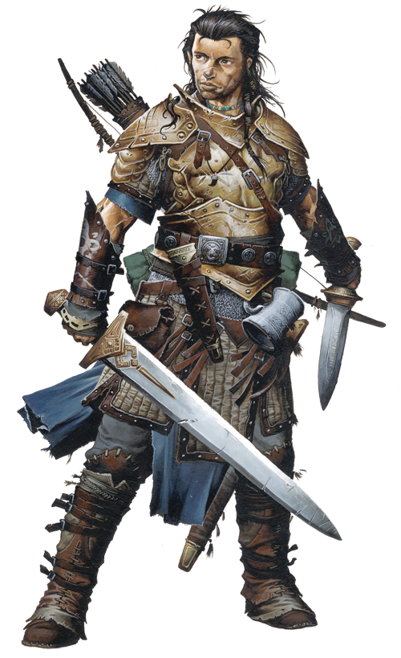
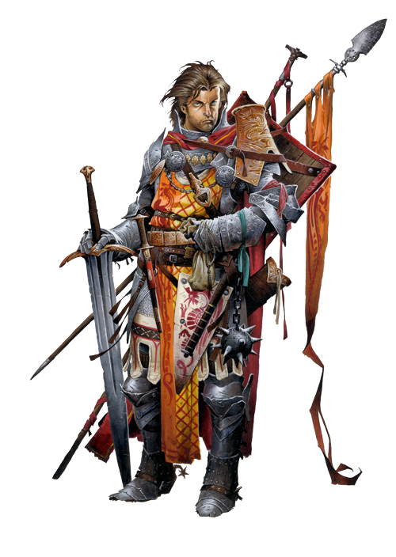
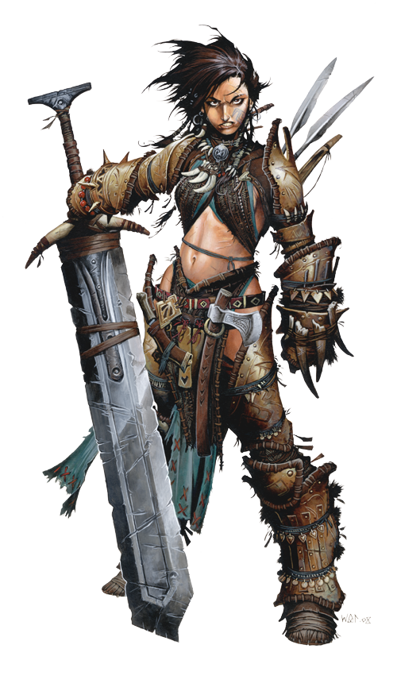
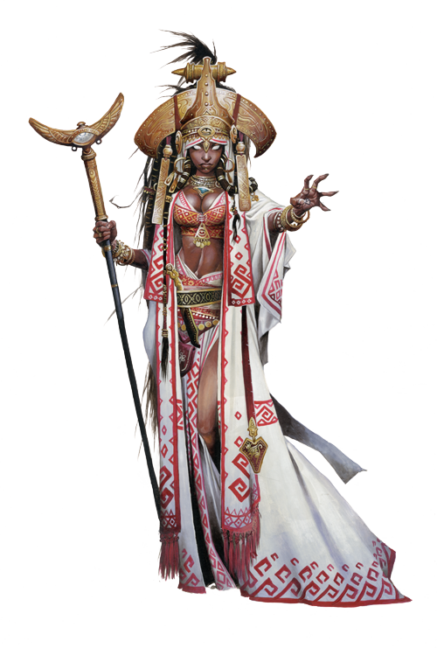
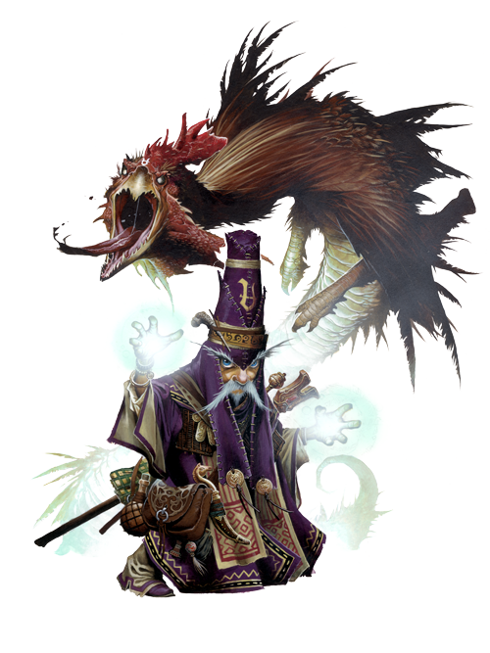
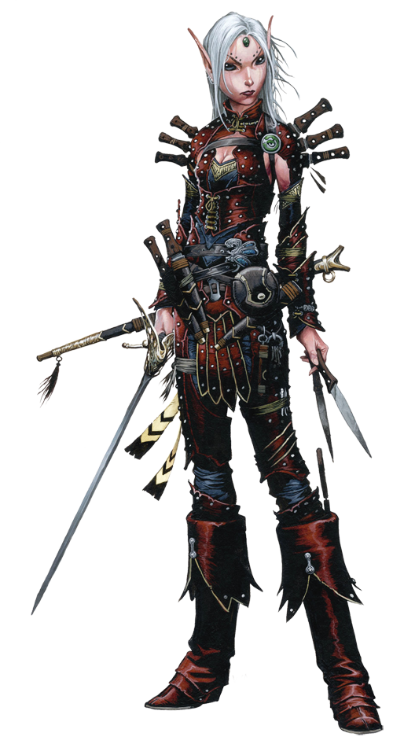
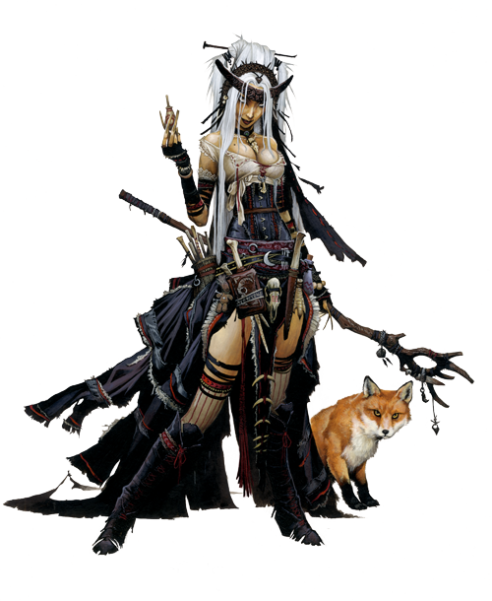
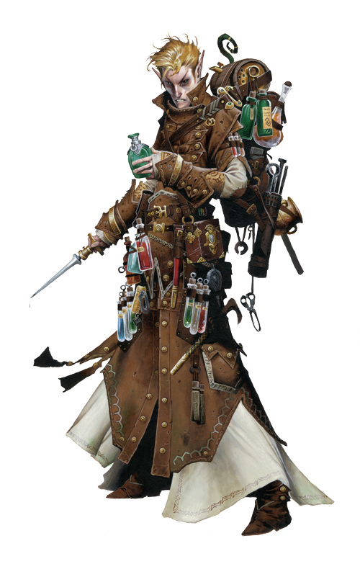
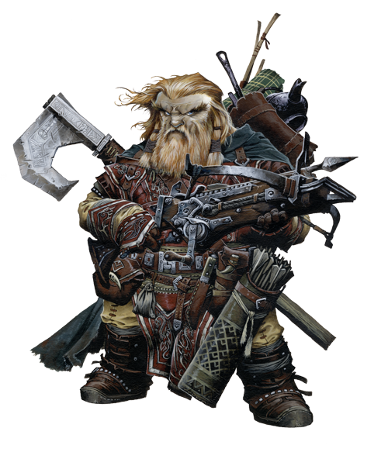
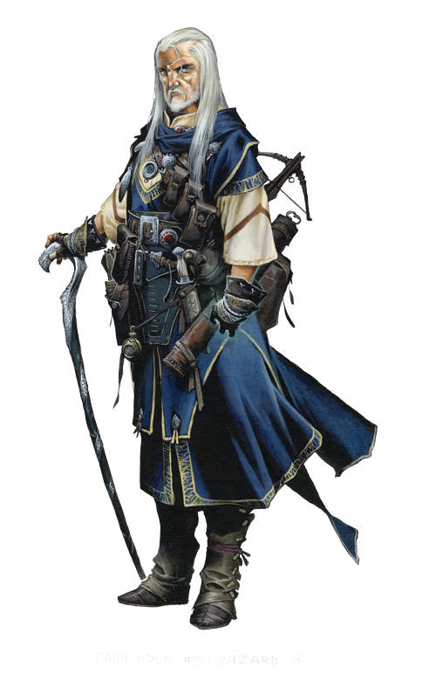
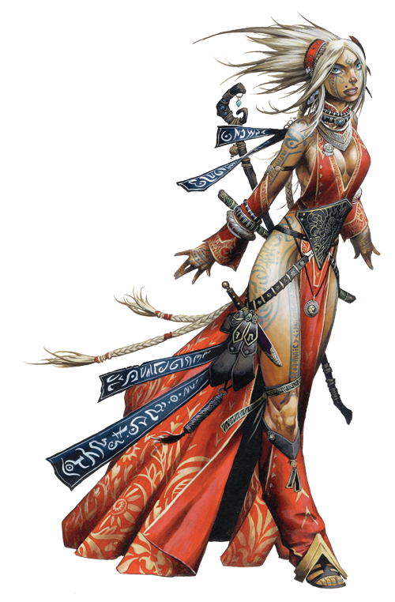
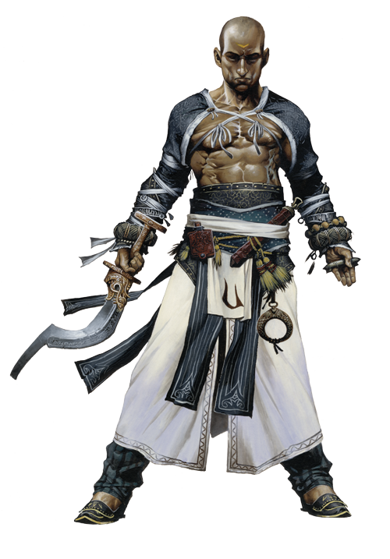
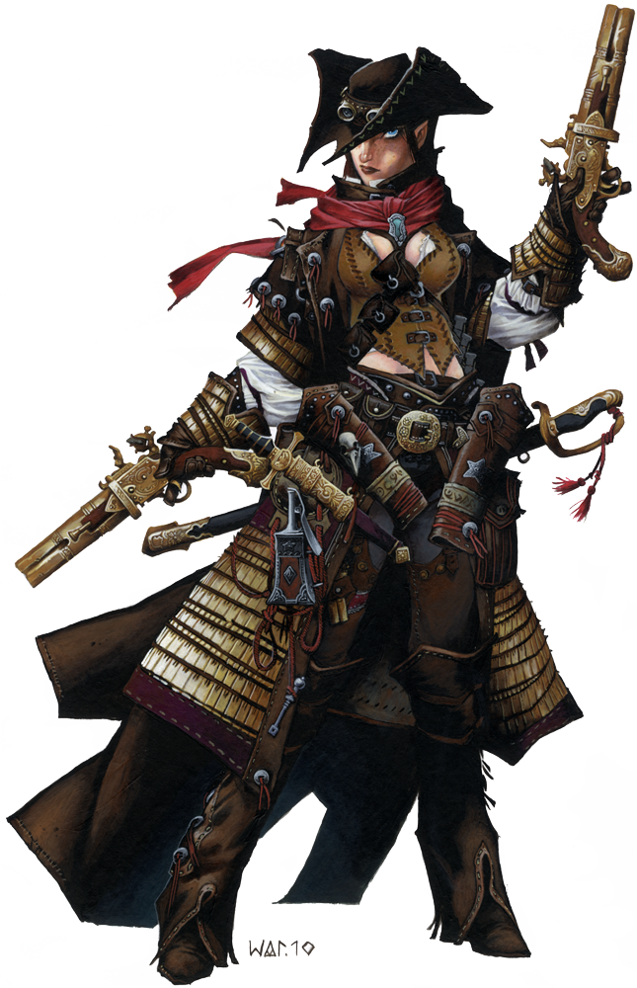
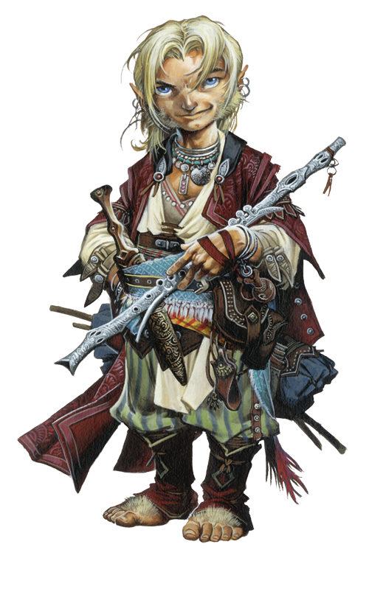
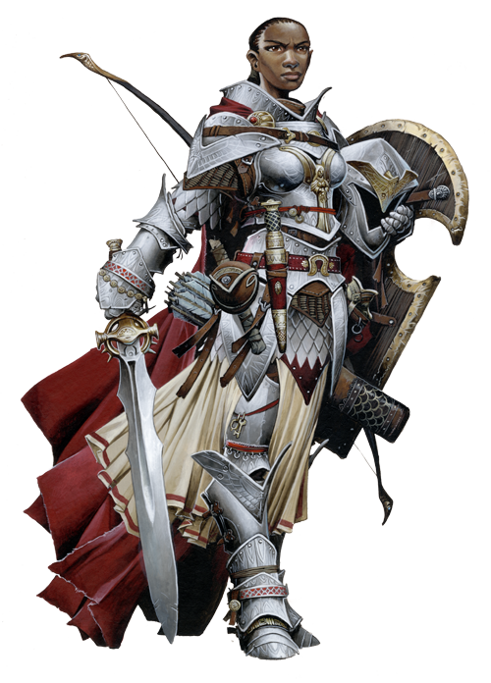
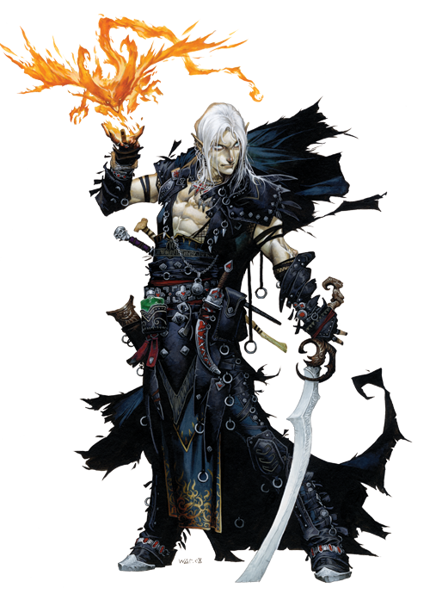

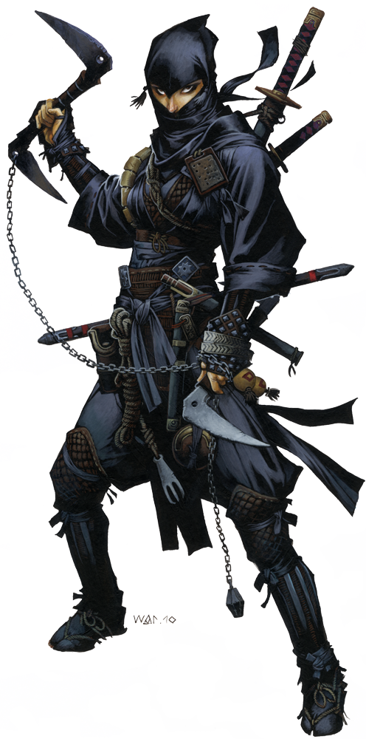
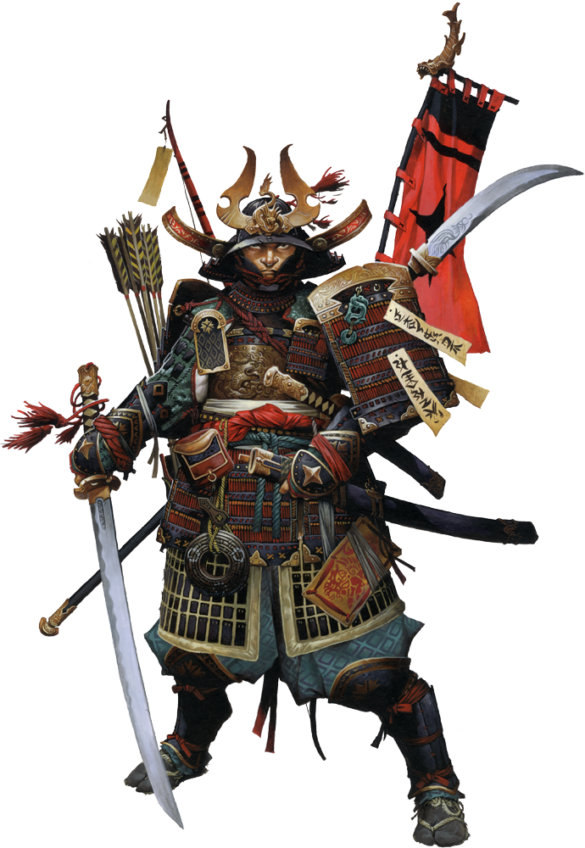
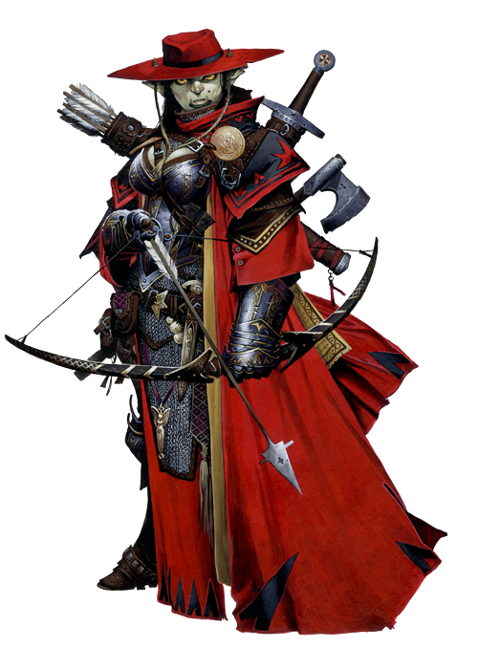
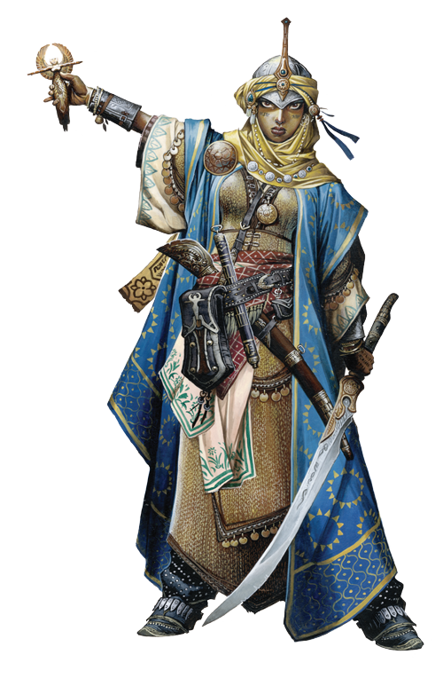
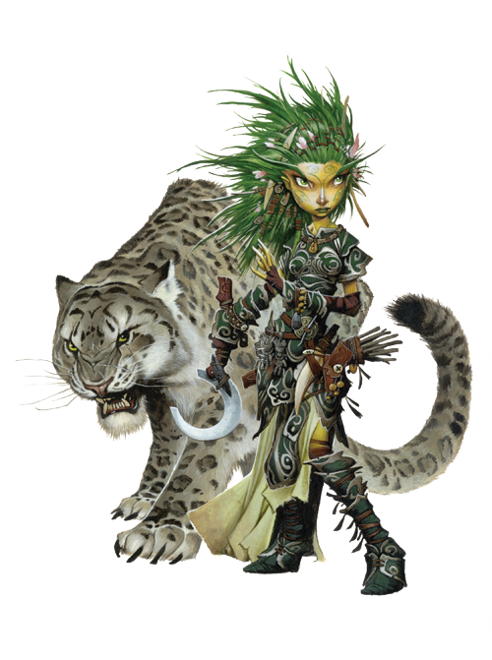
Wind Force | Wind Speed | Checked Size | Blown Away Size | Fly Penalty
Severe | 31-50 mph | Small | Tiny | -4
Windstorm | 51-74 mph | Medium | Small | -8
Hurricane | 75-174 mph | Large | Medium | -12
Tornado | 175+ mph | Huge | Large | -16

Wind Effects on Flight
Wind Force | Wind Speed | Checked Size | Blown Away Size | Fly Penalty
Light | 0-10 mph | - | - | -
Moderate | 11-20 mph | - | - | -
Strong | 21-30 mph | Tiny | - | -2

Fly (page 96)
Flying Maneuver | Fly DC
Move less than half speed and remain flying | 10
Hover | 15
Turn greater than 45° by spending 5ft of movement | 15
Turn 180° by spending 10 feet of movement | 20
Fly at greater than 45° angle | 20

Knowledge (page 99)
Task | Knowledge DC
Easy question | 10
Basic question | 15
Hard question | 20+
Identify aura using detect magic (Arcana) | 15 + spell level
Identify spell effect (Arcana) | 20 + spell level
Identify underground hazard (Dungeoneering) | 15 + hazard’s CR
Identify dangerous construction (Engineering) | 10
Recognize regional terrain features (Geography) | 15
Know obscure or ancient event (History) | 20
Know local laws, rulers, and popular locations (Local) | 10
Identify common plant or animal (Nature) | 10
Know proper etiquette (Nobility) | 15
Identify a creature’s planar origins (Planes) | 20
Recognize a common diety’s symbol (Religion) | 10
Know a monster’s abilities or weaknesses | 10 + monster’s CR

Disable Device (page 94)
Device | Time | Disable Device DC
Simple (jam a lock) | 1 round | 10
Tricky (sabotage a wagon) | 1d4 rounds | 15
Difficult (disarm or reset a trap) | 2d4 rounds | 20
Extreme (disarm a complex trap) | 2d4 rounds | 25

Bluff (opposed by Sense Motive, page 90)
Circumstances | Bluff Modifier
The target wants to believe you | +5
The lie is believable | +0
The lie is unlikely | -5
The lie is far-fetched | -10
The lie is impossible | -20
The target is drunk or impaired | +5
You possess convincing proof | up to+10

Diplomacy (page 93)
Starting Attitude | Diplomacy DC
Hostile | 25 + Cha
Unfriendly | 20 + Cha
Indifferent | 15 + Cha
Friendly | 10 + Cha
Helpful | 0 + Cha
Request | DC Modifier
Give simple advice or directions | -5
Give detailed advice or simple aid | +0
Reveal an unimportant secret or complicated aid | +5
Give dangerous aid | +10
Reveal an important secret | +10 or more
Give aid that could result in punishment | +15 or more

Heal (page 98)
Task | Heal DC
First aid | 15
Long-term care | 15
Treat wounds from caltrops | 15
Treat deadly wounds | 20
Treat poison | Poison’s save DC
Treat disease | Disease’s save DC

Climb (page 90)
Example Surface or Activity | Climb DC
A steep slope, or a knotted rope next to a wall | 0
A rope next to a wall or a knotted rope | 5
A surface with ledges, rough wall, or ship rigging | 10
Any surface with handholds, or an unknotted rope | 15
An uneven surface with narrow handholds | 20
A rough surface, such as a rock or brick wall | 25
An overhang or ceiling with handholds only | 30
Climb Modifiers | DC Modifier
Brace against two opposite walls | -10
Brace against two perpendicular walls | -5
Surface is slippery | +5

Acrobatics (page 87)
Moving Across a Narrow Surface | Acrobatics DC
Greater than 3 feet wide | 0
1–3 feet wide | 5
7–11 inches wide | 10
2–6 inches wide | 10
Less than 2 inches wide | 20
Move through a threatened space | Acrobatics DC
Move through a threatened space | Opponent’s CMD
Move through an enemy’s space | 5 + opponent’s CMD
Long Jump | Acrobatics DC
5 feet | 5
10 feet | 10
15 feet | 15
Greater than 10 feet | +5 per 5 feet
High Jump | Acrobatics DC
1 foot | 4
2 feet | 8
3 feet | 12
Greater than 3 feet | +4 per foot
Acrobatics Modifiers | DC Modifier
Slightly obstructed (gravel, sand) | +2
Severely obstructed (cavern, rubble) | +5
Slightly slippery (wet) | +2
Severely slippery (icy) | +5
Slightly sloped (<45°) | +2
Severely sloped (>45°) | +5
Slightly unsteady (boat in rough water) | +2
Moderately unsteady (boat in a storm) | +5
Move at full speed on a narrow or uneven surface | +5

Skills
Lifting & Dragging (page 169)
Lifting: A character can lift as much as his maximum load over his head. A character can lift as much as twice his maximum load off the ground, but he can only stagger around with it. While overloaded in this way, the character loses any Dexterity bonus to AC and can only move 5 feet per round (as a full round action).
Dragging: A character can generally push or drag along the ground as much as five times his maximum load. Favorable conditions can double these numbers, and bad conditions can reduce them by half or more.

Skills & Encumbrance
Encumbrance Effects (page 171)
 |  |  | Speed
Load | Max Dex | Check Penalty | 30 ft. | 20 ft. | Run
Medium | +3 | -3 | 20 ft. | 15 ft. | x4
Heavy | +1 | -6 | 20 ft. | 15 ft. | x3

Carrying Capacity (page 171)
Strength Score | Light Load | Medium Load | Heavy Load
1 | 3 lbs. | 6 lbs. | 10 lbs.
2 | 6 lbs. | 13 lbs. | 20 lbs.
3 | 10 lbs. | 20 lbs. | 30 lbs.
4 | 13 lbs. | 26 lbs. | 40 lbs.
5 | 16 lbs. | 33 lbs. | 50 lbs.
6 | 20 lbs. | 40 lbs. | 60 lbs.
7 | 23 lbs. | 46 lbs. | 70 lbs.
8 | 26 lbs. | 53 lbs. | 80 lbs.
9 | 30 lbs. | 60 lbs. | 90 lbs.
10 | 33 lbs. | 66 lbs. | 100 lbs.
11 | 38 lbs. | 76 lbs. | 115 lbs.
12 | 43 lbs. | 86 lbs. | 130 lbs.
13 | 50 lbs. | 100 lbs. | 150 lbs.
14 | 58 lbs. | 116 lbs. | 175 lbs.
15 | 66 lbs. | 133 lbs. | 200 lbs.
16 | 76 lbs. | 153 lbs. | 230 lbs.
17 | 86 lbs. | 173 lbs. | 260 lbs.
18 | 100 lbs. | 200 lbs. | 300 lbs.
19 | 116 lbs. | 233 lbs. | 350 lbs.
20 | 133 lbs. | 266 lbs. | 400 lbs.
21 | 153 lbs. | 306 lbs. | 460 lbs.
22 | 173 lbs. | 346 lbs. | 520 lbs.
23 | 200 lbs. | 400 lbs. | 600 lbs.
24 | 233 lbs. | 466 lbs. | 700 lbs.
25 | 266 lbs. | 533 lbs. | 800 lbs.
26 | 306 lbs. | 613 lbs. | 920 lbs.
27 | 234 lbs. | 693 lbs. | 1,040 lbs.
28 | 400 lbs. | 800 lbs. | 1,200 lbs.
29 | 466 lbs. | 933 lbs. | 1,400 lbs.
+10 | x4 | x4 | x4

Survival (page 107)
Track Creature’s Over Listed Surface | Survival DC
Very soft ground | 5
Soft ground | 10
Firm ground | 15
Hard ground | 20
Tracking Modifiers | DC Modifier
Every three creatures in group | -1
Size of creatures being tracked
Fine | +8
Diminutive | +4
Tiny | +2
Small | +1
Medium | +0
Large | -1
Huge | -2
Gargantuan | -4
Colossal | -8
Every 24 hours since tail was made | +1
Every hour of rain since trail was made | +1
Fresh snow since trail was made | +10
Poor visibility
Overcast or moonless night | +6
Moonlight | +3
Fog or precipitation | +3
Tracked part hides trail (and moves at half speed) | +5

Swim (move at quarter speed, page 108)
Water condition | Swim DC
Calm water | 10
Rough water | 15
Stormy water | 20

Spellcraft (page 106)
Task | Spellcraft DC
Identify a spell as it is being cast | 15 + spell level
Learn a spell from a spellbook or scroll | 15 + spell level
Prepare a spell from a borrowed spellbook | 15 + spell level
Identify magic item powers using detect magic | 15 + item’s CL
Decipher a scroll | 20 + spell level

Ride (page 103)
Task | Ride DC
Guide with knees | 5
Stay in saddle | 5
Fight with a combat-trained mount | 10
Cover | 15
Soft fall | 15
Leap | 15
Spur mount | 15
Control mount in battle | 20
Fast mount or dismount | 10

Perception (page 102)
Detail | Perception DC
Hear the sound of battle | -10
Detect the smell of smoke | 0
Hear the details of a conversation | 0
Notice a visible creature | 0
Hear the sounds of a creature walking | 10
Hear the details of a whispered conversation | 15
Find the average concealed door | 15
Hear the sound of a key being turned | 20
Find the average secret door | 20
Sense a burrowing creature underneath you | 25
Notice a creature using Stealth | Opposed by Stealth
Find a hidden trap | Varies by trap
Identify the powers of a potion through taste | 15 + potion’s CL
Perception Modifiers | DC Modifier
Distance to the source | +1/10 feet
Through a closed door | +5
Through a wall | +10/ft. of wall
Favorable conditions | -2
Unfavorable conditions | +2
Terrible conditions | +5
Creature making check is distracted | +5
Creature making check is asleep | +10
Creature or object is invisible | +20

Common Object Hardness and Hit Points page(173)
Object | Hardness | Hit Points | Break DC
Rope | 0 | 2 | 23
Simple wooden door | 5 | 10 | 13
Small chest | 5 | 1 | 17
Good wooden door | 5 | 15 | 18
Treasure chest | 5 | 15 | 23
Strong wooden door | 5 | 20 | 23
Wooden portcullis | 5 | 30 | 25
Stone door | 8 | 60 | 28
Masonry wall | 8 | 90 | 35
Hewn stone | 8 | 540 | 50
Chain | 10 | 5 | 26
Manacles | 10 | 10 | 26
Iron portcullis | 10 | 60 | 25
Iron door | 10 | 60 | 28
Condition |  | DC Adjustment
Hold portal |  | +5
Arcane lock |  | +10

Combat Maneuvers (page 198)
CMB = BAB + Str + size modifier
CMD = BAB + Str _ Dex + size modifier
Bull Rush Push target 5 ft, +5 ft for every 5 exceeds CMD
Disarm Target drops 1 item or 2 items exceeds CMD by 10
Grapple Both target and attacker gain grapple condition
Overrun Move trough target, knocked prone if exceed CMD by 5
Sunder Deal damage to item held or worn by target
Trip Knock target prone, attacker knocked prone if fail by 10

Two-Weapon Fighting Penalties (page 202)
Circumstances | Primary Hand | Off Hand
Normal Penalties | -6 | -10
Off-hand weapon is light | -4 | -8
Two-Weapon Fighting feat | -4 | -4
Off-hand weapon is light and Two-Weapon Fighting feat | -2 | -2

Substance Hardness and Hit Points (page 173)
Substance | Hardness | Hit Points
Glass | 1 | 1/in
Paper or cloth | 0 | 2/in
Rope | 0 | 2/in
Ice | 0 | 3/in
Leather or hide | 2 | 5/in
Wood | 5 | 10/in
Stone | 8 | 15/in
Iron or Steel | 10 | 30/in
Mithral | 15 | 30/in
Adamantine | 20 | 40/in

Armor Class Modifiers (page 195)
Defender is… | Melee | Ranged
Behind Cover | +4 | +4
Blinded | -2 | -2
Concealed or invisible | see page 196
Cowering | -2 | -2
Entangled | +0 | +0
Flat-footed | +0 | +0
Grappling | +0 | +0
Helpless | -4 | +0
Kneeling or sitting | -2 | +2
Pinned | -4 | +0
Prone | -4 | +4
Squeezing through a space | -4 | -4
Stunned | -2 | -2

Attack Roll Modifiers (page 195)
Attacker is… | Melee | Ranged
Dazzled | -1 | -1
Entangled | -2 | -2
Flanking defender | +2 | -
Invisible | +2 | +2
On higher ground | +1 | +0
Prone | -4 | -
Shaken or frightened | -2 | -2
Squeezing through a space | -4 | -4

Common Conditions (page 565)
Blinded: Creature takes a –2 penalty to AC, loses Dex bonus to AC, and takes a –4 penalty on most Str- and Dex-based skill checks and on opposed Perception skill checks. All opponents are considered to have total concealment (50% miss chance) against the blinded character. Creatures must make a DC 10 Acrobatics skill check to move faster than half speed or fall prone.
Broken: Weapons suffer a -2 penalty on attack and damage rolls and only score critical hits on a natural 20 and only deal x2 damage. Armor and shields grant half AC bonus and double armor check penalty. Broken wands or staves use twice as many charges.
Confused: 01-25: Act normally, 26-50: Babble for one round, 51-75: Deal 1d8 + Str damage to self. 76-100: Attack nearest creature.
Cowering: Creature cannot take any actions. Takes -2 penalty to AC and loses Dex.
Dazed: Creature cannot take any actions.
Dazzled: Creature takes -1 on attack rolls and Perception checks.
Entangled: No movement if bonds are anchored, otherwise move at half speed. Creatures take a -2 penalty on all attack rolls and a -4 penalty to Dex. Must make concentration check to cast spells.
Exhausted: Creature moves at half speed. -6 penalty to Str and Dex. Rest 1 hour to become fatigued.
Fatigued: Create cannot run or charge. -2 penalty to Str and Dex. Rest 8 hours to remove.
Flat-Footed: Creature loses Dex bonus to AC.
Frightened: As Shaken, except creature must flee from source.
Grappled: Creature cannot move or take actions that require 2 hands. -4 penalty to Dex. -2 penalty to attacks and combat maneuvers (except checks made to escape). Must make concentration check to cast spells. Cannot take attacks of opportunity.
Helpless: As Flat-Footed, except can be coup de graced. Fort save 10 + damage or die.
Nauseated: Creatures can only take a move action and cannot attack, cast spells, or concentrate.
Panicked: As Frightened, except creature drops held items.
Paralyzed: Creature’s Str and Dex reduced to 0. Fliers using wings fall. Creature is helpless.
Pinned: As Grappled, except creature is flat-footed, takes a -4 penalty to AC, and can only take verbal or mental actions (except checks made to escape).
Shaken: Creature takes a -2 penalty on attack rolls, weapon damage rolls, and ability checks.
Sickened: Creature take a -2 penalty on all attack rolls, weapon damage rolls, saving throws, skill checks, and ability checks.
Staggered: Creature can only take a move or standard action (plus swift and immediate).
Stunned: Creature cannot take actions, drops everything held, takes a -2 penalty to AC, and loses its Dex bonus to AC.

Armor and Weapon Hardness & HP (page 173)
Weapon or Shield | Hardness | Hit Points
Light Blade | 10 | 2
One-handed blade | 10 | 5
Two-handed blade | 10 | 10
Light metal-hafted weapon | 10 | 10
One-handed metal-hafted weapon | 10 | 20
Light hafted weapon | 5 | 2
One-handed hafted weapon | 5 | 5
Two-handed hafted weapon | 5 | 10
Projectile weapon | 5 | 5
Armor | special | armor bonus x 5
Buckler | 10 | 5
Light wooden shield | 5 | 7
Heavy wooden shield | 5 | 15
Light steel shield | 10 | 10
Heavy steel shield | 10 | 20
Tower shield | 5 | 20

Combat
Light Sources & Illumination (page 174)
Object | Normal | Increased | Duration
Candle | n/a | 5 ft | 1 hr.
Everburning torch | 20 ft. | 40 ft. | Permanent
Lamp, common | 15 ft. | 30 ft. | 6 hr./pint
Lamp, bullseye | 60 ft. cone | 120 ft. cone | 6 hr./pint
Lamp, hooded | 30 ft. | 60 ft. | 6 hr./pint
Sunrod | 30 ft. | 60 ft. | 6 hr.
Torch | 20 ft. | 40 ft. | 1 hr
Spell
Continual flame | 20 ft. | 40 ft. | Permanent
Dancing lights (torches) | 20 ft. (each) | 40 ft. (each) | 1 min
Daylight | 60 ft. | 120 ft. | 10 min/level
Light | 20 ft. | 40 ft. | 10 min/level

Mounts and Vehicles (page 174)
Mount/Vehicle | Per Hour | Per Day
Mount (carrying load)
Light Horse | 5 miles | 40 miles
Light Horse (medium) | 3-1/2 miles | 28 miles
Heavy Horse | 5 miles | 40 miles
Heavy Horse (medium) | 3-1/2 miles | 28 miles
Pony | 4 miles | 32 miles
Pony (medium) | 3 miles | 24 miles
Dog, riding | 4 miles | 32 miles
Dog, riding (medium) | 3 miles | 24 miles
Cart or wagon | 2 miles | 16 miles
Ship
Raft or barge | ½ mile | 5 miles
Keelboat | 1 miles | 10 miles
Rowboat | 1-1/2 miles | 15 miles
Sailing ship | 2 miles | 48 miles
Warship | 2-1/2 miles | 60 miles
Longship | 3 miles | 72 miles
Galley | 4 miles | 96 miles

Character Advancement (page 30)
Character Level | Slow | Medium | Fast
1 | - | - | -
2 | 3000 | 2000 | 1,300
3 | 7,500 | 5,000 | 3,300
4 | 14,000 | 9,000 | 6,000
5 | 23,000 | 15,000 | 10,000
6 | 35,000 | 23,000 | 15,000
7 | 53,000 | 35,000 | 23,000
8 | 77,000 | 51,000 | 34,000
9 | 115,000 | 75,000 | 50,000
10 | 160,000 | 105,000 | 71,000
11 | 235,000 | 155,000 | 105,000
12 | 330,000 | 220,000 | 145,000
13 | 475,000 | 315,000 | 210,000
14 | 665,000 | 445,000 | 295,000
15 | 955,000 | 635,000 | 425,000
16 | 1,350,000 | 890,000 | 600,000
17 | 1,900,000 | 1,300,000 | 850,000
18 | 2,700,000 | 1,800,000 | 1,200,000
19 | 3,850,000 | 2,550,000 | 1,700,000
20 | 5,350,000 | 3,600,000 | 2,400,000

Experience Point Awards (page 399)
CR | Total XP | 1-3 PCS | 4-5 PCs | 6+ PCs
1/8 | 50 | 15 | 15 | 10
1/6 | 65 | 20 | 15 | 10
1/4 | 100 | 35 | 25 | 15
1/3 | 135 | 45 | 35 | 25
1/2 | 200 | 65 | 50 | 35
1 | 400 | 135 | 100 | 35
2 | 600 | 200 | 150 | 100
3 | 800 | 265 | 200 | 135
4 | 1,200 | 400 | 300 | 200
5 | 1,600 | 565 | 400 | 265
6 | 2,400 | 800 | 600 | 400
7 | 3,200 | 1,070 | 800 | 535
8 | 4,800 | 1,600 | 1,200 | 800
9 | 6,400 | 2,130 | 1,600 | 1,070
10 | 9,600 | 3,200 | 2,400 | 1,600
11 | 12,800 | 4,270 | 3,200 | 2,130
12 | 19,200 | 6,400 | 4,800 | 3,200
13 | 25,600 | 8,530 | 6,400 | 4,270
14 | 38,400 | 12,800 | 9,600 | 6,400
15 | 51,200 | 17,100 | 12,800 | 8,530
16 | 76,800 | 25,600 | 19,200 | 12,800
17 | 102,400 | 34,100 | 25,600 | 17,100
18 | 153,600 | 51,200 | 38,400 | 25,600
19 | 204,800 | 68,300 | 51,200 | 34,100
20 | 307,200 | 102,000 | 76,800 | 51,200
21 | 409,600 | 137,000 | 102,300 | 68,300
22 | 614,400 | 205,000 | 153,600 | 102,400
23 | 819,200 | 273,000 | 204,800 | 137,000
24 | 1,228,800 | 410,000 | 307,200 | 204,800
25 | 1,638,400 | 546,000 | 409,600 | 273,000

Movement, Light Sources, & Experience
Hampered Movement (page 172)
Condition | Additional Movement Cost
Difficult terrain | x2
Obstacle | x2
Poor Visibility | x2
Impassable | –

Terrain and Overland Movement (page 172)
Terrain | Highway | Road or Trail | Trackless
Desert, sandy | x1 | x1/2 | x1/2
Forest | x1 | x1 | x1/2
Hills | x1 | x3/4 | x1/2
Jungle | x1 | x3/4 | x1/4
Moor | x1 | x1 | x3/4
Mountains | x3/4 | x3/4 | x1/2
Plains | x1 | x1 | x3/4
Swamp | x1 | x3/4 | x1/2
Tundra, frozen | x1 | x3/4 | x3/4

Movement and Distance (page 172)
Speed | 15 feet | 20 feet | 30 feet | 40 feet
One Round (Tactile)
Walk | 15 ft. | 20 ft. | 30 ft. | 40 ft.
Hustle | 30 ft. | 40 ft. | 60 ft. | 80 ft.
Run (x3) | 45 ft. | 60 ft. | 90 ft. | 120 ft.
Run (x4) | 60 ft. | 80 ft. | 120 ft. | 160 ft.
One Minute (Local)
Walk | 150 ft. | 200 ft. | 300 ft. | 400 ft.
Hustle | 300 ft. | 400 ft. | 600 ft. | 800 ft.
Run (x3) | 450 ft. | 600 ft. | 900 ft. | 1,200 ft.
Run (x4) | 600 ft. | 800 ft. | 1,200 ft. | 1,600 ft.
One Hour (Overland)
Walk | 1-1/2 miles | 2 mile–s | 3 miles | 4 miles
Hustle | 3 miles | 4 miles | 6 miles | 8 miles
Run | – | – | – | –
One Day (Overland)
Walk | 12 miles | 16 miles | 24 miles | 32 miles
Hustle | – | – | – | –
Run | – | – | – | –

