

Meet the Iconics
Update Date: 7/29/14 8:49 AM

Meet the Iconics
One of the many lessons we've learned in our tour with Dragon and Dungeon is that people like iconic characters. A lot. It seems like every day a new thread pops up on our message boards wanting to know more about the ill-fated Abelard the paladin, the tiefling fighter, or James Jacobs's notorious Tyralandi Scrimm. As such, when we sat down to develop the iconics for Pathfinder, we knew going into it that what we came up with needed to be more than just easy art reference. These iconics needed to live up their name and represent our world, our ethos, and our whole idea of what gaming is about. Fortunately, with Wayne Reynolds onboard to design the visual elements, we knew that what we received would blow our socks off, which it has.
Along with representing our game world, however, these iconics pull double-duty as pregenerated characters in Pathfinder and the GameMastery Modules. Each adventure will be accompanied by four of our iconics, statted up to the appropriate level and ready for you to sit down and start playing with a minimum of effort.
James Sutter
Assistant Editor, Pathfinder

Core Rule Book

Barbarian Amiri Human Female 1

Bard Lem Halfling Male 2

Cleric Kyra Human Female 2

Druid Lini Gnome Female 3

Fighter Valeros Human Male 4

Monk Sajan Human Male 5

Paladin Seelah Human Female 5

Ranger Harsk Dwarf Male 6

Rogue Merisiel Elf Female 6

Sorcerer Seoni Human Female 7

Wizard Ezren Human Male 7

Advanced Player’s Handbook

Alchemist Damiel Elf Male 8

Cavalier Alain Human Male 9

Inquisitor Imrijka Half-Orc Female 10

Oracle Alahazra Human Female 11

Summoner Balazar Gnome Male 12

Witch Freiya Human Female 13

Ultimate Magic

Magus Seltyiel Half-Elf Male 14

Ultimate Combat

Gunslinger Liriane Half-Elf Female 15

Ninja Reiko Human Female 16

Samurai Hayato Human Male 17

Advanced Class Guide

Arcanist 18

Bloodrager Crowe Human Male 19

Brawler Kess Human Female 20

Hunter Adowyn Human Female 21

Investigator Quinn Human Male 22

Shaman Shardra Geltl Dwarf Female 23

Skald Hakon Human Male 24

Slayer Zadim Human Male 25

Swashbuckler Jirelle Half-Elf Female 26

Warpriest Oloch Half-Orc Male 27

Table of Contents
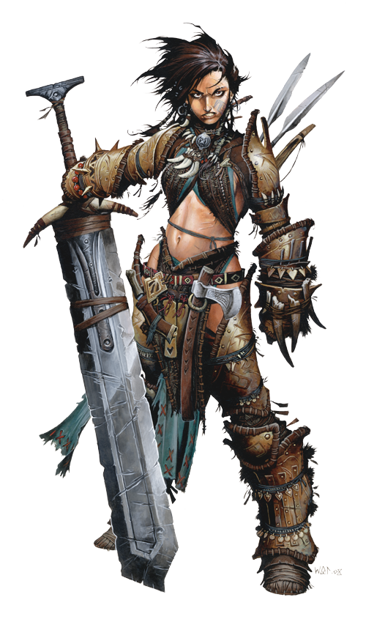
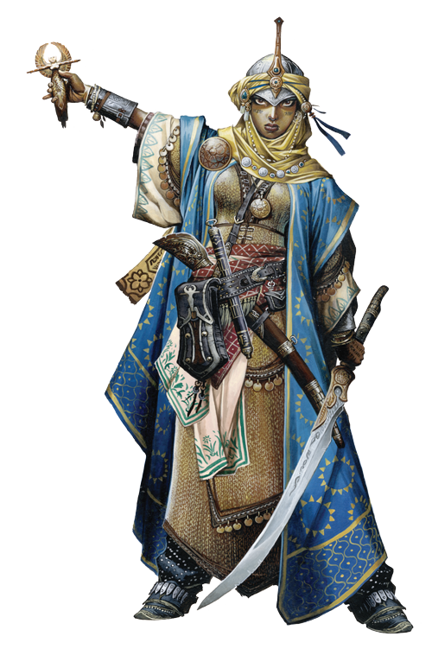
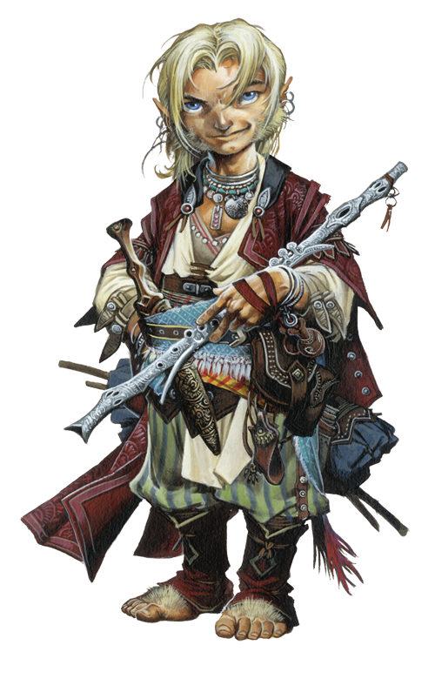
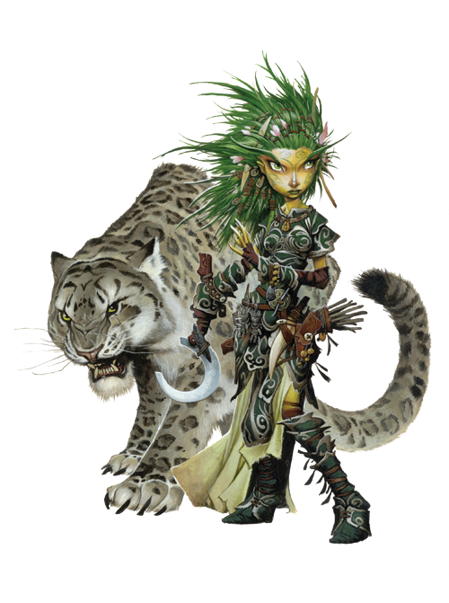
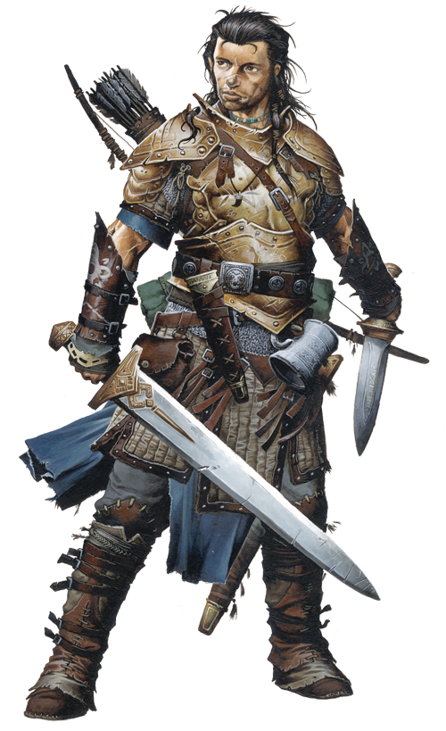
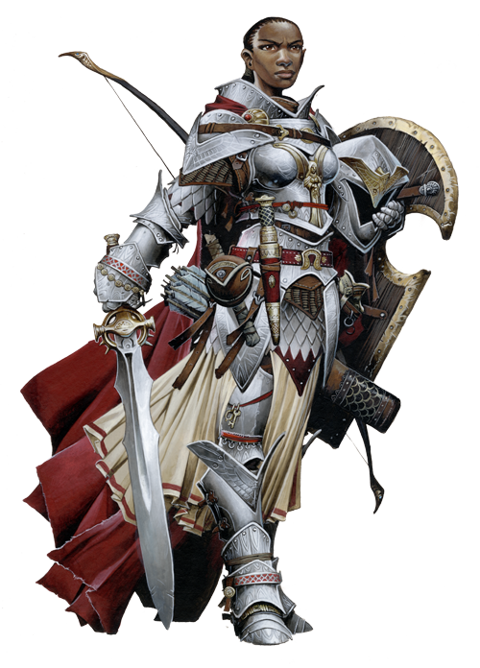
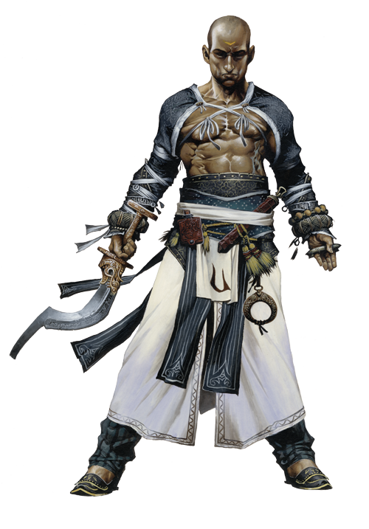
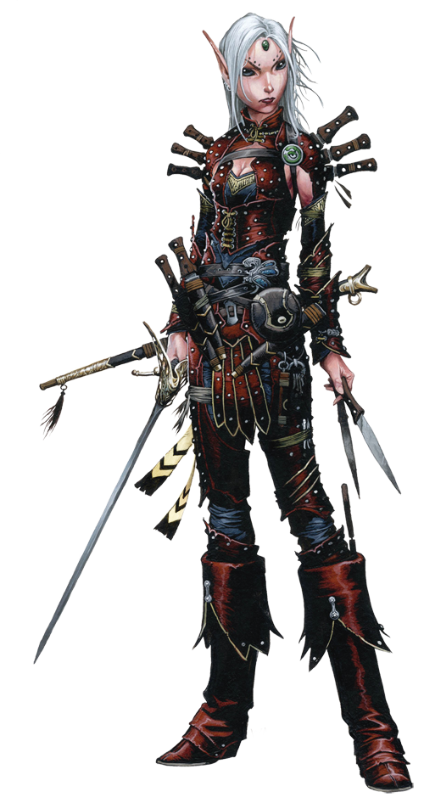
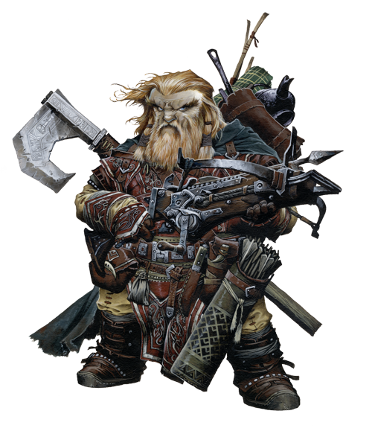
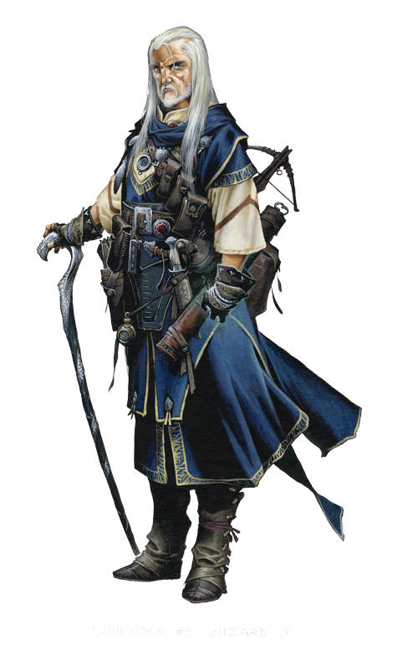
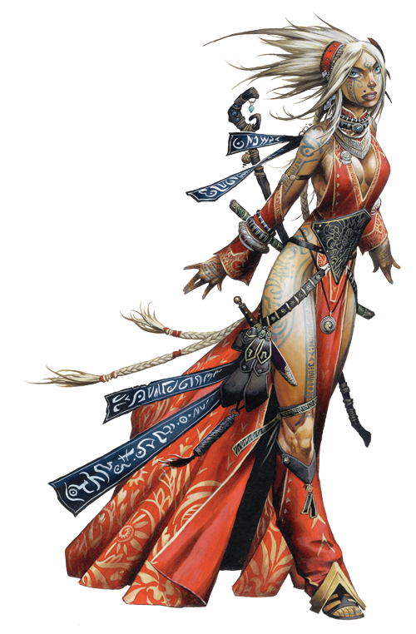
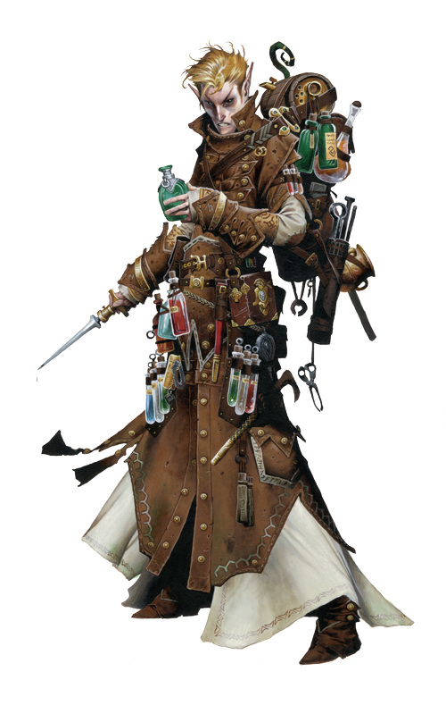
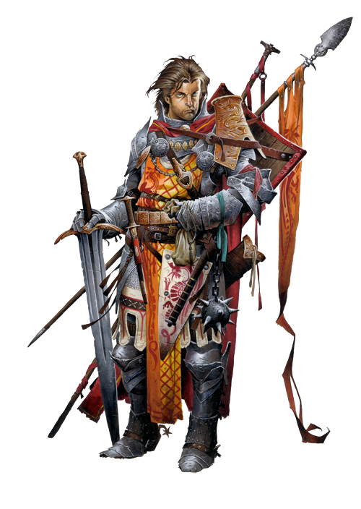
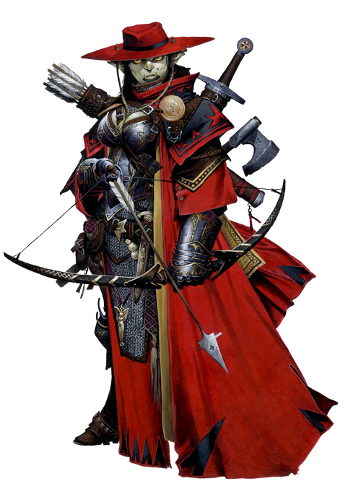
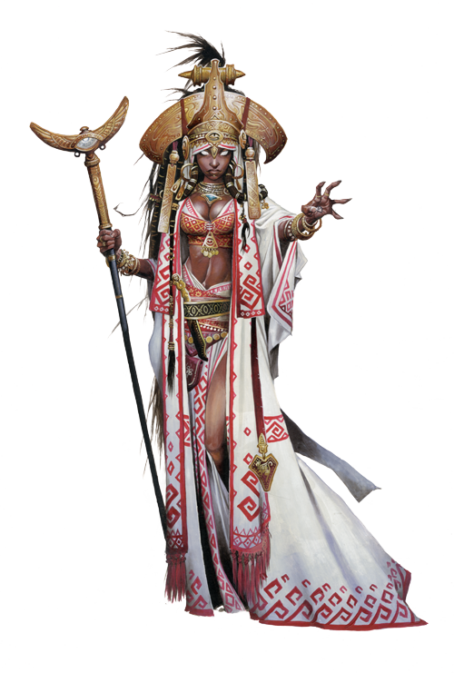
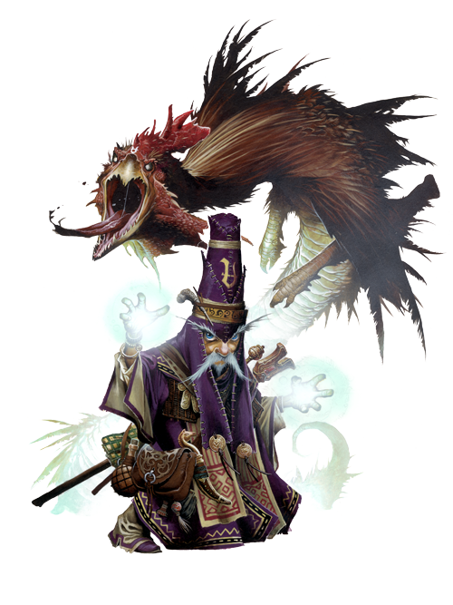
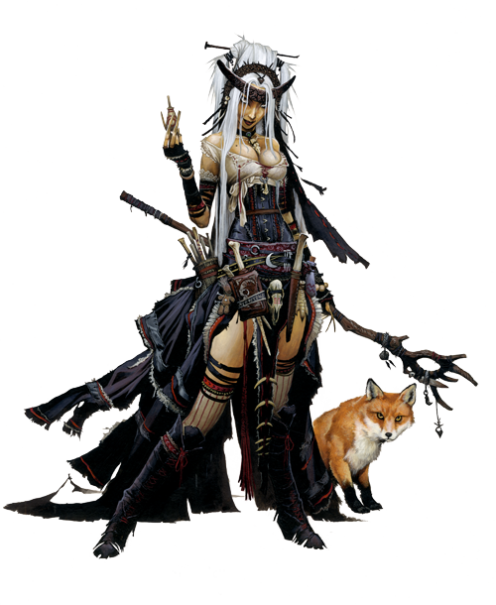
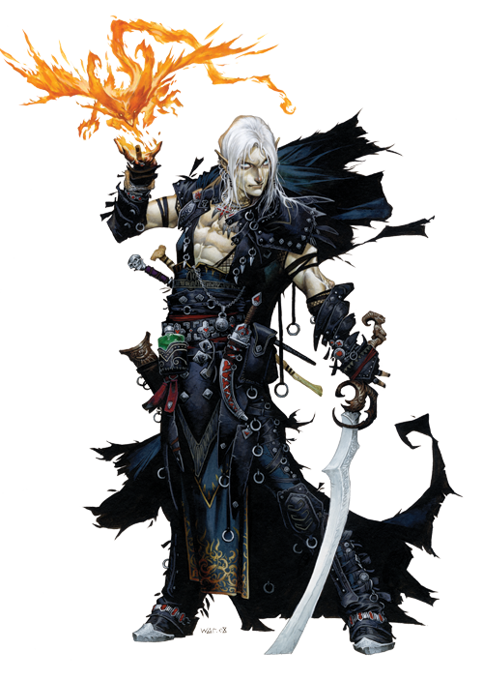
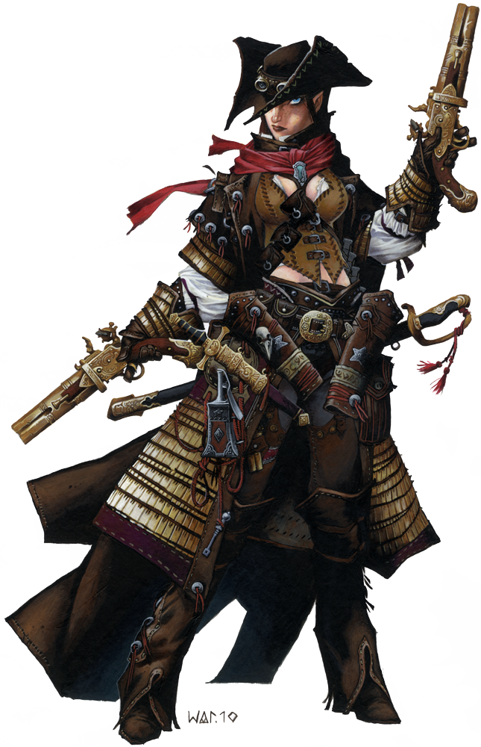
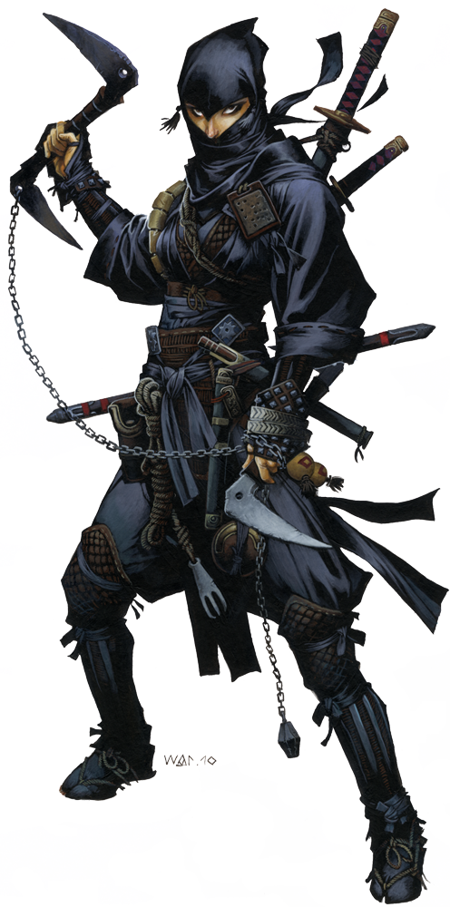
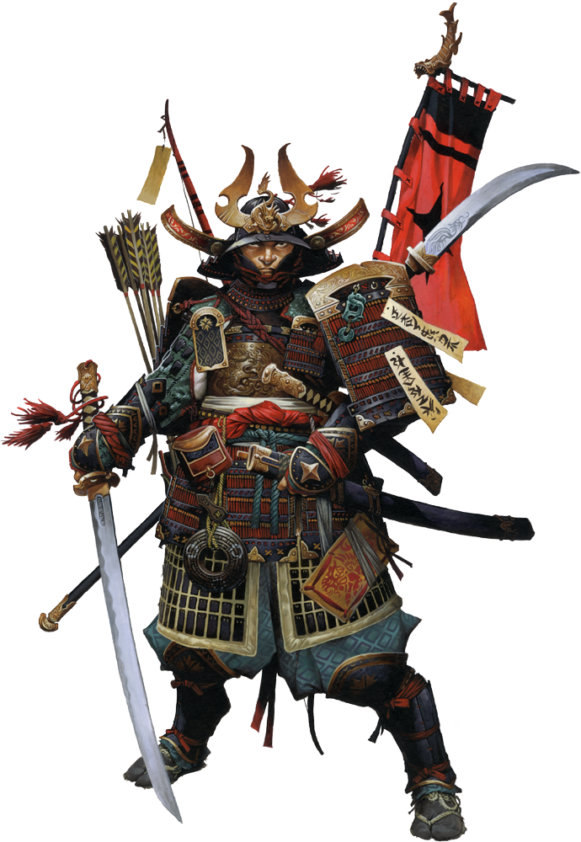
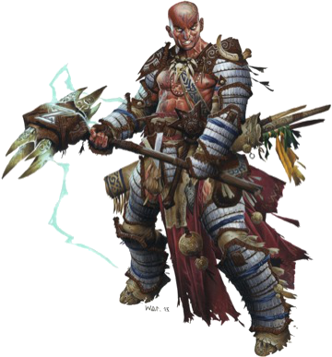
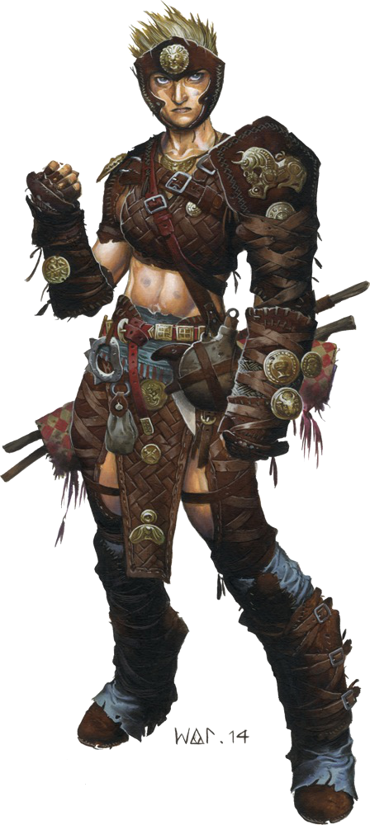
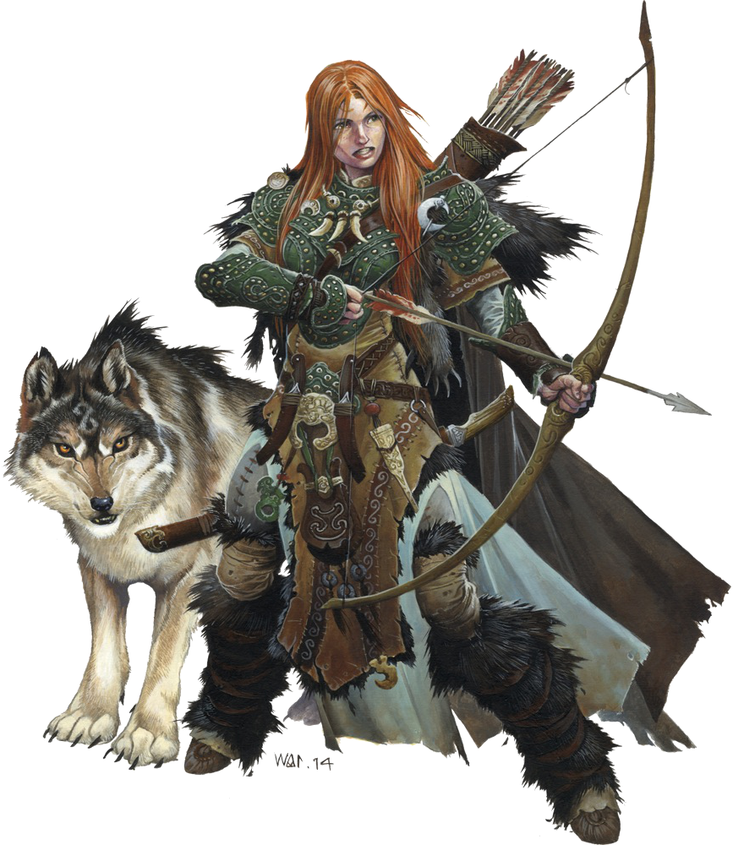
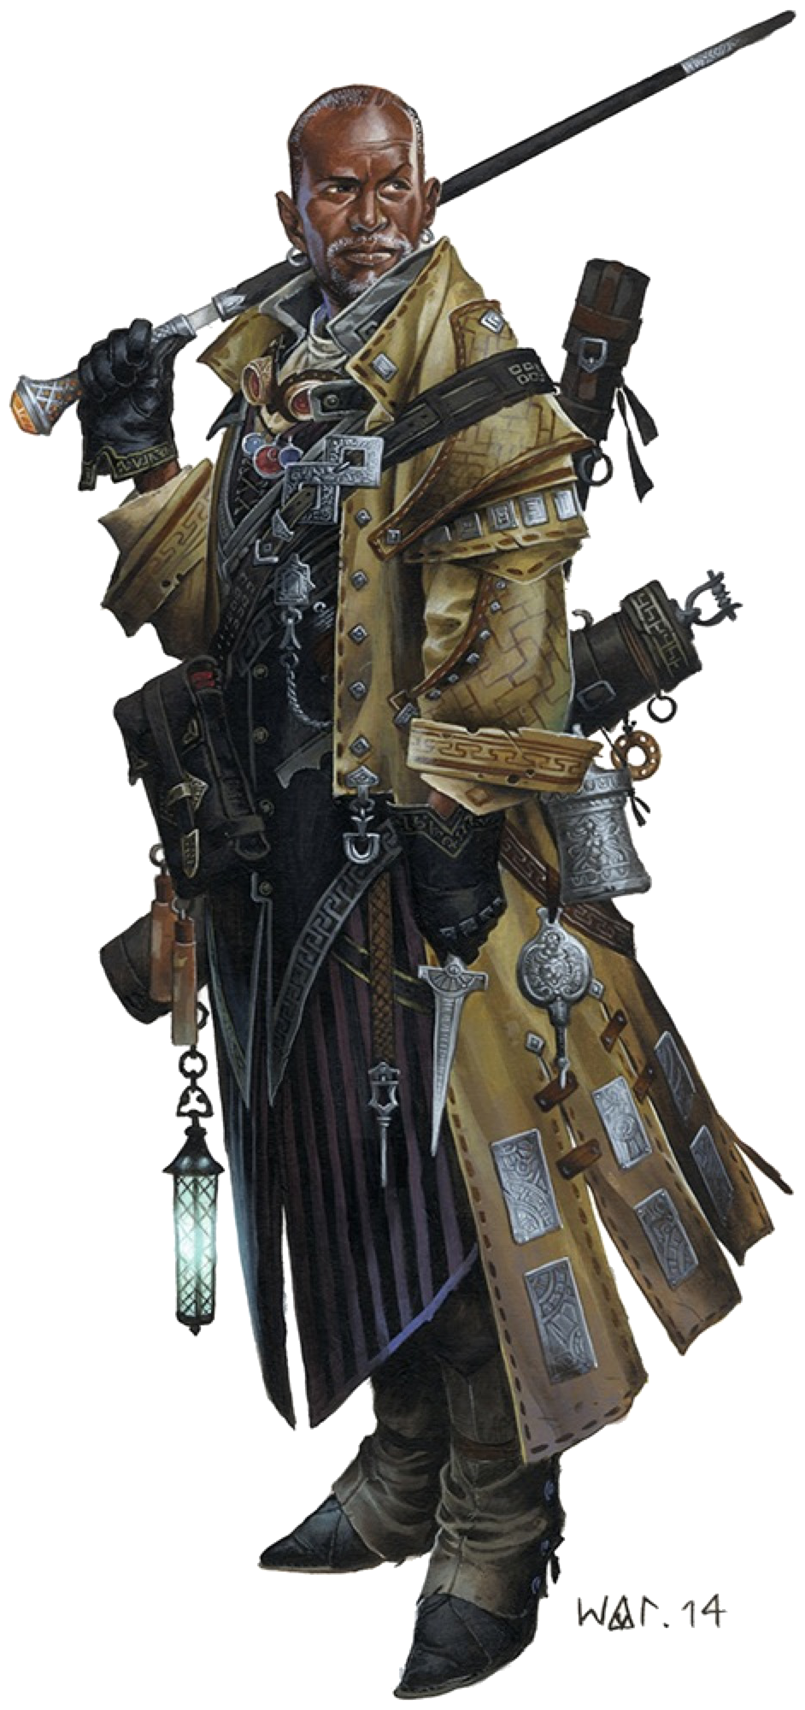
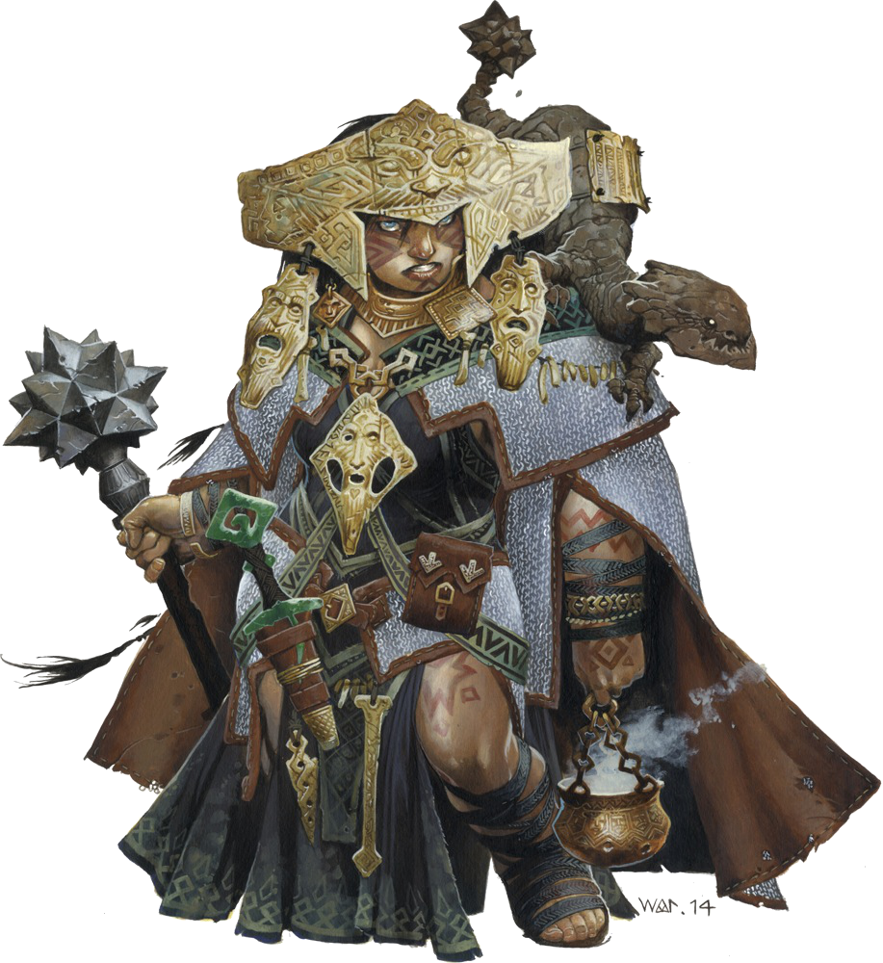
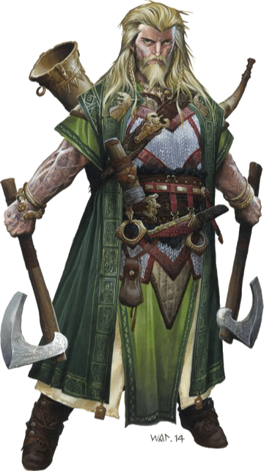
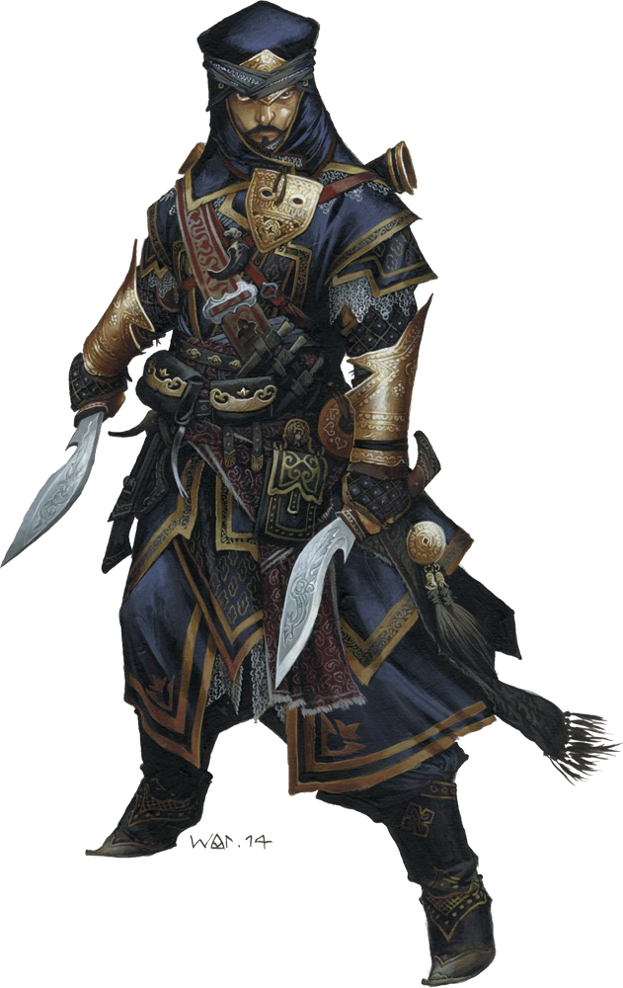
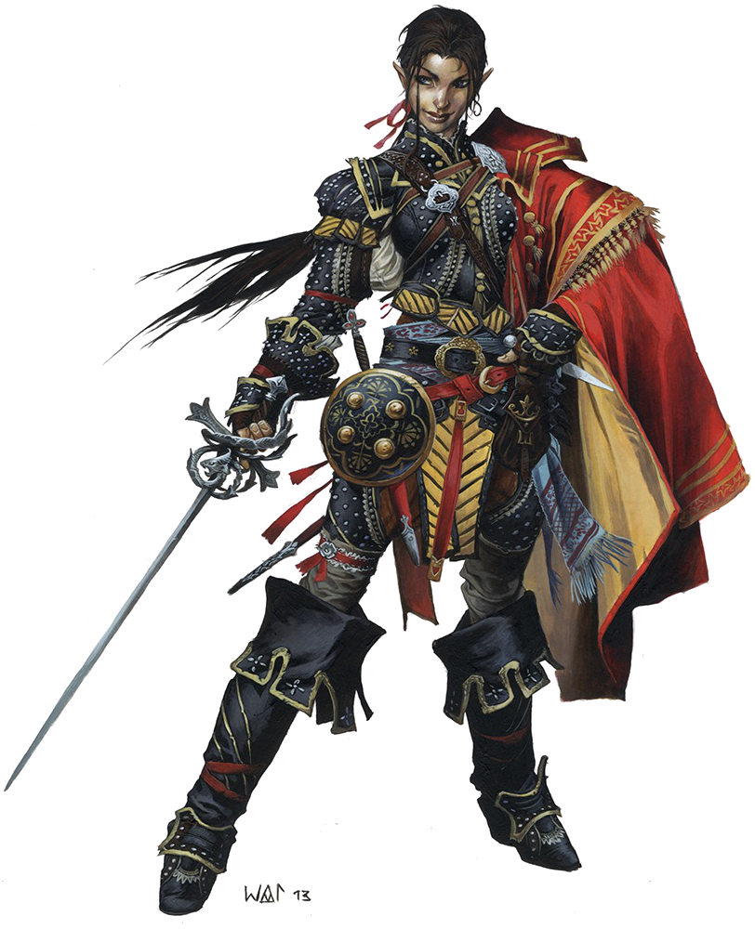
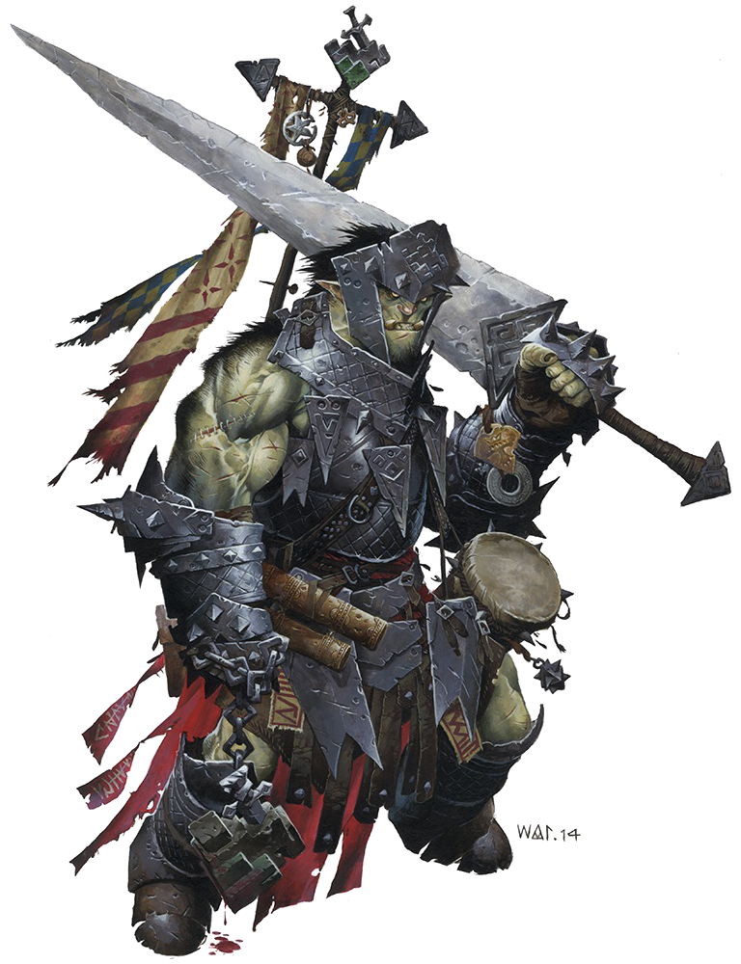
There are a million ways to die in the Realm of the Mammoth Lords. The natives of this brutal land are the nomadic Kellids, and they have made the best of this primal world. Amiri is one of these barbarians. Although she was blessed with a combination of independence and brawn, Amiri's childhood remained one of constant challenge. To the people of her tribe, the Six Bears, brawn, and bravery were not ideal characteristics for a woman to have. To the Six Bears, a woman's role was simple: raise children, tend to the sick, and forge bonds with other tribes. Women were resources. When a tribe wished to form an alliance, they would send gifts of meat, furs, treasure, and daughters. Amiri didn't see herself as livestock, and every chance she got, she tried to one-up her brothers and cousins. When a hunter went out and caught a caribou for the tribe, she would go out and catch two. When a party of orc raiders stumbled into their hunting grounds and a tribal hero killed four, she took it upon herself to kill six. Her constant sense of competition made her few friends, her brothers were both intimidated by her ferocity and enthralled by her beauty, while her sisters knew that each time she went against tradition, they would all be punished.
When Amiri finally came of age, her reputation had spread beyond the Six Bears. The other tribes took to calling her the “Soft Chieftain” of the Six Bears, a name that humiliated her almost as much as it did her kin, inferring that they were weak for allowing one of their women to grow so independent and strong. None of the other tribes wanted any part of her; her continued presence among the Six Bears caused much strife between once friendly tribes, and so the elders determined that there was but one choice, Amiri had to die. The only problem was the commonly held belief that murder of one's kin was the greatest taboo and the surest path to Hell.
The opportunity to be rid of their troublesome sister rose soon enough, when word came of a tribe of frost giants who had been sighted in the nearby mountains. The elders organized a warband to scout the mountains and to drive back the giants, and they made sure that Amiri was included in the band. Shocked but proud to have finally been chosen, Amiri didn't notice how the elders smiled at her eagerness to be on her way. The elders knew that Amiri's sense of competition would swiftly get her in over her head, and in secret tasked the rest of the hunters to goad her into just such a situation.
The warband headed up into the Kodar foothills, and it wasn't long before they found evidence of giants. One morning, the leader of the band rushed into camp, waving a dagger the size of a man's arm over his head. The warrior claimed to have single-handedly slain a giant and to have taken his dagger, and the others in the band congratulated him on his skill and bravery. Amiri took the bait, and announced that she would return by sundown with an even greater weapon. She could have no way of knowing that the dagger was part of the deception, that the warband had brought it with them as a prop to incite her into a foolish plan.
What the warband themselves didn't anticipate was that Amiri would find a frost giant. After wandering the mountains, she came to an immense body at the foot of a cliff; the giant had fallen to his death weeks before, and at his side lay his immense bastard sword. Although Amiri knew that she had not killed the giant, she also knew that all she needed was his sword as proof, certainly her kin wouldn't think to dispute her claim with such a grand trophy. Yet, when she returned to the place she had left her kin, she found the camp empty. Concerned, worried that they had fallen victim to the region's dangers, she tracked them, catching up with the warband halfway back to the tribal camp. As she approached the camp, though, she realized something was amiss, they were talking of her, and they were laughing.
Creeping unseen to the edge of the camp, she realized that she had been duped. She heard her kin mocking her ways, of how she had fallen for their ruse, and how even now she was likely cooking in a giant's stewpot. That they seemed grateful and so at ease with her death was not what enraged Amiri. It was the proof that her own people thought of her as a fool that did it. Eyes blazing, Amiri stepped into the camp and held her new sword out, proclaiming that even now she had bested them. The other warriors, shocked to see her alive, quickly fell back to laughter, pointing out that she could hardly wield such an ungainly weapon. Her fury growing, Amiri hefted the weapon and tried to adopt a menacing pose, but the weapon's size threw her off balance and she toppled over, much to the other barbarian's growing amusement.
It was enough. With a roar, Amiri leapt back to her feet. Her rage filled her body, clouded her vision, and stole over her soul. Her immense sword had decapitated two of the barbarians before they realized that death had come. The battle was swift and brutal, with Amiri not noticing the blows that landed on her, simply stepping from one traitor to the next and cutting them down.
When her rage finally subsided, Amiri realized what she had done. She knew that the hunters had certainly deserved their fates, but they were still kin. That her reasons for murdering them were, to her, valid didn't change the ties of blood. She knew that she had cut those ties, and so she turned her back on the remains, trusting that they would be discovered by another hunting party soon enough. As she headed west into the lands of Irrisen and the unknown reaches beyond, her heart was for the first time free, no longer was her future tied to traditions that would constrain her. She has come to value her oversized sword, and even though she can only truly wield it properly when her blood rage takes her, it has become as much a part of her as her fierce independence or her fiery heart. She no longer sees herself as a member of the Six Bears, but never speaks of the circumstances that forced her to flee her homeland. Some things are better left unsaid.

Amiri – Female Human Barbarian
The priests of Sarenrae lead double lives. Known to her faithful as the Dawnflower, the Healing Flame, and the Everlight, she teaches temperance and patience in all things. Compassion and peace are her greatest virtues, and if enemies of the faith can be redeemed, they should be. Yet, there are those who have no interest in redemption, who glory in slaughter and death. From the remorseless evil of the undead and fiends to the cruelties born in the hearts of mortals, Sarenrae's doctrines preach swift justice delivered by the scimitar's edge. To this end, she expects her faithful to be skilled at swordplay, both as a form of martial arts promoting centering of mind and body, and so that when they do enter battle, their foes do not suffer any longer than necessary.
Her priests are often categorized into these two camps: those who favor redemption as a method to defeat the enemy, and those who favor the blade. Kyra is certainly one of the latter. Born in a small farming town to loving parents, Kyra grew up in the shadow of one of the Dawnflower's shrines. She was taken at a young age with the beauty of the shrine's stained glass, and the grace of the three priestesses who practiced swordplay on the nearby hill each dawn as they offered their morning prayers. When bandits attacked her small town, Kyra watched as the priestesses did their best to reason with them, and when that came to naught, to end them before they could do more damage. Unfortunately, the bandits were too strong, and the village burned. Kyra was one of the few survivors, and on the smoking ruins of the shrine she swore her life and sword arm to Sarenrae, swore to protect those who could not protect themselves and to not spare the blade when the time for redemption passes.
Possessed of a fierce will and pride in her faith and skills with the scimitar, Kyra has traveled far since her trial by fire. She lost her family and home that fateful day, yet where another might be consumed by anger and a thirst for revenge, Kyra has found peace in the Everlight, and in the belief that, if she can prevent even one death at evil hands, her own losses will not have been in vain.

Kyra – Female Human Cleric of Sarenrae

Lem – Male Halfing Bard
Although Lem was raised in the lap of luxury, his childhood was anything but comfortable. He had the unfortunate luck to be born into slavery, to a mother indentured to one of Cheliax's countless noble families. Lem was sold a half dozen times to different nobles before he reached the age of two. Such is the fate of most of Cheliax's halflings (often called “slips” by that nation's citizens). Halflings are much valued as slaves in Cheliax since they take up less room and since their inborn optimism, ironically, stunts escape urges. Halflings born into slavery in Cheliax are prone to think of their lot in life as “lucky.” They are fond of saying, “At least we aren't living in the gutter or starving!”
Nevertheless, halflings who rankle at the concept of enslavement do appear, halflings like Lem. Growing up a slave in the devil-haunted empire of Cheliax exposed Lem to a shocking range of decadence and debauchery. He learned from a young age how to say what his superiors wanted to hear, and as he grew older, these skills often secured him less onerous jobs. While his kin toiled in basement washrooms or tended hellhound stables, Lem was taught to play the flute so he could entertain at family gatherings. Yet Lem was not blind to the discomfort of his brothers and sisters, and when he learned that a dozen of his kin were to be sacrificed to a devil as an offering to seal a new trade contract, Lem knew the time to act had come. Taking advantage of his increased mobility in the manor, it was a relatively simple trick to light a few fires in secret corners and then ensure that all of his halfling kin were safe in the slave's quarters. The manor burnt quickly, but Lem was shocked to see his kin rush back to the manor in a hopeless attempt to aid in extinguishing the flames. As the place burnt to the ground, and the halflings bemoaned their fate and the loss of their shelter, Lem slipped away into the night, bitter, and distraught over this unexpected turn of events.
Lem left Cheliax by stowing away on a merchant vessel and never looked back. He rarely speaks of his childhood today, but one can see its effects in his high disdain for law and order, and his intolerance for cruelty. Always quick to side with the underdog, Lem has learned that his most powerful traits are his optimism and sense of humor, virtues that almost make up for his small stature and impulsive nature. Lem's reasons for traveling with his current companions vary upon the day and his mood, but he certainly values their strengths, and the never-ending supply of comedy material their antics provide him.
In her many explorations and journeys, Lini encountered numerous large animal predators, with whom she seemed to possess a certain affinity. More than once, Lini's traveling companions or enclave came under threat from some great bear or razor-clawed cat, but with a series of soothing noises and precise motions Lini always tamed the beast and sent it on its way.
Lini's success at calming animals came to an end one day when a snow leopard bound out of the trees and pinned her to the ground before she could react. Her friends scattered, leaving Lini alone to face the beast. Although fascinated by the cat's power and speed, and appreciative of its beauty, Lini trembled under its massive paw and tears leaked from her eyes. She knew she faced her doom, and she found it cruelly ironic how death came to claim her.
Yet the leopard did not strike.
“Your friends have abandoned you,” a calm feminine voice intoned out of Lini's sight. “Despite the times you saved them, they left you to die.” Although Lini could not see the woman, Lini knew of the Norn of the forest and suspected she was one of them.
“Please help me,” Lini whispered, her chest struggling to rise under the great cat's crushing paw.
“You do not need my help, little one. You need hers.”
Lini looked at the snow leopard, deep into its eyes. She saw neither hunger nor malice. Still struggling just to breathe, Lini stared into the great cat's eyes and asked, “Will you help me?”
Inexplicably, the snow leopard lifted its paw from Lini's chest. A coughing fit then overcame the small gnome, and when she finally recovered, she looked around her. The snow leopard was gone and Lini saw no sign of the Norn. She looked around frantically, suddenly alone and scared, a small gnome in a large world.
“Come back,” Lini cried. “Don't go! Please don't go. Don't leave me alone.” She sank to her knees, tears afresh on her face, until she heard the sound of approaching footsteps.
The snow leopard had returned. With the delicateness of a mother tending to her cubs, the great cat licked gently at Lini's face, whisking away her tears. Lini threw her arms around the leopard's neck. “You are my friend, aren't you? I will call you Droogami. That is what we call good friends.”
Lini looked down then and picked up a stick from the forest floor before clambering up the cat's side to perch on its back.
“Let us go, then, Droogami. We have no need for this place.”
In the years since her departure from the Lands of the Linnorm Kings, Lini has collected more than a dozen sticks, one from each forest or wood she visits. In her resting time after long days of travel, she sits at Droogami's side and peels the bark from the sticks, smoothing and polishing them incessantly

Lini – Female Gnomish Druid
Valeros was born on a quiet farm in Andoran, where he grew up listening to the tales of traveling merchants, soldiers, and dreaming of adventure and exploration. Though this longing only increased, as he grew older, so too did the demands of helping his aging parents run the farm, and slowly but surely the mounting responsibilities of agricultural life quashed any possibility of travel or seeing the world. Finally, just a month before a marriage of convenience to a local farmer's daughter could lock him into place (but not before he'd sampled a few of the joys of married life), Valeros came to the realization that the door to a storybook life of adventure was at last closing for good. Seized by a sudden, desperate need for a larger life than cattle and corn, Valeros packed quietly and left in the middle of the night with no more than a change of clothes, some pilfered food, and an old axe handle to discourage any ruffians who might seek to divest him of either. It was to become a theme that would follow him for the rest of his life.
In the years since, Valeros has come a long way from the wide-eyed young man who sought only the joy of exploration (and maybe a pretty, worldly girl or three to regale with his stories). Life on the road, it seems, is much harder than the bards' tales, and adult Valeros has the scars to prove it. Discovering himself to be a deft hand with a sword, Valeros quickly fell in with the rough-and-tumble mercenary crowd, there learning the dirtier, grittier facts of warfare. Though none could deny his prowess with a blade (or better yet, two), Valeros's association with various mercenary groups never seemed to last for long. There was his time as a guard for the Aspis Consortium, which ended when certain shipments kept coming in light under Valeros's watch (never mind that the exploited locals were dying for lack of grain, and only needed a little to make it through the winter). Then there was the stint as a freelance bounty hunter, during which Valeros discovered that it's a lot easier to hunt down escaped murderers than it is to haul in a young woman on the run from a loveless marriage. And of course, there was the infamous incident with the Band of the Mauler, to which Valeros will only say that he was positive their leader had been crushed under that cave-in, or else he never would have touched the man's wife.
In the end, after acting as hired muscle for dozens of different employers, Valeros finally realized that the only way to keep from getting blamed for things which weren't his fault, not really, was to go into business for himself as an adventurer, traveling with those who properly appreciated him and letting those who didn't fall by the wayside. And if some of those companions happen to be pretty women, such as a certain Varisian sorcerer or elven rogue, all the better.
While admittedly not the best at following orders, Valeros is an extremely talented two-blade fighter, easily earning his keep in any group through the tenacity and absolute fearlessness; some might say thoughtlessness, with which he flings himself into combat. Despite his reputation as a bruiser and scofflaw, Valeros has picked up a fair bit of education here and there during his travels, and can even read (something his “respectable” parents never learned to do). A worshiper of Cayden Cailean, the only god who properly understands the need for freedom in the common man's existence, Valeros takes an easy-come, easy-go approach to life, wealth, and relationships. Though a fan of fine weapons and creature comforts, the only object he's never without is the tankard on his belt (for you never know when someone might offer you a drink). Noble at heart, and fiercely loyal to those few who manage the considerable feat of establishing themselves in his affections, Valeros nevertheless hides such sentiments under a jaded and crass demeanor, frequently observing that there's nothing better than “an evening of hard drinking and soft company.”

Valeros – Male Human Fighter
Birthed to parents of the padaprajna caste of warriors in beautiful Vudra, Sajan Gadadvara and his twin sister Sajni learned to hold a temple sword before they could walk. Strict padaprajna discipline forged a tight bond between the twins, who spent even their infrequent times of rest together, practicing the latest martial techniques taught to them. On their twelfth birthday, the twins were forcefully separated: Sajan went to live with the fighting men of the ghana padaprajna, while Sajni joined the battling women of the sastra padaprajna. Despite their separation, the twins continued to meet when they could, sparring and joking as they had in their childhoods.
As the insightful narrative of the Vigrahin Patitraka states, “A warrior's life is to war.” Thus, it was that Sajan's lord embroiled himself in a conflict with a neighbor. Most of the army fielded by Sajan's lord consisted of conscripts wielding tools of their trades, while the valuable padaprajna watched the battle in reserve. The warriors deduced quickly that they stood on the losing side, but they were duty-bound to fight to the death when instructed. Instead, their lord stole from them the glory of battle-death when he sued for peace after his conscripts fled the field. As part of his surrender, the lord gave over half of his sastra padapranja, including young Sajni.
Distraught, Sajan returned to his barracks in tears (for which he received severe beatings from his own father), and vowed that night to be reunited with his sister. Several weeks passed before he found his opportunity for escape. He fled into the countryside and slipped stealthily into the city of Sumadhadra, through whose gates Sajan watched his sister pass. After several days of clumsily seeking information on his sister, he finally discovered that all the traded sastra padapranja were loaded onto ships bound for distant Jalmeray.
Sajan quickly hired himself as a guard aboard a ship bound for the far-away island, and several months later he found himself on its heavily guarded docks. Within a week, Sajan uncovered the fates of most of the sastra padapranja, who worked as guards and courtiers for the island's thakur. Sajni was not among them. More weeks passed before Sajan learned that his sister had, like him, signed on as a guard aboard a trading ship, hers bound for a place called Absalom.
Sajan knows he cannot return to Vudra, for the padapranja there would execute him as a deserter. He cares not for his home country, however, and continues to seek out any clue that might point him toward his sister.
Although still viewed by many theologians and traditionalists as a newcomer to the world's faiths, Iomedae the Inheritor seems poised for greatness among the divine. Certainly her numerous orders of paladins have risen swiftly to take on the vaunted role of paragon in many societies. Evangelical in their exuberance to spread word of her wisdom, Iomedae's missionaries were pivotal in the defense during the fabled Siege of Solku. They sacrificed their lives saving the town from gnoll slavers, and although none of them survived the siege, their presence lived on, particularly in the eyes of young Seelah.
Seelah's family came to the walled town of Solku as pilgrims fleeing the atrocities of distant Geb to the distant south. Unfortunately, they traded one peril for another, and within months of their settling in Solku, the gnolls of White Canyon began their infamous pillaging. Seelah's parents were slain in the first of these raids, leaving her orphaned at the age of 14 in a strange town. She did what she must to survive on the city streets, pickpocketing and bullying and even hiring herself out as a mercenary. When a group of Iomedae's knights arrived to defend Solku, Seelah was immediately taken with their beautiful, shining armor, and within an hour she had stolen a particularly fine mithral helm with a golden bird upon its brow. Yet, then, something strange happened, Seelah became overwhelmed with guilt at her theft. For days, she agonized over the act, trying (and failing) several times to pawn the helm. During the Battle of Red Hail, Seelah realized that one of the bravest knights, a woman named Acemi with hair in long braids, fought the battle without her helm. This was the woman's undoing; in holding Solku's gates, she took a mortal wound to the skull from a gnoll's flail. The woman's heroism carried the day, but that evening she died of her wound.
Wracked with guilt, Seelah approached Acemi's body as her companions prepared for her pyre. They watched silently as Seelah placed the stolen helm over the dead woman's head, and then climbed onto the pyre aside her to join her in death. The paladins were moved beyond words, they had known from the start that Seelah had stolen the helm, but Acemi had forbidden her brothers and sisters from collecting it, hoping that the helm would bring the desperate orphan enough money to survive for another few months. The knights of Iomedae took Seelah in that night. Although she has come to terms with Acemi's death, Seelah still regrets the theft that ironically brought her into Iomedae's arms. She originally came to Iomedae out of guilt, but in the past several years, that guilt has transformed into a powerful love and faith in the Inheritor.
The young paladin wears her hair in Acemi's style and is trained in the use of the longsword. In so doing, she hopes to carry on the good work that Acemi might have done had she not fallen at the Battle of Red Hail. It's the least she feels she can do to make up for a death that she allowed to happen.

Seelah – Female Human Paladin of Iomedae

Sajan – Male Human Monk
The elves have a name for elven children unfortunate enough to be born and raised in human society, the Forlorn. In a few rare cases, these foundlings or orphaned elves find loving homes with humans, although the fact that, over the course of their childhood, one-time playmates become their effective guardians and foster parents results in a strangely skewed sense of the self. Most Forlorn aren't as fortunate, they live on the streets as almost eternal urchins, watching alone as their companions age and move on to greater things.
Merisiel is one of the Forlorn, only now emerging from decades spent as a child of the streets into a young adult ready to make her own way in life. A master at stowing away on ships, she's called dozens of cities home, leaving one for another when her companions outgrew her or she outlived them. Life has been hard for Merisiel, made more so by the fact that she's always found it difficult to master skills that come easily to her companions. Never the sharpest knife in the drawer, as the saying goes, Merisiel has learned to make up for this by carrying at least a dozen of them on her person. When things go wrong with her carefully laid plans (as they almost always seem to do), the knives come out and what needs to be done gets done. To date, Merisiel hasn't met a problem that can't, in one way or another, be solved with daggers.
Merisiel's life experiences have taught her to enjoy things to the fullest as they occur; it's impossible to tell when the good times might end. She's open and expressive with her thoughts and emotions, and while she's always on the move and working on her latest batch of plots for easy money, in the end it comes down to being faster than everyone else, either on her feet, or with her beloved blades.
She wouldn't have it any other way.

Merisiel – Female Elven Rogue
Not all dwarves are meant for the mines. As a young dwarf, Harsk spent every spare moment outdoors under the wide skies of southeastern Varisia, particularly at night beneath the stars, where his keen vision made him a hunter without compare. While generally uninterested in his family's traditional smithing, he still inherited enough of their tinkering ability to construct his own crossbow, a heavy, highly accurate weapon that few others are able to wind. Eschewing the company of his fellows, few things made Harsk happier than crouching in a tree stand with his bow, listening to the wind through the forest leaves and waiting for deer or larger prey to wander by.
That all changed twenty years ago, when his elder brother, a fine captain named Sigur, led a dwarven war band from Janderhoff against a small party of giants that had descended from the Mindspin Mountains to raid and pillage. Out of affection, Sigur offered his less-experienced sibling the chance to come and prove himself as Sigur's chief scout and second-in-command. Calm and peaceful by nature, Harsk turned him down, failing to see the honor his brother was doing him until several days after the company had departed. Traveling light and fast, Harsk caught up with his brother quickly, but not quickly enough. Misjudging the size and skill of the raiding party, Sigur led his band into an ambush, where it was slaughtered to the last dwarf.
With his brother's blood still fresh on his hands, Harsk went mad with rage. That night, he stalked through the giants' camp like a vengeful wraith, slaughtering giant after giant with his crossbow before melting back into the forest, only to reappear elsewhere and take another victim. When the last giant was left gurgling in the dust, Harsk took up his brother's axe and slipped off into the trees, vowing to forever be the voice of justice in the wild places, to keep balance and prevent the sacrifices of noble men like his brother.
Harsk, like many of his kind, is gruff and taciturn, but there ends most of his connection to dwarven society. Something of a loner, he prefers to spend his time outdoors, communing with nature, though he occasionally travels alongside others whose goals match his own. Uninterested in the beer and ale that so characterize dwarves in the minds of human society, Harsk instead drinks pot after pot of strong tea to keep his senses sharp. While he never lets his brother's he wields it only as a last resort, knowing that his true skills lie in the hunt and striking from darkness.

Harsk – Male Dwarven Ranger
Unlike the barbarians-gone-native on the eastern plateau or the colonial Chelliaxian immigrants of the south, Seoni is a native Varisian, a nomadic race whose closest real-world cultural analogue is the Romani. Or at least, she's mostly Varisian, as might be apparent from her otherworldly grace, there's something not quite human in her ancestry. Though she doesn't have any hard facts, Seoni herself has picked up on some of this, and is constantly pushed to search deeper into the mysteries of her heritage by strange dreams that she doesn't understand.
More than just ornamentation, Seoni's runic tattoos play a large role in her personality. Coming from a people where tattoo magic maintains a strong following, hers are simultaneously a manifestation of her power and a tool to aid in her castings. The sheer number adorning her skin, as well as the similar patterns woven into her clothes, are a mark of status among her tribe, though many of the so-called “civilized” residents of Varisia look upon such body modification with distaste.
Despite being a consummate adventurer, Seoni is something of an enigma to her compatriots. Quietly neutral on most matters, bound by codes and mandates that she rarely feels compelled to explain, the sorceress keeps her emotions tightly bottled. Extremely detail oriented, what the more pugnacious members of her party call a “control freak,” Seoni is a careful and meticulous planner, a schemer who frequently finds herself frustrated by the improvised plans of her more impulsive companions. Despite all of this, Seoni has stuck by her comrades through numerous tight spots, a fact that continues to amaze and confuse Valeros, who wonders loudly (although not altogether unappreciatively) about “the witch and her schemes.”
As with so many things, however, if Seoni understands her motivations, she's keeping that knowledge to herself.
For many adventurers, wanderlust strikes at a young age when minds are impressionable and the urge to escape the doldrums of home life become too much to resist. In other cases, there's never a choice at all, being raised on the streets leaves few other options available for those who do not wish to become criminals. Rare are those who come to adventuring late in life.
This was Ezren's path to adventure. Born to a successful spice merchant in one of Absalom's more affluent districts; Ezren's childhood was pleasantly safe. As the fourth of six siblings, he never knew the responsibility implicit in being the eldest (and therefore the one expected to carry on father's trade) or the freedom of being the youngest. He enjoyed the comforts of a well-to-do family, lived in a neighborhood relatively safe from crime, and seemed poised for a life of mediocrity.
That changed when his father was taken away, charged with heresy by the church of Abadar. The charges were too spurious to stick, and while his father escaped excommunication, the damage had been done; his father's business fell to pieces. Shocked, dismayed, and convinced that his father was innocent; Ezren abandoned his future and spent his adult life trying to repair his father's ruined reputation. So, when Ezren finally uncovered irrefutable proof of his father's guilt, and he realized he'd wasted his life on a lie, he turned his evidence over to the church and said goodbye to his home, his family, and his life.
At the age of 42, Ezren is full aware that he's missed his adulthood, yet at the same time he looks forward to discovering the world, and making a difference for a cause that he believes in. His dissatisfaction with family, religion, and government left him precious little to trust but his own intellect; in fighting for his father's redemption, he had become a gifted researcher, scholar, and intellectual. Lacking the spry limbs of youth, the trust in religion, the strong arm of the soldier, or the way with words of the politician, Ezren felt he had but one option open. He traveled to tarnished Oppara, capital of Taldor and one of the oldest cities of the continent of Avistan, hoping to join one of several prestigious schools of wizardry. Yet, time and time again, he was turned away due to his age. No wizard seemed to want an apprentice who, in many cases, was older than them. So, Ezren was forced to strike out on his own once again.
Over the next decade, as he traveled Avistan, Ezren studied where he could, picking up tricks of the wizard's trade here and there. The combination of arcane study mixed with his worldly first-hand experiences have given him an edge over young wizards fresh out of apprenticeship and eager to make names for themselves. Ezren knows about the many ways the world can trick and betray you, but now he's finally begun to master the art of magic, giving him the tools to fight back.

Ezren – Male Human Wizard

Seoni – Female Human Sorcerer
Flayleaf may ease your mind. Pesh may invigorate your humors. Yet, as any sage and scholar can tell you, knowledge is the most addictive drug. And once the quest for learning has its hooks into you, once your eyes have been opened, there’s no tearing free.
Damiel Morgethai was born, as so many elves are, in the nation of Kyonin. One of innumerable scions of the prestigious Morgethai family, he grew up in the picturesque town of Riverspire, where the southwestern border of Kyonin’s great forest gives way to fertile, rolling plains. When finally old enough to pursue a trade, the exceedingly precocious young elf was loaded up with what funds his family could spare and packed off to the shining capital of Iadara, to study alchemy under several of the art’s great masters. And it was here that the trouble started.
Damiel took to alchemy immediately, reveling in the idea of transmutation, the changing of one thing into another, by means chemical or arcane. “Alchemy,” he was fond of proclaiming to his friends, “is pure magic, even when it isn’t.” Within a few short years, the brilliant and studious Damiel had learned enough from his instructors that they set him loose to pursue his own studies, becoming advisors and respected colleagues rather than true masters.
Yet, he had learned more than just strange formulae in Iadara. As cheerful and innocent as it seemed on the surface, Damiel’s obsession with what he called “the Change” went beyond the simple curatives of an apothecary, beyond even the magical and explosive concoctions of those alchemists trained for battle. In his eternal quest to understand his theories better, Damiel gave himself literally to his studies, and began to use his concoctions on his own flesh, striving to unlock the full potential of his body. What emerged from those long, sleepless nights was someone new. Someone dangerous.
Officially, Damiel’s banishment from Kyonin was the result of plagiarizing another alchemist’s discoveries, or perhaps siring an illegitimate son with an embarrassed noble. The documents don’t speak of the way his former friends noticed the change in his eyes, which became increasingly wild, as lack of sleep and increasing amounts of “invigorating aether” took their toll. They don’t note the sudden rash of crimes in the districts he frequented, daring thefts and capricious arson. And they certainly don’t mention the young woman found in the alley behind his apartment, her face burned near away in an ultimately successful attempt to hide her identity, and the identity of her killer. In truth, the later would be difficult to decipher anyway, as even the killer himself might have trouble recognizing the monster that would take a girl’s life simply for seeing something she shouldn’t.
Damiel was no longer the man that he once was. In his thirst for ever-greater secrets, he had unlocked enormous potential, strange tinctures that quickened his movements to a blur, or twisted his constitution to survive any poison or malady. Yet, while he gained ever-increasing control over the vagaries of his flesh, these discoveries took their toll on his mind. He fell deep into addiction, deeper than even the aether he was so fond of could match. He would lose himself to the Change, only to wake from a maddened stupor and find that he’d done terrible things. And worse, that he no longer cared.
Exiled from his homeland, Damiel wandered for many years, slowly learning to control and live with his addictions. Gone were the blackouts, the uncontrolled and senseless violence. In their place grew a hard and haunted-eyed young man, handsome save for his wild look and the puckered scars along his veins. Seeking to peddle his secret knowledge, he traveled to Daggermark in the River Kingdoms, joining up with that city’s Poisoners’ Guild. For a time, his unique concoctions made him a minor celebrity in certain circles. But as the months passed, Damiel’s control over his base nature slipped, and the old lust for the beautiful chaos of unconscious (and unconscionable) action took over, loosing the beast of the Change to walk the streets. In the end, the Poisoners’ Guild took terminal offense to Damiel’s “exploits,” and though the elf argued hard that his deviant handiwork, being unpaid, was none of the guild’s concern, he was forced to go his own way once again.
Today, Damiel has grown further, into a man of two minds. The first, the greatest remaining shadow of the Damiel Morgethai That Was, truly repents for the arbitrary and senseless suffering he’s caused, and attempts to keep his darker urges in check. The second is that man brought forth by the Change, the mad and capricious soul that holds all other creatures in contempt, and exists only to feel the heat of the explosion on his face or see the shifting colors of poisoned flesh. This latter comes forth primarily in combat, where Damiel’s potions push his body faster than it has any right to move, flitting through the fray to fling corrosive ash or nick warriors so delicately with his poisoned injection-blade that many don’t know they’ve been cut until they find themselves unable to breathe. Though Damiel no longer gives his vile tendencies full rein, and carries himself well in social situations, most who look into those bagged and bloodshot eyes quickly understand the truth of his nature: unbalanced, unstable, unpredictable, and totally indispensable in a fight, which is why he still manages to fall in with other adventurers from time to time. And as he continues to mature, some of them even survive his companionship.

Damiel – Male Elven Alchemist
Deference and respect are the privileges of noble birth. Few know this better than the man who calls himself Alain, yet equally well does he know that such things are not always freely given where they are due. And in those cases, it's the burden of the nobly born to correct the error, and to take by force that which is their right.
Alain was born in Taldor with the proverbial silver spoon in his mouth, son of a wealthy but relatively minor noble house. As a boy, he showed remarkable affinity for both physical activities, especially the martial pursuits, and the ins and outs of courtly etiquette and intrigue. Though both traits made him the quite popular with the peerage, especially the young ladies of the court, necessitating more than one woman being shuffled off to a nunnery on a nine-month “vacation,” Alain's wealth and natural abilities also gave him an excessively healthy sense of self-importance, sometimes getting him into trouble that would have crippled a man of lower station. By the time Alain's father realized that the cane-scarred whipping boy might not be the most effective means of corralling his youngest son, Alain was already near grown, and thoroughly convinced of his own competence in all things.
Though Alain regularly dismissed such noble studies as literature and linguistics, “If the elves want to speak, let them learn a man's language,” he could never get enough of bards' tales of battle and bloodshed, often keeping the minstrels at his favorite taverns playing late into the night. Excel as he might at the joust or the ritualized combat of the nobility, he longed for the primal exultation of war, where his mastery over his fellow men would not just be avowed or lauded, but proved undeniably by the blood on his sword, as clear as the red-dripping talons of an eagle. He had the nobility of society. Now he wanted the nobility of nature.
Unfortunately, for Alain, any serious clash of arms lay far beyond the borders of his father's expansive holdings, and neither his father nor his two elder brothers showed the slightest desire to sustain a blood feud with another house. All three men attempted to turn Alain to knighthood, a socially safe and proper outlet for his bloodlust, yet the idea of serving as a squire for any length of time, of letting someone else give him orders, was unthinkable to young Alain. At last, when he could stand it no longer, the young scion gathered what funds and personal affects he could carry and declared him a sellsword, setting off for the “crimson poetry of the fray.”
True warfare has little in common with heroic ballads, and few who see its raw and naked face come back unchanged. Certainly, this was true for Alain. Yet, where some men learn wisdom in the wrack, at last understanding the price of a life and the senseless ease with which it's taken, Alain learned something else. In the clash of spears and the screams of horses, the man who had been a trumped-up merchant's son became an elemental force of destruction, cutting down swaths of men who were never his enemies, but merely his opponents. Though he became rich in his own right off of the heavy purses his patrons heaped upon him, Alain cared only for what the rewards represented: that here was a man whose worth was proven, in fire and iron.
Today, Alain wanders as he wills, taking commissions when they suit his fancy and embarking on his own expeditions when they don't. Thanks to his prowess on the battlefield, warriors are often drawn to fight at his side, and to Alain's secret surprise he's developed quite a knack for leading them, issuing gruff and decisive commands. These companions are almost always cohorts rather than friends, though Alain does a fine job of managing his troops and urging them on to ever-greater feats, long experience has taught him that soldiers are a short-lived lot, and hence he sheds few tears when it's time to pay the butcher's bill.
As much as his life revolves around the battlefield, Alain still retains the social graces that made him so popular (for better or worse) in the courts of his upbringing. If greeting another warrior or potential client, he may introduce himself as simply Alain, comporting himself with a calculated aloofness designed to increase others' opinions of his abilities. Where an attractive lady is concerned, however, his rough edges immediately smooth, and many are the highborn women who've fallen prey to the “rogue knight” calling himself Alain Germande, Third Son of House Germande, Bearer of the Shielding Spear, and any other honorifics that strike his fancy.
In truth, whether leading soldiers in a suicidal charge or booting serving girls out of his bed in the morning, Alain cares little about the people around him. More than money, love, or lust, Alain cares about his reputation, and strives with every encounter to increase his own legend, whether as scoundrel or saint. Perhaps the only creature he truly values is his horse, Donahan. Exceedingly well trained, and having accompanied Alain for longer than any of his human compatriots, Donahan represents everything Alain looks for in a partner: absolute loyalty, absolute trust, and absolute obedience.

Alain – Male Human Cavalier
Wails regularly echo through the eastern wing of Gravecharge, Pharasma's cathedral in the university city of Lepidstadt. Yet such aren't the breathless screams of the dead that so often ring through the corners of Ustalav, but rather the cries of life. Since its construction, Gravecharge has maintained a clean and well-supervised hospice for sick and orphaned youths. Just as the goddess Pharasma concerns herself with the transition of life to death, so does she cherish even the most tragic lives.
Imrijka came to Gravecharge in the arms of a city watchman, wrapped in a tattered uniform and held at arm's length. The guard claimed his patrol had found "the thing" during their dawn patrol to the Spiral Cromlech, a Kellid ruin overlooking the city that was notorious for ill fortune and mysterious disappearances—but never for mysterious appearances. Hearing a babe bawling amid the moon-bleached standing stones, the guards bold enough to investigate momentarily took her for some stray fiend-child and almost slew her amid the eerie ruins. Identifying her as a half-orc infant did little to stay the hands of those ready to mete out death, but the argument that matters of life and death should be left to Pharasma sheathed the blades of those not truly eager to spill a child's blood—regardless of the color of her skin.
Dubbed Imrijka after Gravecharge's first high priestess, Imrijka Castavelik, the pistachio-skinned girl was cleaned, clothed, and given a place among the cathedral's other orphans. At first, she terrified those youths, being larger, stronger, and more vicious in her biting than some children double her age. But only for a time. The priestesses of Pharasma explained the mysteries of their goddess's will and the vastness and variety of her creations, teaching the children that they were blessed to have such a unique new sister. For a time, behind the cathedral's walls, that was even the truth.
When she was old enough to understand and be understood, Imrijka reported to the offices of Jarlos Teym, Gravecharge's high exorcist, for the first time. He asked her a great deal about her life, how she felt about her studies, the clergy, the other children, and if there was anything he could do to make things more comfortable for her. A shy girl, Imrijka declined. Subsequent discussions bent toward the future, Imrijka's dreams, her prayers, and her vision for a long life. Finally, though, after months of building a rapport with the girl, Teym asked about her past. But for Imrijka, life began with the cathedral, priestesses, and other orphans. Teym pressed, insisting on answers, even verifying them with magic. After one particularly intense interview, a confused Imrijka finally started asking her own questions: Why did it matter? Why did Teym care? Couldn't what she might be outweigh what she might have been?
Deeming her mature enough to know, Teym explained his tenacity: someone had come to adopt Imrijka. Thrice. Every Kuthona for the past 3 years. First came a man dressed like a count's footman, articulate and with more questions than answers. He left after raising the clergy's suspicions with his too-pointed inquiries about Imrijka. A year later he returned, this time with a human woman of vulpine beauty who claimed to be Imrijka's mother—though her apparent age made that only the barest possibility. It was Teym's own suspicions and skill at discerning lies that kept the strangers from Imrijka, and the unusual pair left with wordless detachment. Finally, only a few months past—days before Teym's first meeting with Imrijka—the two strangers returned, led by a man dressed in white and silver. The bold newcomer spoke as one used to being obeyed and demanded Imrijka be handed over to him. Teym personally denied him, insisting to know what right he had to the girl. A father's right, the man persisted. The high exorcist ordered them out of the cathedral in that instant, but before they obeyed the man in white smiled. "She's not like us," he said, eyes glimmering. "Excellent."
Despite Teym's explanation, Imrijka understood only that her parents had come for her and that the high exorcist had sent them away. She held back both questions and tears, nodding blankly until Teym excused her. But she didn't return to her room. Rather, she exited through the front doors of Gravecharge and out onto the snowy streets—where someone waited.
A man in white sat upon the icy benches of the nearby circle, slowly feeding bits of shredded meat to the crows. Seeing Imrijka enter the plaza through the flurry of sound-deadening snow, he rose and walked toward her. Wary, she approached. In his gloved hand appeared a strange token, a disk etched with barbaric symbols and a figure impaled upon a spear. She reached for it.
A merciless iron arrow shattered the man's hand, sending the strange icon spiraling into the snow. Teym stood across the circle, another arrow nocked in his bent hawthorn bow. Around him whipped the black-edged crimson of Pharasma's inquisitors, woven flames that engulfed any flakes the whirling wind blew against them. "Back, girl," he commanded in a voice Imrijka had never heard him use.
The man in white might have been carved of ice. He had never flinched. Though the icon was knocked away, a tangle of disjoined fingers and bloodless flesh-ribbons remained outstretched toward Imrijka. Her small tusks clattered against her teeth, but she didn't scream.
"Another time, dear," the man whispered, just for her. Then the snow whirled around him. For a moment, he seemed to be one with the cold, a blizzard-born prince. Then he was gone, leaving Imrijka cold and frightened—but not alone. High Exorcist Teym's cloak around her was heavy, and warm, and smelled strongly of tobacco and dust—what Imrijka imagined a grandfather should smell like. It didn't smell anything like the man in white.
Until Imrijka reached maturity and was fully able to defend herself, she rarely left Gravecharge Cathedral. When finally she did, it was in the crimson and black of an initiate inquisitor of Pharasma's faith. Even after the retirement of High Exorcist Teym, she continued to serve the church and the man she'd adopted as her grandfather, assisting him in his more scholarly pursuits as a consultant on religious antiquities at the University of Lepidstadt. She's traveled much of Ustalav and beyond—guarded an expedition to the boney towers of Kalexcourt, spent a night in the haunted hotel known as House Beumhal, been shouted off the porch of retired monster hunter Ailson Kinder (but not before getting her copy of Hunter’s Moon signed), and had numerous other adventures. She regularly returns to Gravecharge, where several of her childhood companions have grown into positions within the church's sphere of influence—including Brel Vhalsik, an argumentative Kellid theologian with whom she shares a complicated relationship. But increasingly her interests and Teym's research send her beyond Ustalav's borders, where she treads with her goddess's blessing, bringing judgment to all who would violate the laws of life and death. In her travels, she's faced significant prejudice, but tales of Pharasma's "monster monster-hunter" and Imrijka's ever-present arsenal convince most bigots to keep their fool mouths firmly shut. Through it all, she's never seen the man in white again—at least, not with total confidence, as there have been far too many shadows and half-recognized faces to be sure. She recovered his strange gift on that snowy day and wears the disk openly, hoping that someone someday might recognize it and lead her to some hint of where she came from and who she was. But for now, the future holds far greater promises for Imrijka, and she strides into it boldly, confident in her faith,
where she's going, and who she is.

Imrijka – Female Half-Orc Inquisitor

Alahazra – Female Human Oracle
Only those who refuse to see truth are truly blind. Such is the verdict of Alahazra, bride of the sun and prophet of the burning sands.
Alahazra was born in a small Rahadoumi town east of Manaket, one of the many way stations on the caravan route known as the Path of Salt, which leads from Azir all the way to distant Sothis and takes its name from the waves of the Inner Sea and the dried tears of the slave chains that march along it. The daughter of a wealthy and widowed wainwright, Alahazra wanted for nothing, growing up with the best tutors money could buy, all the time being groomed for a potentially lucrative marriage, or perhaps even induction into the Occularium, Manaket's prestigious wizard's college.
All of that changed on the morning when sixteen-year-old Alahazra woke to find herself suddenly and inexplicably blind, her eyes clouded by a white mist that gave her only vague outlines of her surroundings. Beside himself with grief, her father called in the best healers to be found in the godless land, only to discover that the situation was worse than he could have imagined. For when the bards with the healing touch reached out to the fevered child, they were suddenly cast back by a blast of flames that burned the girl's sickbed but left her magically unharmed. Yet even this might have been bearable, had the fleeing bards not revealed the rest of their discovery: that the girl's flames bore no hint of sorcery or arcana. Though Alahazra's staunchly atheist father could scarcely believe it, his proper Rahadoumi household harbored a burgeoning cleric.
Confronted by her enraged father and frightened by the new abilities that she felt burning inside her skin, Alahazra protested her innocence loud and long, but to no avail. Sickened by what he saw as a betrayal of both his trust and his national pride, Alahazra's father did his daughter a final kindness and cast her out with no more than the clothes on her back, instructing her to run before the Pure Legion arrived to take her into custody, and let her gods be her new family, for she no longer had one in Rahadoum.
Blind, weak, and weeping with frustration and rage, Alahazra stumbled southeast into the desert, seeking what meager shade and water the badlands had to offer. For days, she wandered, seeking only to put distance between herself and any pursuers who might still seek revenge for her presumed heresy, until at last she collapsed in the lee of a dune, dehydrated and dying.
It was there, staring up through milky cataracts at the burning ball of the sun and letting the wind slowly bury her in the hot sand of the dunes, that Alahazra had her first revelation. Behind those ruined eyes, a vision of debilitating color suddenly exploded. In it, Alahazra saw herself not as she was, but as she, one day would be, strong, proud, and fierce. In that moment, Alahazra understood that she was more than just a girl. She was a force of the desert, a voice of sun, sand, and flame, and she would bring its truth to the people, whether they were ready for it or not. Baking slowly in the hot coals of the great Garundi desert, Alahazra came to know herself, and in doing so first harnessed the magical flames that had been building inside her.
With the aid of her newfound abilities, Alahazra moved steadily east, crossing into Thuvia and following the Path of Salt until she finally came to rest in Osirion. There she roamed as she willed through the great cities and barren plains, offering wisdom, healing to the righteous, and cleansing fire to the wicked. In time, her notoriety grew, offering her passage into higher social circles, and it's whispered that she made consorts and admirers of several powerful men, possibly even entering the court of the Ruby Prince. Alahazra herself, however, speaks little of her past. For her, only the future is of concern, and her duty is to defend it as best she can; with clarity of vision, that disdains sight.
Now a grown woman, and still attractive enough to turn the heads of slaves and rich men alike, Alahazra is kind but distant, often letting conversation drop in favor of taking in the sounds and smells of her environment. When she does speak, in her low, throaty voice, her words have the weight of command. Alahazra has little patience for fools (most notably those who let money or pride blind them to truth and justice), yet also has a soft spot for orphans, and in her own stern way often sees herself as the mother to her adventuring companions. Though she maintains that she has never worshiped a god, the cornerstone of her bitterness toward both her father and her homeland, she has come to respect a wide variety of deities, whom she refers to as “powerful and strategic allies.” And while her detractors might call her cold, in battle Alahazra's burning rage, especially toward injustice and intolerance, still comes roiling out in a wall of divine flame.
The final decade of the Age of Enthronement brought hope and innovation to the people of the Inner Sea region. In the north, Chelish explorers from Korvosa founded the city of Magnimar. In the east, Taldor and Qadira reached an uneasy peace after centuries of antagonism and open warfare. In the treacherous Mana Wastes of the south, refugees fleeing persecution in Nex settled the Duchy of Alkenstar as a beacon of light and progress in a sea of magic-warped madness. And not far away, in Nex's capital city of Quantium, the Arclords adopted an orphaned gnome child named Balazar into their most prestigious school of magical instruction.
Diligent students of the scribbles and writings of the long-lost archmage who founded that nation, the Arclords deciphered codes and texts from the margins of newly discovered spellbooks and concluded that "children of the First World" would play an important role in the magical administration of the departed wizard's kingdom. In the years before the death of Aroden, prophecy was a much more valuable currency in the lands of the Inner Sea, and in 4601 the tradition-obsessed Arclords scoured the gnome communities infesting their beloved cities for young gnomes to press into service. To prevent their great works from falling victim to what they considered a chaotic and untrustworthy race of childlike anarchists, the wizards culled only the youngest (and thus in their minds least corrupt) gnome children from their parents, imprisoning or destroying families with the temerity to go against the marginalia of the wizard who had founded the nation and declared the city open to creatures of all races so long ago. To the Arclords, any gnome resistance was a revolt against the ideals of the nation itself, akin to treason.
By 4606, the human god Aroden was dead, the power of prophecy was broken, and the Arclords' eugenics experiment was veering toward abject failure. As the gnome orphan brood developed into maturity in the decades that followed, they brought chaos and catastrophe to Quantium's magical academies. And at the center of that chaos stood Balazar: an impulsive youth with a temper to equal the bright red ferocity of his prodigious mustache, a burning match on a bed of tinder.
In the early years of his instruction, Balazar revealed almost no magical acumen whatsoever, preferring to spend his days conducting merry pranks on his fellow students and instructors instead of absorbing himself in the meticulous study of the Arclords' curriculum. When one such prank resulted in the transmutation of an instructor's tower into a living being of elemental stone (thanks in part to a mysterious glowing rock pilfered from the school's vaults), Balazar and three gnome associates found themselves expelled from the academy, exiled from Quantium, and sent on the first wagon train to Ecanus, the sprawling southern city whose world-famous fleshforges churned out a legion of horrors to bolster Nex's armies and terrorize its squalid countryside.
The Ecanus assignment was intended exclusively as punishment, but the city's masters welcomed the gnomes with open arms, eager that their unconventional attitudes, boundless creativity, and unpredictable obsessions might aid them in conquering one of the most enduring mysteries of the monumental fleshforges. For deep within the dungeons below the military complex, in a room designed by the Archmage Nex himself, lay an extraplanar rift known as the Void Chasm, a shaft of sheer sides and cloying, multicolored mists that had driven insane all who had previously gazed within it.
One by one, Balazar's gnome associates gazed within the abyss, and one by one they lost their tenuous grip on reality. Balazar watched in horror as the color drained from their hair and skin, as if the whole of their life from birth to bleaching transpired within the span of a few moments. When the emotional strain grew too great and the gnomes cried out in anguish, the pitiless fleshforge instructors pushed them into the trench, where their howls soon faded beneath the swirling mists. If the gnomes could not discover the purpose of the Void Chasm, the administrators reasoned, perhaps a sacrifice to the unknown powers below would do the trick.
As he stood on the precipice of the Void, Balazar wondered if perhaps he should have studied more diligently in the relative comfort of Quantium's academies. Reluctantly, he cast his gaze into the miasma and felt the weird energies of the Chasm worming their way into his mind. Worse, he heard whispering voices in the mists, calling out to him and begging him to step over the edge. At first he thought the voices to be those of his lost fellow gnomes, and called back to them one by one even as the color drained from his hair and he felt his mind slipping away. But the voices were not those of his friends. They belonged to… something else.
It took all of Balazar's limited concentration to sift the many voices from each other. Some were angry, demanding to be left alone. Others beckoned with honeyed words of sweet oblivion. But one voice among the tumult spoke softly and plainly. "I will help you," it said in reassuring tones. "Give me form and allow me to leave this prison, and you and I will become as one."
With the hands of the fleshforge administrators on his shoulders, about to give the final push that would send him into nothingness, Balazar tried to imagine what the voice would look like. He dreamed of a creature with a vast serpentine body, with grasping talons and horrifying scales. And, perhaps because he had not eaten that day and was growing hungry, he imagined the voice speaking through the beak of a monstrous chicken. And then, just as he felt the muscles of his captors tense for the final push, the creature he had imagined emerged from the Void Chasm fully formed and fully real, screaming a hideous avian cry and weaving through the air with serpentine grace. Its claws tore at the necks of the administrators, its hideous beak making a mess of their unbelieving eyes. And all along, in reassuring tones only he could hear, it spoke to him. "Do not be afraid, little one," it said. "We were meant to be together."
Somehow, Balazar and the avian entity that called itself Padrig managed to win their way free of the fleshforges, of Ecanus, and even of Nex. As he fled up the eastern coast of Garund on a succession of merchant and smuggler vessels, Balazar and Padrig grew closer and closer to one another. Padrig explained that he was a bodiless being known as an eidolon, and that only Balazar could give him structure and form due to the affinity of their minds and souls. As the gnome made his way from Nex to Katapesh to Absalom, Balazar grew more and more adept at shifting Padrig's form to add more legs, terrible wings, or other features fitting the dangers and situations at hand. When things got too dangerous to be seen with a magical creature or when discretion was more important than protection, Balazar dismissed Padrig to some extraplanar hidey-hole, only to call him once again to his side when needed.
Although a great deal of the young Balazar's mischievous spirit remains, the horror of the Void Chasm remains with him to this day. Other gnomes often confuse his stark white hair for a symptom of the insidious bleaching that threatens all gnomekind, but through his constant and relentless travels Balazar remains as engaged and full of life as any of his healthy gnome brethren. When other gnomes inquire about his "condition" with the best of intentions, Balazar sometimes flies into an impatient fit of grumpiness, chastising his would-be helpers and instructing them to mind their own business.
Privacy is very, very important to Balazar, for the Nexian wizards he betrayed have not forgotten his singular mastery of the Void Chasm. Agents of the Arclords of Nex dog his travels at every stop, pushing him further and further away with each season. Balazar knows that each new stop—however temporary—will provide him with ample opportunity to learn new things and meet new people, to master the magical craft that always eluded him in Nex, and to do honor to the friends and colleagues he left behind. Despite occasional moments of maudlin reflection on all he has lost, Balazar takes comfort in his enduring friendship with the eidolon he recued from oblivion so long ago. As long as he travels with Padrig, he knows he will never be alone.

Balazar – Male Gnome Summoner
Born in a small village north of Trollheim in the Linnorm Kingdoms; the child who would come to be known, as Feiya was the daughter of two Tian merchants from Minkai who had come over the crown of the world to Avistan to start a new life. Travelers by nature, they spent the short northern summers making slow loops through Hagreach and the Thanelands, facilitating trade. What few memories Feiya has of that life are happy ones: the jostling of wagons, the smell of campfires, and wandering alone through fields and forests, marveling as the wildness closed around her.
That happiness came to a sudden halt on the fateful day that brought her to the attention of a recently sundered coven of witches who dwelled on the border with Irrisen. Led by a particularly cruel green hag named Nysima, the coven had lost its youngest member to a squad of Blackravens from Trollheim and was still reeling from its sudden loss of power. They witnessed the child as she skipped away from the caravan stop, following a family of deer deep into the woods, and immediately set upon her.
There’s no telling what cruelties the witches would have visited upon the girl had they not suffered their recent loss. As it was, another, no less horrific, fate awaited young Feiya. The two crones seized the child and whisked her away to the east, their mad cackling drowning out the young girl’s terrified screams. By the time they reached their snow- and thatch-covered huts, they had given the child a new name and were already envisioning the return of their lost powers.
The next twelve years were a blur of pain, terror, and misery as Feiya endured the crones’ sadistic attempts to teach her their dark craft. Alternating between tutelage and torture, the witches frequently let their cruel natures impede their instruction. For while the young girl showed unmistakable promise and aptitude, she also possessed defiance that only the harshest of punishments could suppress. On numerous occasions, Feiya tried to escape her imprisonment, only to be tracked down and captured after no more than a few hours. The retributions for these failed attempts have scarred her body and mind in ways that no magic can ever heal.
One brisk autumn day, after being beaten for failing to properly brew a batch of poisonous blue whinnis, Feiya was sent off to gather herbs. While harvesting more whinnis root, she spied a fox watching her from atop a large rime-covered rock. Unlike the region’s typical arctic specimens, this creature had a striking red and orange coloration that stood in stark contrast to the endless snow. There was something about the way the creature watched her that beckoned to Feiya. She approached carefully, and was astonished by his calm and focus. As she neared, the fox trotted a small distance away, turned, and gave her a look that was clearly an invitation to follow. This process was repeated again and again, and before she knew it, Feiya was following the fox on another escape attempt.
By sundown, the two witches had realized Feiya’s intentions. Furious, they set off in pursuit, confident that, as with all previous instances, their hunt would be brief. This time, however, Feiya had guidance. The fox led her along trails never before seen by human nor hag, staying always just ahead and out of reach. When she needed nourishment, the fox led her to game and fresh water. When she needed rest, it stood vigil while she slept. In this manner, Feiya was able to elude capture for more than two weeks.
One particularly cold evening, however, Feiya’s luck ran out. With her pursuers hot on her trail and the fox nowhere to be seen, she found herself trapped in a river valley surrounded on three sides by impassable mountains. Feiya could sense the witches closing in, could hear their promises of pain on the chilling wind. She took shelter in a shallow cave behind the waterfall that fed the river, a curious little grotto whose far wall was emblazoned with a crude carving of a butterfly. Like an animal run to ground, Feiya steeled herself for the coming confrontation. She had come too far this time to surrender without a fight. She determined then and there that her days of living under someone else’s yoke were over. She would have her freedom, either in this life or the next.
It was at that moment that the fox reappeared. Only now, there was something different in the way he approached her. He had always shown a preternatural intelligence, but as Feiya stared into his eyes, she saw a consciousness and a determination that would have frightened her had she not come to trust the animal so implicitly. As she watched him, Feiya was startled by a sudden and overwhelming flurry of sensations invading her mind. She sank, dazed, and to the cave floor as the feelings slowly crystallized into coherence. Less a voice than a series of emotions, the promise it offered was unmistakable. Feiya said nothing, but her acceptance was as clear as it was quick.
What followed will forever haunt Feiya’s dreams. Raspy promises of pain and suffering rose above the din of the waterfall as the witches drew near to cave mouth. Feiya could see the outlines of their hunched bodies just beyond the blanket of cascading water, but before she could act, another sound arose. It started as a low rumble, then quickly gained volume, drowning out both hags and water and sending tremors through the cave floor. Then the valley erupted with the screeching and roaring of what could only have been a forest’s worth of wild animals, punctured occasionally by the shrill curse of a hag.
Long minutes passed as Feiya stood, too frightened to move. Then, as gradually as it began, the noise subsided until all that remained was the crash of the waterfall. Feiya crouched down behind a rocky outcropping, afraid to leave the shelter of the cave. As the minutes turned into hours, exhaustion claimed her, and, despite her anxiety, she succumbed to a fitful sleep. When dawn finally arrived, Feiya stepped out from the cave, not quite sure what she was expecting to see. A fresh blanket of snow had covered the land, hiding any clues she might have found concerning the events of the previous night. Yet, the feeling of relief was palpable. The fox crept up and paused at her side. She was finally free.
Feiya never discusses the events of that night, or the particulars of the strange pact she entered into. She may one day try to track down the parents she barely remembers, but for now she is content to roam the world, relishing her freedom, seeking new experiences, and developing her newfound power. Though she desperately desires the company of others, formative years spent away from civilized society have left Feiya lacking in social graces, and her awkwardness often leads to unfortunate misunderstandings. Nevertheless, her inherent good nature tends to win out, and her occasional flares of temper are countered by her steadfast loyalty to her friends. Feiya relishes travel, and having identified the butterfly carving in the waterfall cave as the found-mark of a Desnan priest, she gladly embraces that faith, hoping that her wanderings may cast more light on who she really is, and what entity fosters her magical abilities.

Freiya – Female Human Witch
Born from a dead mother amid screams and disgrace, this sickly half-elf would never have survived had he fallen into his stepfather's waiting arms. In a cruel trick of fate, his half-sister's tears stole the infant Seltyiel's chance for a mercifully short life.
The bastard son of the duped Lady Phiaura Bhrostra and the brigand-sorcerer Lairsaph, the so-called Feign Prince of Cheliax's Whisperwood, Seltyiel was never meant to survive. Through guile and illusion, the half-elf was conceived as a living disgrace to the sonless Bhrostra family, stern, martial-minded traditionalists who had long hunted the woodland bandits. The tragedy of his wife's death in childbirth, compounded by the dashed promise of a male heir, nearly drove Lord Ghran Bhrostra mad, and only his daughter's sobs stayed the lord's blade. For the next 12 years, a continuing river of tears ensured the young bastard's life.
Raised by his sister Sioria, young Seltyiel lived a humiliating fiction. In words, he was Lirt, an adopted waif who lived in the light of the Bhrostras' boundless charity. In the truths whispered from servant to mocking lord, though, he was living proof of Lord Bhrostra's failure as a husband, a lord, and a man. Keenly aware of his family's disgrace, Lord Bhrostra frequently reminded his wife's son of his loathing with beatings and broken bones.
Two weeks before Seltyiel's 13th birthday, with the bedridden youth already nursing a thrice-broken arm, a drunk and enraged Lord Bhrostra rampaged into the bastard's attic room. The boy could scarcely fight against the burly lord and took a fierce beating before reflexively lashing out. Catching the unsuspecting lord below the waist, the boy's blow sent Lord Bhrostra stumbling backward and tumbling down the steep attic stairs. Seltyiel stared down at his stepfather's unconscious body in terror. Without a word to his sister; the bloodied, and crippled, half-elf fled into the Whisperwood that night.
For days, the boy wandered the forest, soaked by rain, slashed by vipervines, chased by a boar, and pushed to the brink of starvation. As his continued merciless fortune would have it, though, three scowling brigands found the youth. Terrified, Seltyiel repeated the name he'd heard Lord Bhrostra curse a thousand times over: Lairsaph. Bemused, the scoundrels dragged the boy to his father.
Lairsaph laughed for nearly an hour after discovering that Lord Bhrostra had actually raised his whelp, and in cruel amusement welcomed his son into his camp. The Feign Prince gave the boy the name Seltyiel, a corruption of the elven word for malicious humor, and turned his mind to finding a use for the youth. In the weeks following his son's arrival, the sorcerer made several cruel attempts to coax forth some evidence of the boy's inborn arcane ability. Despite his efforts, though, it swiftly became apparent that his son possessed none of the brigand lord's sorcerous blood. Disgusted, Lairsaph dismissed Seltyiel, relinquishing him to the ranks of his craven, sycophantic followers.
For the next decade, Seltyiel scraped out a life among the thieves of the Whisperwood. Pale, morose, and slight of frame, he suffered endless abuses at the hands of his father's gang, and as Lairsaph and his men grew rich off brigandry and violent raids, the half-elf performed menial tasks and scavenged from scraps. Gradually, though, as the boy grew into a young man, he cultivated a quiet intellect and began collecting the objects his father and his men discarded, typically the letters, ledgers, and books of the merchants they preyed upon. Slowly he taught himself to read, first Taldane, then other languages. As he neared his 20th birthday, he made his greatest discovery amid a treasure-stripped caravan wagon: a tattered tome, a book of simple magic. Seltyiel became obsessed. For years, the bastard read the tome over and over, learning its runes, memorizing its symbols, and gaining some measure of control over the cantrips within.
In the half-elf's 23rd year, Lairsaph and his men made a daring robbery, stealing a fully-loaded tax wagon headed back to Egorian from the Majestrix's eastern holdings. Although cunning, the brigand lord was unprepared for the infernal queen's swift reprisal and the skill of her hunters. A half-legion of Chelish soldiers led by an Order of the Rack Hellknight tracked Lairsaph to his hidden camp and turned an evening's debauchery into a night of fire and blood. The swift attack scattered the Feign Prince's men, making them easy pickings for the merciless soldiers. In a blur of shouts and slashing blades, Seltyiel found himself fleeing, to his shock, at his father's side. Through the night, war hounds and the tenacious Hellknight pursued the father and son. Lairsaph exhausted every spell he could conjure attempting to stymie the ironclad hunter, but still the infernal knight came. Finally, knowing his capture would mean a lengthy torture followed by a dramatic execution, Lairsaph turned to his son, drew him close, and, with the butt of his spear, shattered Seltyiel's kneecap.
Knowing only that the criminals of the Whisperwood were led by an elf, the Magistrix's men drug Seltyiel back to Egorian in chains. For weeks, the half-elf suffered constant tortures and arcane assaults to his mind. Gradually, though, his captors accepted that he was not the brigand lord Lairsaph, but merely the Feign Prince's dupe. Dismissed as just another bandit, he was thrown into a dank Chelish dungeon and, for nearly 5 years, left to rot.
During Seltyiel's imprisonment, the whispers came. Seemingly drifting from the darkness in the depths of his reeking cell, they were a cool balm to the fires of his angry wounds and smoldering hatred. They reminded him of his fear, his violent youth, his loathing, and betrayal. They also told him much: tales of magic more ancient than the gods, paths to lost treasures with feckless guardians, and the names of beings who could teach him secrets unknown to men. For long years, he listened, and his soul turned to steel. If he were to ever have anything, he would have to take it himself. He would have riches and influence like Lord Bhrosta. He would have respect and fear like Lairsaph. He would have revenge.
In 4707, Seltyiel was released. Cold and determined, he walked from Egorian to Westcrown, murdering two thieves met along the way with arcane fire. Using their twice-stolen coin he bought passage on a ship with no clue as to its destination. He would kill his fathers, he would have revenge, but first, he would have power.

Seltyiel – Male Half-Elven Magus

Liriane – Female Half-Elven Gunslinger
Shieldmarshal Dahmok's greatest failing was teaching his middle daughter to read. After the loss of their mother, a lively but capricious elven explorer who viewed ten years and three children as a “fling,” he had hoped to rear homebody children. Even with their halfblood status stretching the years he spent with his treasured children, the old marshal shuddered at the knowledge that one was already slipping away.
While older Suzeressa took to the practical household arts and younger Milliceene pursued a love of natural sciences, middle-born Lirianne lost herself for hours at a time in tales of shining knights, devious fairies, and mighty dragons, all subjects absent from her homeland of Alkenstar. Raised among bricks, smoke, and bureaucracy, the young half-elf dreamed of the life of adventure and fantasy promised by the collection of fairy tales left by her absent mother and her own ever-growing library of penny dreadfuls. Naturally, she aspired to follow in her father's footsteps and become a shieldmarshal, protecting Alkenstar from the hostile giants and hideous mutations of the Mana Wastes. Preferring to keep his little girl safe at home, Dahmok calmly explained she could never become a shieldmarshal, running with the first excuse he could come up with, that her beloved long hair would become entangled in firearm mechanisms. To his surprise, he awoke the next morning to discover Lirianne grinning like a fool, with her long tresses roughly chopped, eagerly packed, and ready to follow him to work.
For twenty years, the little half-elf pushed herself to meet ever more insane requirements laid down by her aging father. Schoolmates nicknamed her “the Phantom” as she vanished often to practice her quick draw or memorize technical volumes. Tutors and governesses thought her adle-brained as she sat staring, redrawing engineer's schematics in her mind rather than follow her lessons. Even before she was old enough to entertain her first romance, she had mastered the construction and firing of a rifle, and could reckon complex trajectories by eye alone.
An old man and long since retired by the time his daughter reached womanhood, Dahmok could no longer forbid her entry into the shieldmarshals. But the old patriot's influence lived on in his successors, and to honor his service they assigned Lirianne to a quiet domestic position, safeguarding farming settlements along the secure Alkenstar-Martel road. Ten years of her life passed rounding up drunks and mediating water rights, eating away at her passion for adventure in ways her father's disapproval never could. Her childhood dreams eventually forgotten, Lirianne's steely eyes dulled with the tarnish of a thousand mundane details.
It was kismet when a storm of wild magic blew off the Spellscar Desert, past Alkenstar, and into her jurisdiction. The rampant arcane energy, fallout from centuries of wizard warfare, warped space and time around it. The magical swells lashed out, reshaping hillsides, boiling sand into glass, and calling forth bizarre creatures from the dawn of history. The only marshal at hand, Lirianne leapt into service. As townsfolk huddled in their cellars and buildings crumbled into twisted forms of misbegotten wood and bone; a bolt of green lightning lashed out, striking the half-elf even as she confronted the storm's abominations.
Lirianne awoke soaking and half-drowned on distant shores. The bizarre country was flush with thick forests and green hills, plant life like she'd never seen. Wandering inland, she soon encountered a lumber caravan beset by malicious fey. In a heartbeat, a childhood's worth of stories welled up inside her, and she rushed into battle with a passion long since forgotten. The grateful caravan loaded her with all the supplies and information she could manage, confirming that her inexplicable odyssey had deposited her cleanly in the midst of those same shining knights, devious fairies, and mighty dragons who had occupied so much of her youth.
Now a wanderer in the strange land of Avistan, Lirianne struggles to balance her resurgence of childhood wonder and adult dedication to justice, all while confronting her long-ignored elven blood. While thoughts of family and the familiar industrial life of Alkenstar occasionally tug at her roaming heart, sights remain unseen and people remain unsaved, and Lirianne will be damned if she'll fail in either.
Situated on the western coast of Minkai, Reiko’s hometown of White Wave was a quiet fishing village, little more than a collection of shacks and cabins clinging to a steep cliff face overlooking the harbor. Crushed under oppressive humidity in the summer, the air thick with clouds of stinging flies and gnats, and subject to dangerous storms in the winter, White Wave had little to offer any lord, and thus little was demanded of it.
All that changed when Reiko was twelve. Due to bureaucratic disputes and shifting borders between noble fiefdoms, White Wave fell under the control of a new lord, Entobe Hisashi, and this one had grand plans for the holding. The sea cliffs would be the perfect place for a new shrine, a series of shining towers that would please the gods and bring favor upon the Entobe family for generations. An ambitious project, it would take many hands to complete. And Lord Entobe knew precisely where to find them.
When Reiko thinks of her childhood, she no longer remembers searching through tide pools, or climbing high up the dangerous cliff walls to the sounds of her mother’s laughter and her father’s anxious scolding. Instead, she remembers the smell and taste of rock dust in her mouth, her fingernails smashed and bleeding from hauling rocks. She remembers the long hours of toil in the cruelly hot sun, carrying water for the townsfolk forced to cut stone in the quarry, their fishing dories left to rot in the harbor. Yet most of all, she remembers the faces of her parents growing steadily leaner as they made her take their rations of rice and soup.
For many months, the people toiled. Lord Entobe’s enforcers brooked no laziness, as they deemed it when the old or young keeled over from exhaustion, and punishments were severe. The village’s tiny graveyard filled quickly, and soon bodies began to wash up on the shore as townsfolk too exhausted to dig graves cast their deceased loved ones into the sea.
And then, seemingly overnight, the gods turned against the project. Shortly after dusk one night, three of the five tower foundations collapsed, killing one of the crueler taskmasters. Though it meant months more work, the people secretly took joy in the irony, and that joy sustained them as they began to clear away rubble and rebuild. Yet, strange things kept happening to the necessary supplies. Tools were broken. Timbers rotted. Stone turned brittle, and rope frayed and snapped. Guards died in mysterious ways, always seemingly accidental. The fury and fear of the overseers and the architects was a wonder to behold, and the common folk secretly toasted whatever kami were responsible.
Only one house did not share in the amusement. Though they said nothing to her, Reiko could tell that her parents were tense, and the arguments that came through her walls after they thought she was asleep ran late into the night. And then one painfully hot summer evening, unable to sleep despite her exhaustion, Reiko left her room and found a black-clad figure crawling through a second-story window.
Before Reiko could scream, the figure was at her side, hand covering her mouth. And then the tight-fitting black cowl was removed, and Reiko was looking into the solemn eyes of her mother.
After that night, many things changed. Reiko learned that her mother was no shepherd girl from the inland fields, as she had always been told, but had instead grown up in the mountains as part of a clan of ninja, a deadly but honorable band of assassins and spies with a history going back hundreds of years. On the run after an ill-fated ambush, she hid out in the tiny village and fell in love with a simple fisherman, Reiko’s father. Despite her husband’s concern and disapproval, Reiko’s mother began to teach their daughter some of the secrets of the clan. Though she flatly refused to take Reiko on any of the solitary raids with which she plagued Entobe’s people, the two spent many hours together in the darkness, climbing the cliffs of White Wave, practicing with the swords her mother kept hidden in their rafters, and moving silently across rooftops and ship rigging. Reiko proved a capable student, and at last, there was something to look forward to after days of backbreaking labor.
And then Reiko’s mother went too far. Caught in the act of sabotaging a stone-hauling cart, she killed several of the overseers before escaping back to their home. Immediately she hid her gear in the midden and put an end to her and Reiko’s midnight activities. But it was too late.
Furious, Lord Entobe himself came to the site, arriving in a grand procession of warriors, spellcasters, and investigators. The afternoon after his arrival, he halted construction and ordered the townsfolk to assemble. Reiko and her mother, both assigned to the task of serving tea to the guards for the day, stood at the back of the crowd, watching Entobe take the makeshift stage that had been erected in his honor.
Addressing the crowd, Entobe announced that the person behind the attacks had been discovered, and that the treachery in their midst would be ending. Then he held up a familiar object, the black mask belonging to Reiko’s mother, still damp and stained from the trash heap.
That was when the guards parted ranks to reveal Reiko’s father, bound at wrists and ankles. There was no mistaking the gash across his throat, or the red stain trailing down his shirt.
Reiko shrieked and rushed forward, but her mother caught her shoulder and spun her around. Their eyes met.
“Run, little spider,” her mother said. Then a hidden blade dropped from her sleeve into her hand, and she leapt for the mob of guards on the stage.
Reiko ran. Using all the skills, her mother had taught her, she slipped out of the village and away down the cliffs, evading Entobe’s guards, and dogs. For days, she ran along the sea’s edge, keeping to the stones at low tide to leave no prints or scent trails, until she was sure that she was far from Entobe’s holdings. Then she turned east, into the mountains, in search of her mother’s clan.
In the end, she found them, yet not in the way she expected. For Entobe had also uncovered her mother’s clan allegiance, and in a fit of pique had hired them to hunt down any remaining members of her family. One again, Reiko found herself on the run. And this time she didn’t stop until she was far, far to the west, on the shores of a strange land called Avistan.
Today, Reiko is a grown woman. Cool and aloof, quick with a cutting remark or withering glare, she’s nevertheless managed to get along for nearly ten years in a land where Minkai itself is a legend, and ninja are little more than exotic fairy tales. Though she’s studied with the most capable thieves and assassins in the region, Reiko has yet to find the carefully codified engagements of honor and subtlety that her mother spoke of, and grows tired of Avistan’s seemingly endless collection of brute highwaymen and lowbrow killers. Still, the lack of corrupt lords like Entobe in places like Andoran, her new nation of choice, is a small comfort, and she’s heard whispers that a secret branch of the Eagle Knights may be exactly what she’s looking for. Regardless of whether such rumors pan out, and despite a decade on foreign soil, Reiko still views her time around the Inner Sea as a training exercise. Someday soon, she’ll retrace her steps back to Minkai. And when she does, both the Entobe family and her mother’s traitorous clan will finally learn
the magnitude of their mistake.

Reiko – Female Human Ninja
Honor is strength. It is a maxim that Nakayama Hayato has known since birth, and one whose barbs he still feels deep in his flesh. Yet Hayato also knows a deeper truth: that just as a sword must bend to avoid breaking, so too must honor. And the more rigid the steel, the easier it shatters.
Hayato was born a retainer on the estate of Lord Nakayama Hitoshi, just a few days' ride from the great city of Oda in Minkai. The son of the chief falconer and his wife, Hayato, whose name means “falcon,” quickly proved just as proficient with the dangerous birds as his father, emulating their proud and fierce natures.
It was while accompanying his father on one of Lord Nakayama's hawking outings that he first came to the lord's attention. At eight years old, Hayato was assigned the honor of being the personal attendant to the lord's son, Masao, assisting the privileged child with his falcon. All went well until the noble son, still new to the sport, mishandled his bird and nearly lost an eye for his trouble. The furious lordling prepared to kill the falcon then and there, but Hayato interceded, explaining the boy's error. Enraged even further, Masao began beating Hayato, drawing the attention of the rest of the hunting party. Though Hayato bowed low and accepted the savage blows of his master, he neither cried out nor begged for mercy. When Masao finally tired, Lord Nakayama himself addressed the bloody servant child, asking him why he had been so bold as to correct his superior. Without faltering, Hayato bowed to the lord and said simply, “Because it was the truth.”
From that point on, Lord Nakayama took the young Hayato under his wing, frequently assigning him duties within the manor house, engaging him as a companion for his son, and seeing to his education in matters both martial and intellectual. In time, Hayato grew to become a powerful warrior, rising to the position of head samurai of the Nakayama holdings. When Masao died in a drunken duel at the age of twenty, thus depriving Lord Nakayama of an official heir, the bereaved lord began to look more and more to Hayato as a son, even allowing him to take the family name.
Yet, Masao's death was only the beginning of the Nakayama family's misfortune. It was shortly after this episode that Kaneka Yoshiro, a traveling lord and government official with a position high in the Imperial Court, visited the Nakayama estate. With considerably more prestige and official sway than Nakayama, Kaneka was received with full honors, yet it quickly became apparent that the guest was interested in more than just hospitality. Within a few days, Kaneka's cunning insults, and lewd advances toward Nakayama's wife, and barely concealed challenges to Nakayama himself left Hayato's lord with no choice. Honor forbade him from allowing the slights to stand unanswered, yet challenging a governmental superior was as good as a death sentence.
In the end, honor won out, just as Kaneka knew it would. Nakayama challenged Kaneka to a duel, and was quickly slain by the talented swordsman. In recompense for the “insult” Kaneka had suffered, the Imperial Court allotted all the Nakayama holdings to Kaneka. Nakayama's widow, faced with the prospect of a dishonored existence among peasants, had no choice but to accept Kaneka's proposal of marriage if she wanted to retain her position.
Though the Nakayama samurai were bound by direct order of the court to honor their new arrangement, and plied with substantial gifts by their new master, Hayato saw the theft for what it was. Several nights later, having watched Kaneka's celebrating guards drink themselves into unconsciousness; Hayato crept into his former master's bedchamber and confronted the usurper even as he lay sleeping with his new wife. Though Kaneka screamed for his retainers, in the end it became clear that his only option was to fight. Taking up the sword that Hayato tossed onto the bed, Kaneka did everything he could to kill the samurai quickly, yet Hayato would not be denied his revenge. At last, bleeding from several terrible wounds, Hayato succeeded in getting past the noble's guard, ending his short-lived dominion over the Nakayama estate in a fine spray of blood.
As Kaneka fell to the floor, pink froth spilling from his lips, Hayato dropped his sword and knelt beside it. Knowing that to attack any lord in this manner, let alone the man the government considered his rightful master, would bring sure execution, he drew his tanto and prepared to die with his honor intact.
A hand on his shoulder stayed his blade. When Hayato looked up, he beheld Lady Nakayama, now Lady Kaneka, in her dressing gown, its yellow silk stained with the blood of her most recent husband. With tears in her eyes, she thanked Hayato for avenging Lord Nakayama and returning the estate to her control. Yet, with her next breath, she condemned him forever. Taking his hand in her own, an undreamed-of show of affection and familiarity, the noblewoman forbade Hayato from taking his own life. Instead, she snuck him out of the manor and into a carriage bound for Oda, with only a string of coins, his armor, and a command to live as best he could. When the morning sun rose, it found Hayato on a caravan traveling north, bound for the icy reaches of the Crown of the World and from there on to the mysterious lands of the Inner Sea.
Now in his mid-thirties, Hayato is a hard man who keeps to himself. Though he has long since learned to speak Taldane, he remains terse by nature, feeling that everyone in his new home speaks too much but says too little. He operates as a fearless and talented mercenary, or ronin, as he terms it, for those whose cause seem righteous, yet refuses to bow to anyone regardless of status, saying only that he has had his fill of masters. Hayato is loyal to those few friends who can get past his stone-faced demeanor, yet remains secretly tortured by his conflicting senses of honor. To continue living as a masterless samurai, let alone one who has committed a great crime, is shameful, yet to deny Lady Nakayama's command would be equally shameful. With no clear answer, Hayato has temporarily shelved the problem. Yet deep in his heart, he harbors a secret hope: that perhaps one day he might raise an army of champions and take it back over the Crown of the World, rooting out the corrupt politicians of his homeland and restoring the honor of himself, his adopted family, and the samurai code he was born to uphold.

Hayato – Male Human Samurai

Arcanist
When Crowe was a young man waiting to depart on his first horse gathering, he had the same dream every night for five weeks. It always started and ended the same way. Each time the storm came. Each time the stampede thundered out of the canyon to the south. Each time his body was trampled to pulp before he woke up soaking with sweat.
Every night.
Crowe was born under an auspicious sign during a thunderstorm that scoured the Storval Plateau one burning autumn evening. After generations of uncertain prophecy by the tribe’s shamans, the holy ones were reluctant to predict much about the newborn aside from foretelling that he would one day become a significant force.
From a young age, Crowe was trained to be a perfect groom, and it was clear that in time he would become a good trainer. He learned from his mother and father, as well as from his aunts and uncles, for even among the animal-loving Shriikirri-Quah, his family had a way with horses. They even supplied many a burn-rider of the Sklar-Quah with their signature steeds, and foreigners came from miles around seeking to trade for the family’s fearless stallions.
Crowe’s father was known throughout the Storval Plateau for his skill at capturing and breaking wild horses, and his mother could read the face of nature as if it were her own child’s. Together, Crowe’s parents trained their horses, content with their lives. But their son was becoming unruly.
As a youth, Crowe often got into fights then claimed that he didn’t remember how the scraps had started. He would feel his heart beating against his ribs. He would hear the blood thrumming in his ears, and that would be the last thing he recalled. People in the tribe grew cautious around the boy. After far too many of these sorts of scuffles, his mother began asking him why he was so angry. Crowe claimed again that he didn’t remember, that the last thing he had heard before each fight broke out was the storm.
As Crowe grew stronger of frame, he learned the traditional ways of Shoanti warfare. He trained with the weapons of his ancestors and learned how to protect his people and their way of life. Crowe learned the klar, mastered the earthbreaker, and also studied the natural world and the ways of magic that his mother followed. Throughout his tutelage, he challenged his elders and was challenged by his not-so-infrequent gaps in memory. Some in the tribe thought this was simply an excuse for his misbehavior, and many blamed his parents for his violent outbursts.
Though Crowe was still considered to be too young for a long outing, his father decided that taking his son on his first horse gathering would teach the boy discipline. The herds would be funneling through the canyon in a matter of weeks, and Crowe’s father hoped to gather a few more horses, the most prized of which were the foals of Bright Star—a stallion that had eluded him for the past five years. Rounding up even one or two of the foals would be a major boon to his family’s stock.
Crowe, his father, and seven other men and women from the tribe traveled for three days. Horses are predictable beasts, and the Shoanti knew where the herd moved in the uplands. The herd would race through the canyon until it leveled out to a dry riverbed that cut through the blistered land. When the herd came through, the hunters would be ready with ropes and snares.
In order to test Crowe’s patience, his father sent the youth ahead to the canyon’s mouth. He wanted his boy to wait, to listen to hooves and snorts echoing down the canyon. He wanted him to throw the loop around a horse that he could call his own. He wanted Crowe to concentrate on his task and listen past the distraction of the storm.
Crowe crouched upon a flat umber rock, trembling with terror. All he could hear was the storm in the distance, a low, rolling rumble that thundered in his eardrums. He was sure what he heard was his fear, his rage. This was the canyon. This was the night he would die. Why couldn’t he just leave? Just walk away from it all?
Tradition.
The thunder beating in his ears changed. It wasn’t just internal; it was echoing through the canyon. The herd was coming. Crowe looked to the sky as dark clouds rolling in from the south obscured the setting sun. The others shouted orders and set up positions with their snares. Crowe scrambled back to his designated post as hundreds of horses filled the canyon, their hoof beats driving a pounding echo off the canyon walls.
Then the storm broke. Thunder rumbled and crashed through the canyon and lightning bathed its rusty walls in flashes of white.
After the storm had passed, Crowe awoke to find his cousin sitting on his chest and slapping his face, claiming that he was to blame for the carnage spread all around him. More than a dozen horses lay dead, and half of the hunting party lay trampled in the riverbed. They said Crowe was to blame. They said there was no storm. They said he had done it.
Slick with blood, confused, and full of no uncertain amount of shame, he stumbled through the night. The dawn broke on Crowe’s new life—a life not burdened by tradition, a life that was numb to fear.

Crowe – Male Human Bloodrager
She was raised to be Lady Kessilandrie Anicia Vlastos, but the thousands of cheering fans that fill the arena's seats when she fights shout her preferred name—Kess the Bull.
Kess never squared herself with the life of pomp and nobility. As a kid growing up in an estate in the Westpark District of Oppara, she spent her time in opulent gardens, tipping over rocks to look for bugs, climbing the massive oaks, coordinating mock battles against imaginary monsters with her sisters and brothers in the plum orchard, and generally getting into trouble.
It was during these pretend adventures that she started learning how to fight. Her brothers and sisters were snobbish, bullying brats that never left the awkward young girl alone. Never one to just take abuse, Kess ended many of those make-believe bouts in flat-out fistfights. It wasn't the wooden swords and staves the kids played with that she mastered in these brawls, but rather a solid left jab, a well-placed kick, or a leg sweep. Her height gave her good reach, letting her even get in a good strike at her oldest brother to silence his bullying.
After too many busted lips and bloody noses, Kess's parents tried to send her to dueling masters in order to teach her the art of swordplay, hoping to channel her energy into a safe and respectable form of combat—something of which nobles could be proud.
As far as Kess was concerned, fencing was for dandies and duels were just tiresome ego dramas. This affluent instruction just didn't stick. After losing too many matches by dropping her training rapier and socking her opponent in the jaw, she was nearly expelled. An older student, sympathetic to her fighting style, tipped her off to an underground fighting ring in a seedy part of the city.
Her first night in the pit was exhilarating. The organizers paired her up with a brawny farm boy whose jaw jutted out as far as his forehead sloped back. He hit hard, but he didn't know a thing about technique. Using her skill and rangy frame to her advantage, Kess had him mewling on the ground in less than a minute.
Using the ruse of attending fencing class, Kess made her way to the underground rings every chance she could get. It was there that she discovered real honor—not that bogus social contract she grew up under. In those pit fights, she learned focus and found her calling. The roar of the crowd charged her, and she pushed her body, testing herself.
Kess learned a multitude of styles and forms from the various fighters and promoters that flowed through the ring, as well as the worship of Kurgess, god of bravery, competition, and sports. She also began to dream of bouts in the far-off nations from which many of her colleagues hailed. In particular, she focused on the gladiator nation of Tymon in the River Kingdoms, from which her coach had won a medal.
Yet everything came apart the night her older brother—eager to gamble on the fights—stumbled into the secret venue and noticed her in the ring. Her father was furious, and her mother worried. This was no way for a proper, highborn lady to act. What if she were hurt or killed? What would happen if other families were to find out? Which of them already knew?
For her own safety—and to quash a scandal—her parents threatened to send her off to their country estate, or even to a boarding school. In no way eager to have her destiny decided for her by others, Kess beat her parents to the punch and snuck down to the docks, boarding a Taldan merchant vessel headed up the Sellen River. With her wits, her skill, and a purse bulging with her winnings in the ring, she set off for Tymon. Once there, she fought enough bouts in the arena to get noticed by the masters of the Valknar Gladiatorial College, using the prize money from her Opparan fights to pay for tuition.
Yet Tymon is small, and Kess easily bored. While still one win shy of being considered “bloodied,” she was lured away from the city by the call of new arenas in distant locations, taking up the life of an adventurer not for treasure, but for the fun of it. Every so often, Kess attempts to alleviate some of her mother's worry by sending letters home telling of her adventures, yet has learned to obscure where they're sent from, lest her father send agents to track her down and try to bring her home.
Kess wears her bruises and scars as proudly as she wears the medals adorning her outfit—prizes from various fights, as well as a short stint with a mercenary company. Even though she tries to be positive and upbeat, she knows that she's often aggressive and sarcastic. Kess isn't afraid to say what's on her mind, especially when facing authorities that try to tell others what to do. She doesn't pay much mind to complicated bureaucracies and outdated social mores, and tends to live her life the way she wants. The only time Kess shows a strong respect for rules is during a competition—she doesn't tolerate cheaters. Kess is competitive, though she encourages others in their own tasks. She keeps her body fit, and trains every chance she gets—a crucial counterbalance to her love of good food, strong drink, and long nights of celebration after a fight.

Kess – Human Female Brawler
There’s always a need for a skilled hunter, someone who can track down a threat and put an end to it. And when a quarry is particularly dangerous or elusive, there’s only one hunter the people seek: Adowyn.
Born to a pair of skilled woodworkers in the quiet town of Crowstump on the northern border of Nirmathas, Adowyn was always a wild child, more comfortable sneaking around in the mud chasing the town rooster than practicing her letters or learning to carve. She grew up surrounded by peoples from far-away lands, merchants and traders who had come to make deals with her parents. Fascinated by their stories, Adowyn was eager to see the world beyond, and when a journey with her father finally gave her that chance at the age of 14, she was overjoyed.
That joy was short-lived, however. Not a day after Adowyn and her father left home for the dark forest trails of the Fangwood, a diseased bear charged into their camp, savaging Adowyn’s father before she could even cry out. Using the bow her father had carved for her, she sank arrow after arrow into the beast, tears streaming down her cheeks. At last the bear fell. The creature was dead—but so was her father.
Lost in the woods, Adowyn found herself in the Blight, an area of the Fangwood where the trees grew thick with disease and rot. Worse still, she found that no matter which direction she walked, all paths led back to her meager camp. She spent six months alone there, hunting and scavenging what food she could find and honing her skills at the hunt. The beasts of the Blight were cunning and deadly, and making her the prey nearly as often as she was the predator. Yet all of that changed when she found Leryn.
Wounded by a fight with a rotting treant, the lean gray wolf was limping through a clearing when Adowyn chanced upon him. She knew right away that the wolf was not from this place, but rather was trapped in the Blight like she was. She approached him with a scrap of meat from her most recent kill, earning his trust. Over the following month, she nursed the wolf back to health and named him Leryn, after her father. She soon found that she could sense his mood, knowing instinctively when he was hungry, angry, or excited. They shared much with each other in those first months. She exulted in his feral appetites, his thrill of the hunt, and he learned to calm his urges, gaining her patience and determination.
Years passed, and the two became an inseparable team, learning to anticipate each other’s moves and hunting together as one. Now the whole of the forest was their prey, but still they could not escape the Blight. Indeed, the rot in the wood seemed to be growing worse by the day, and neither hunter could shake the sense of something just beyond their reach, stalking them but never revealing itself.
For months the tension grew. Adowyn and Leryn slept in shifts, keeping watch over their small hovel. Finally, in the dead of night, their mysterious watcher revealed itself, smashing the side of their home while unleashing a terrifying howl. Rolling out of the debris, Adowyn and Leryn rose to face the threat.
A gigantic bear rose up before them. Like the beast that killed her father, this one too was poxed, but it was far larger, with sickly green foam spilling from its lips. Leryn leapt upon it, clawing and biting at its flank while Adowyn drew forth her bow. Taking aim, she sunk a shaft deep into its left eye. With an agonizing growl, the bear shook loose the wolf and tore off into the woods, with Adowyn and her friend in hot pursuit.
The chase lasted until dawn, when the Leryn's fangs finally managed to sink into the bear’s throat, bringing it down. The pair stopped over their kill to admire their work, and it was only then that they realized they were no longer in the Blight.
It was by sheer chance that they found their way to Crystalhurst, a community of druids in the southern Fangwood. They stayed there for a while, regaining their strength and sharing what they had learned with the druids, who swore to put an end to the Blight. The druids thought that Adowyn might make a fine disciple for their order, but her bond to Leryn perplexed them, as it was stronger than any they had ever known. In the end, they excitedly concluded that the pair must be something new entirely, and were eager to study them. Yet while Adowyn learned a great deal in her short time there, Crystalhurst was not a place she meant to stay. Soon, she and Leryn set out once more, intent upon returning home to see Adowyn’s mother and sister.
The young woman who returned to Crowstump was nothing like the girl that had left. The townsfolk kept their distance from her and the fierce wolf that padded along behind her. Returning to her home, she found only strangers. It seems that her mother and sister, heartbroken after the loss of Adowyn and her father, had left years ago to start a new life somewhere less troubled by painful memories.
In the years since that day, Adowyn has wandered the Inner Sea with Leryn at her side, working as bounty hunter. She’s stalked a naga through the bleak wastes of Osirion, brought back a master thief from the sewers of Oppara, and even managed to recover the tail feathers of the elusive Jade Hawk without harming the reclusive bird. The only quarry she hasn’t managed to track down is her own family, but that search never ends—one day, she’ll be reunited with her loved ones.
Adowyn is never found without Leryn by her side. To others, she is quiet and brooding, but she can frequently be found having animated conversations with her wolf, as if he were responding in kind. She wears the armor and garb of the rangers of Nirmathas, a gift she was given after hunting down a patrol of Molthuni regulars that were stalking behind the lines terrorizing small villages. The bow she carries is her father’s, a weapon she treats with reverence. In battle, Adowyn and Leryn single out their foes with grim determination.

Adowyn – Female Human Hunter
The rule of law is only as strong as the people who uphold it, and few know this fact better than Quinn.
The child of a former noble family of Galt, Quinn was raised to despise the chaos that had robbed his parents of their proper name and station, forcing them to hide as middle-class apothecaries. Yet for Quinn himself, trained as a legal clerk and never having personally known the aristocratic comforts his parents mourned, this was no true inconvenience. What frustrated him about his nation was not that power resided with the people, but rather that it was wielded in such a capricious fashion. His fellow citizens' constant false accusations and refusal to abide by court rulings—not to mention the Gray Gardeners' tendency to pronounce sentences completely outside the system—drove young Quinn to distraction.
When Quinn was 37, having recently lost both parents to an outbreak of plague, his simmering rage finally came to a head. After the ruling faction sentenced a man to death with flagrant disregard for due process, Quinn overstepped his usual role by investigating the matter himself, turning up irrefutable proof of the man's innocence. When his attempts to reopen the case were stymied, he returned the night before the scheduled execution and set the man free—only to run straight into a Gray Gardener patrol. The prisoner escaped in the ensuing fracas, and even as Quinn ran, he heard the Gardeners shouting his name.
Quinn fled for the Taldan border, knowing that there was now a price on his head. Yet despite all he'd lost, he found himself laughing—for here, in this tragic debacle, he had finally discovered a sense of satisfaction he'd been missing his whole life. He had upheld the law and defended the innocent in spite of government negligence and corruption. By working outside the legal system, he'd helped guide it back toward a righteous path. And he wanted more.
Thus began a new chapter in Quinn's life. Roaming the nations of the Inner Sea, he constantly keeps an ear out for allegations of unjust accusations or abuses of power. When he finds one, he investigates the case himself, using a lifetime of association with law enforcement agents and detective agencies like The Sleepless to help him ferret out the truth. If the legal system seems fair, he often shows up unexpectedly at the court proceedings, presenting sworn evidence and acting as defending counsel for the accused. If he finds a court to be corrupt, he takes a more direct hand in protecting the innocent. While he respects the law, he also knows that people are imperfect, and that breaking local laws is sometimes necessary in order to uphold more universal ones. Of course, his meddling is rarely popular with the opposition, and so Quinn generally moves along as soon as he's seen justice done and taken steps to ensure that the victim won't suffer further abuses.
Quinn is a genial, gentlemanly sort, quick with a joke and able to fit easily into both high society and low. His well-honed analytical mind is capable of astounding feats of logic and deduction, and he's fond of sharpening it still further with alchemical extracts learned from his parents and his own personal studies. While formidable in combat, he uses a sword cane so as not to unduly tip off his enemies to his abilities, believing that the best weapon is the one your foe never sees coming. He's loyal to his friends, and sometimes seems to have a connection in every town, yet is also wary of associating too long or too openly with his allies, knowing that his fight for justice has made him unpopular with various powerful factions.
Though now well into middle age, Quinn has no intentions of slowing down. As he's fond of telling companions, "a man needs only three things to change the world: a quick wit, a righteous heart, and a stylish coat."

Quinn – Male Human Investigator
It's a sorry lot for a proud dwarven daughter to be raised a miserable dwarven son, but everyone receives one lot in life, and Shardra Geltl never knew to expect better. Childhood was kind, her sisters loved her, her brother protected her, and always she had the whispers of tools and books to keep her company. Adolescence, though, came bearing heavy burdens. Her siblings moved on with their own lives, replaced by harsh teachers and taskmasters. She weathered a staggeringly awkward first kiss as her childhood best friend grew into a handsome lad, followed by a painful arranged engagement to a lovely girl from the neighboring Dechl clan. But the mines and refinery of Xolgrit fed the war machine of Rolgrimmdur far above, and militant efficiency demanded all citizen-soldiers accept and excel in their roles, no matter how miserable.
But Shardra still had the whispers to keep her company on lonely nights.
Books quipped bits and pieces of their tales, bowls jabbered gossip shared over breakfast, and picks stammered the poems of the rocks they clove. And while the odds and ends of Xolgrit kept her company, the stones of the Old Road, carved long ago by dwarves still hunting for the sky, sang legends. More and more often, the shy dwarf slipped away to wander the crumbling paths, learning the deeds of her ancestors away from the clamor of duty and expectation. She assumed the whispers were her friends, there to keep her safe and offer respite from the dull ache of life. Then one "trustworthy" stone crumbled beneath her feet, dropping her into darkness.
The fall was short. Her arm met stone with a wet crunch, but the ache from the shattered bone faded away as the whispers rose in deafening song. All around stretched an ancient cavern. Hot springs bubbled across its floor, while mosaics and beaten gold masks decorated the walls. Mundane beasts and fantastic creatures wandered past, unperturbed by her presence.
A single tuatara waddled forward as she cradled her limb. It borrowed a tongue from the whispers and spoke. "What are you?"
"I—" She opened her mouth to speak, borrowing too from those old, quiet chants. And although the whispers had a word for all things in creation, they had no words for the expectations of others. "I don't know."
From that day on, the whispers poured themselves through Shardra's reptilian friend, speaking louder and more clearly with a mouth to form the words. She soon named the creature Kolo—an old dwarven word for the beauty in everyday things—and told Kolo of Xolgrit and Rolgrimmdur, and of the beauty of the stars in the night sky, and how to tell past and present and future apart. And Kolo taught her how to speak to spirits and borrow their favor to mend her broken bones, and of dwarven faith from long before they mingled their worship with the deities of the surface world. It taught her how to glean deeper secrets from the artifacts of the dead, and how to greet the Ladies of Crag and Ember—powerful elementals who laid claim to the hot springs and the surrounding tunnels. Most precious of all, Kolo taught her of the rivethun—dwarves who drew great power by embracing the disjunction between their bodies and souls—and she learned to brew the alchemical tinctures her past sisters used to quiet the rages of adolescence and bring their minds and bodies into harmony.
As Shardra's mystical skills and budding femininity began to show, her parents lamented their loss of a son and the addition of yet another dowry. Their irritation changed to joy as their daughter's dealings with the spirit world guided Xolgrit's miners to rich new veins of ore and long-lost treasure troves. The Geltl clan's fortunes reversed as Shardra's confidence, skills, and womanhood blossomed, and eventually clans from Xolgrit and beyond offered handsome bride prices.
Shardra's gifts attracted more than suitors, however. Lonely spirits and treasure hunters alike came to Xolgrit hoping to profit by the young shaman's insight. Neither settled peacefully into the community's rigid order. The string of lootings, possessions, drunken brawls, hauntings, and soured beer drew the attention of Rolgrimmdur, and the city-state dispatched a squad of soldiers—under the command of Captain Itcel Dechl—to put down the ragtag mercenary gangs squatting in town. Shardra herself turned her magic on its source, driving the spirit invaders back to the hot spring and demanding the Ladies of Crag and Ember keep their subjects under control.
Unsatisfied by her easy victory over a band of drunken thugs and grave robbers, Captain Dechl and her soldiers traced Shardra's path through the Old Roads, and eventually claimed the sacred shrine (and the wealth covering its walls) as a cultural treasure for Rolgrimmdur. The elemental Ladies raged at the presumption, swearing in turn to reduce Xolgrit to rubble. Both sides declared the dwarf maiden a traitor and cast her aside as they charged into battle. Shardra lashed out, seizing control of an earth elemental and using its might to collapse the ancient shrine.
With nothing left to fight over, the opposing armies fled.
Lacking any evidence of Shardra's actions but burning with frustration, Dechl used what remained of her authority to accuse the spirit-talker of heresy. Although friends and family staunchly defended her innocence, Shardra took the allegations as a chance to act on plans that had grown increasingly tempting. She left Xolgrit and her tutors, childhood friends, and family by paths only the stones remembered. Shardra reached the surface a guarded but curious woman, more interested in stories of the long dead than the bickering of the living. With Kolo the crag tuatara at her shoulder, Shardra now wanders the world, uncovering lost treasure and listening to the tales it has to tell. Permanent ties still chafe, even ones as shallow as a favor owed or an unpaid tavern bill, but her heart softens toward any who wander. Despite her love of the world's vast mysteries, a small part of the shaman yearns for the joy and companionship she once felt with her sisters, and Shardra corresponds with her family often, ever watchful for any discovery that might provide an excuse to write or visit her distant, glittering home.

Shardra Geltl – Female Dwarven Shaman
Past the Ironbound Archipelago, across the Steaming Sea, lies the Broken Bay, haven of scoundrels, raiders, cutthroats, and killers in the bloodiest Viking traditions of the Lands of the Linnorm Kings. As a youth, Hakon waited impatiently to come of age and join the seasonal southern raids of his countrymen, eagerly absorbing the tales of distant lands they brought back with the plunder. The proud raiders boasted of desperate battles at sea, of ceaseless storms and sea monsters and foreign towns cloaked in sheets of cascading flames. Hakon committed these stories to memory, adding his own embellishments to create an oral history for his people—vowing to one day make a place for himself within it.
Key to Hakon's youthful mythology was Hrolf Harfargr, one of the few honorable huscarls of Broken Bay's despicable King Ingimundr the Unruly. Hakon's account of Harfargr's victory over the ice troll Rimeclaw became something of a phenomenon in the Bay's capital settlement of Bildt. Other skalds tried to outdo Hakon's telling, adding ever more fantastic feats to the story, increasing Harfargr's reputation and influence. Nevertheless, even the embellishments acknowledged the original tale as Hakon's as much as that of Hrolf Harfargr, and the young storyteller became a minor celebrity in Broken Bay. When he turned 15 later that year, Harfargr claimed him for his crew and appointed Hakon as his personal lore keeper and legend-spinner.
Hakon composed epic poems of Hrolf Harfargr's encounter with the brine dragon Kelizar, his crushing victory at sea over Styrbjorn Threefingers, and his romance with his greatest rival, the Viking hero White Estrid. Hakon stood beside the two lovers as Harfargr and his men joined forces with Estrid on her legendary run through a Chelish blockade at the Arch of Aroden to find harbor in the distant city of Absalom, at the heart of the Inner Sea. On that months-long journey, Hakon recorded the tales of heroes like White Estrid, Runewulf the Unbeliever, Molgard Swordhand, and the twins Bolgi and Bjarni, slayers of the frost wolf Kuldnir.
To keep the memories fresh in his mind, Hakon embroidered representations of the stories into cloth badges sewn along the hem of his long coat. As he moved from badge to badge, Hakon added to the legend of his shipmates, who looked on in excitement with each of his tellings. The smiles and encouragement of heroes stung Hakon in his heart, however, and what should have been pride was instead replaced with regret and shame. For Hrolf Harfargr intended that his personal skald would survive to tell his legend, and thus kept Hakon as far from danger as possible. Over the years of his time in service to White Estrid, Hakon observed the great deeds of heroes triumphing over enemies again and again, but always as a witness, and never as the participant he so wanted to be.
Upon their return to the Lands of the Linnorm Kings from the extended Absalom expedition, White Estrid and Hrolf Harfargr had a falling out that separated Hakon from the band of heroes that had so inspired his imagination. As Estrid and her crew went on to defeat a linnorm dragon and claim the kingdom of Halgrim, Hakon followed Hrolf Harfargr back to the Broken Bay. Over the next several years, Hakon watched as Harfargr's legend faded. King Ingimundr openly undermined him and tempted the fading lord to strike against him. The final humiliation sentenced Harfargr to serve upon the crew of a long ship captained by a spiteful Viking named Girt Bearwearer, a hated enemy. Worse, the king ordered Harfargr to sea without his official lore keeper and the recorder of his legendry deeds. Instead, Ingimundr assigned Hakon’s younger brother, Ostog, to his place at the oars.
Hrolf Harfargr, Ostog, and Hakon's old companions Bolgi and Bjarni set out on Girt Bearwearer's ship among a great armada of raiders with hungry eyes on the rich lands of the distant south. They never returned to the Broken Bay, but soon stories made their way to Hakon of a mutiny at sea in which Hrolf Harfargr and his allies attempted to take the long ship from its wicked captain. Their heroism was rewarded with sword thrusts and blood eagles. A victorious Bearwearer had his slain enemies thrown overboard, food for sea birds and the ravenous beasts of the deep.
But other stories made their way back to Bildt, too. Tales of a brash young warrior named Ostog the Unslain, a survivor of treachery at sea who somehow washed ashore in the Varisian town of Sandpoint and who immediately set about creating a legend of his own. Hakon had to know if the tales of Ostog's distant deeds were true, so he set off on a ship of his own to Sandpoint in an attempt to reunite with his brother. He arrived only to find Ostog had already departed, leaving behind him the mangled corpses of twisted monsters and wicked men. Hakon began work on a new series of badges for his coat in Sandpoint—the Saga of Ostog the Unslain.
Hakon and a band of companions followed Ostog all the way down Avistan's western coast, tracing his brother's footsteps in the drying blood of the young barbarian's dismembered enemies. His travels took him into the deepest deserts of Osirion, back to Absalom, and to a dozen ports in between. Though Hakon has not yet caught up with Ostog, the skald's journeys have brought him his own measure of renown. In Nisroch he slew the dark druid Roverud. His twin axes—Hagrum's Keel and Limbrender—struck down the marsh giant Fogulnur, gaining Hakon the legendary Horn of Valenhall, a mystical artifact he only partially understands. Tales of these victories fill his companions with unparalleled battle spirit and combat prowess, further cementing Hakon's growing legend. Now the badges of Hakon's own exploits stand beside those of the true heroes of the Broken Bay, but the skald knows that his journeys must continue until his deeds shine like those of Hrolf Harfargr, White Estrid, and Ostog the Unslain. Only then will the Saga of Hakon be complete, daring those who come after him to even greater feats of bravery and legend.

Hakon – Human Male Skald
Open hostilities between the kingdoms of Taldor and Qadira ceased more than 200 years ago, but subtle squabbles and sub-rosa schemes continue to the present. Often these intrigues take the form of economic influence or political stratagems, but occasionally, when the stakes are high enough, they extend to outright atrocities. Triggering these strikes (or answering them in kind) without sparking an open war requires an agent with particular expertise. An agent like Zadim.
Zadim, the so-called "Shadow of Sarenrae," travels the lands of the Inner Sea as an associate of Sarenrae's church, providing deadly solutions to problems the religion cannot resolve through diplomacy and forgiveness. The world of Golarion teems with misguided folk who can be turned from darkness, but it also contains multitudes that are beyond redemption, who revel in evil, wickedness, and selfishness. Zadim is one answer to their depravities, and his response comes with an unmistakable air of finality. Zadim was born into Qadira's influential Cult of the Dawnflower, a militant sect devoted to rooting out evil and spreading Sarenrae's light throughout foreign lands cloaked in the darkness of ignorance. His early studies at the great temple in Katheer distinguished Zadim as a dedicated servant of the cult. True, Zadim lacked the divine connection to the goddess that granted many of his fellow cultists command over fabulous magic powers, but his acumen in other affairs soon gained the attention of the cult's inner circle. Zadim excelled in battle training, easily besting his young peers in combat. He also proved himself an expert in observation and understanding, often taking advantage of personality quirks and tells among his fellows that they weren't even aware they had. The cult's leaders knew exactly what they had in Zadim—a weapon to strike killing blows against their enemies.
Zadim's masters began tempering their stories of Sarenrae's mercy and redemption with encouragement to bring justice to the irredeemable. They revealed the scope of their designs not just on familiar foes like the creaking "empire" of Taldor to the north, but also on places like Osirion, Katapesh, and Absalom. Zadim was trained to stand in the shadowy vanguard of their efforts throughout the Inner Sea region, clearing away enemies with blade and garrote long before the more visible elements of the Dawnflower Cult made their presence known.
As the depth of the cult's plan became clear to him, Zadim began to realize that his masters were just as interested in spreading the political influence of Qadira—and its distant puppet masters in the Padishah Empire of Kelesh far to the east—as they were in spreading the doctrine of the Everlight, but the revelation came too late to inspire a change in Zadim's direction. He had trained for years to become a killer, and kill he must, in the name of Qadira, Kelesh, or the cult. Sarenrae had blessed him with unique talents, and he intended to put them to use in the field.
Zadim's first assignment outside Qadira was meant to be easy, a clear-cut case of a true villain deserving of the cult's final justice. The noble Sir Gordreth Chrysolian—Gordreth the Butcher—had been an administrator in the Taldan caravan city of Yanmass when he publicly executed twenty clerics of Sarenrae about 30 years ago, during a particularly vicious Taldan pogrom against the Cult of the Dawnflower. Shortly thereafter, the Butcher vanished, escaping divine retribution for his unholy crimes. Recently, though, agents of the cult spotted the aging aristocrat in Yanmass, and Zadim was dispatched to put him to the blade.
Upon arriving at the caravan city, Zadim learned from his informants that the Butcher had sought asylum at the manor house of a respected paladin of Abadar named Jevantus, who had gained widespread acclaim in the city after using his god-given abilities to cure hundreds of children infected with the deadly dvezda plague. Further investigation revealed that the paladin Jevantus and Gordreth the Butcher were one and the same man. The decades in hiding must have taught the vile Taldan noble something of chivalry and honor, for Abadar himself blessed the one-time villain with miraculous powers of healing.
A chance encounter with a fellow servant of Sarenrae, an earnest young cleric named Kyra, triggered a crisis of faith in Zadim, and the killer revealed his role in the plot to the young woman. Kyra, who subscribed to a far less militant doctrine than that preached by the Dawnflower Cult, rejected Zadim's bloody tactics, reminding him that Sarenrae herself valued goodness, redemption, and healing over murderous tactics, no matter the quarry. If Gordreth the Butcher had truly been redeemed, killing him for past deeds meant directly violating the most holy values of Sarenrae, erasing the man's redemption in an act of bloody murder.
Such an affront, she assured, would be enough for Sarenrae to withdraw her favor from a dedicated follower, stripping away the divine bond so important to the servant's faith and work. But Zadim was not a cleric, and had no spells to lose. His duty was not just to Sarenrae, but also to his masters in the Cult of the Dawnflower, and to Qadira, and to the Padishah Empire of Kelesh. If they decreed that Gordreth the Butcher must die, who was Zadim to deny their wisdom? He assured Kyra that he would not strike against the paladin, but to himself he resolved that he could not make the decision of whether his target would live or die until he could look him in the eye and judge the quality of his character for himself.
That evening, Zadim crept into the private gardens of Jevantus, kukris in hand, his pounding heart nearly giving him away with its thundering. At the center of the garden he discovered the old paladin praying to Abadar before a beautiful fountain. Statues of children rescued from the ravages of disease peered over the paladin's shoulder as Zadim stepped silently toward his prey. As he approached, the paladin turned toward Zadim, a strange expression of calm and acceptance marked upon his visage. It was as if he had expected such a visitor for many years, and knew that final judgment had finally arrived.
As he looked into the eyes of his quarry at last, fists clenched around the hilts of his hungry blades, Zadim made his choice.

Zadim – Human Male Slayer
Jirelle may have been born and raised on a ship, and she might call the Shackles her homeland, but she never considered herself a pirate, even if only to distance herself from the darkest part of her childhood: her mother.
Today, Jirelle is a friendly sort with a biting wit and a charming personality. She makes new friends as swiftly as she strikes with her rapier, and while she has a flair for the dramatic (why merely attack a foe when you can make a show of it with a twirl of the cape or a somersault or two?), she never favors ostentation or glory over the opportunity to help a friend in need. Jirelle understands that the strength of one's relationships with friends, allies, lovers, and family make one strong. It was her mother's failure to forge such bonds that allowed a young Jirelle to escape from a life that would have likely seen offered as sacrifice to the shark demon Ovonovo before the close of her thirteenth birthday.
On the subject of her mother or her ship, the Bloodcrow, the typically light-hearted half-elf grows serious. Jirelle does not share the secrets of her childhood with just anyone. As such, few know how she engineered the sinking of the Bloodcrow and the death of her wretched elven mother off the coast of Tempest Cay. Jirelle often jokes that she befriends for life, with the playful, only slightly malicious glint in her eyes implying what might happen to those who would betray such friendship.
After escaping the Bloodcrow, Jirelle spent some time surviving as a street rat in the alleys of Drenchport. Armed with a fine rapier and clad in her mother's magical cloak (the only two things she managed to escape the Bloodcrow's wreckage with), Jirelle kept every coin and bauble she earned in a thrice-locked chest she keeps well hidden and protected. At first, she'd hoped to save enough money to afford a move from the Shackles to distant Taldor, drawn by tales of a land where duels and extravagance and civility promised a better life. But when rumors of a strange, ghostly ship plying the sea-ways of the Shackles reached her—fearful stories of a vessel commanded by an imperious banshee and bound by undeath—Jirelle realized that in sinking the Bloodcrow she'd done the exact opposite of what she'd intended. Rather than spare the Shackles of a brutal pirate queen, she'd unleashed an even deadlier scourge upon the Fever Sea.
Today, Jirelle seeks the funds to someday finance a ship and crew of her own. She plans not to become a pirate—for a life of plunder and cruelty holds no appeal for the daring swashbuckler—but to finish the job she started on the eve of her thirteenth birthday. Jirelle knows she can't do this on her own, though. So she seeks true and able allies, knowing that only with bravery and trust will the Bloodcrow's days be numbered.

Jirelle – Female Half-Elf Swashbuckler
Oloch has no memory of a time before pain—pain suffered, and pain inflicted. A half-orc of the Haskodar tribe in Blisterwell, Oloch was raised—if it can truly be called that—with the knowledge that his parents had been quarry slaves who died in the ancient mine's cramped tunnels shortly after his birth. Constantly forced to fight for survival against his larger, stronger tribe-mates, Oloch quickly learned that the best defense is a total lack of fear or restraint. Those who thought to casually bully the child soon learned the error of their ways, for in Oloch's mind, every fight is a fight to the death, and anyone who pretends otherwise leaves themselves vulnerable.
This fearless ferocity did not go unnoticed. As Oloch reached his teenage years, the tribe's leaders began harnessing the boy's abilities. Whether in the gladiatorial pits or in battle against the sometimes-allied One Eye tribe, Oloch shed blood on command—both his own and that of others As his victories mounted, the tribe's priests of Gorum took control of Oloch's education, wrapping him in armor and teaching him the glories of the Lord in Iron. In Gorum, Oloch finally found someone he could look up to: a being of perfect strength, without the pathetic fallibilities of even the other battle-priests. More, Gorum looked into Oloch's heart and put to rest any nagging doubts the half-orc had about his love of violence. He saw the dark thrill Oloch felt as his oversized sword split the spine of an enemy—and rewarded it with magic.
As time went on, Oloch began to chafe at even the meager restrictions placed on him by his orc superiors. Who were they to tell him when and where to fight? And so perhaps it was inevitable that, upon learning the truth of his heritage—that he was no slave child, but rather the stolen son of a human adventurer—he took the chance to sever ties (and limbs) and strike out on his own, taking with him only his favored gear and a description of the fearsome warrior woman who bore him.
Fortunately for Oloch, the legend of a woman brave enough to adventure alone in the Hold of Belkzen—and rumored to tryst unashamedly with orcs—is a hard one to stifle. So it was that he soon found himself standing before the gates of the human settlement of Trunau, calling for its leader, Halgra of the Blackened Blades, to stand forth and meet her son.
To his surprise, she did, and Oloch found himself both shocked and vaguely discomfited by the warmth with which Halgra greeted her lost son, welcoming him into her house. There she told him the story of his birth—how he was the product of a short-lived dalliance with a powerful orc leader she refused to name, and how he had been stolen from her as an infant during a raid on her campsite. She introduced him to his half-siblings, and offered him a place as a defender of Trunau.
Yet a wolf can never be a simple dog, no matter how much it might long to wear the chain. To Halgra's horror, Oloch's lust for battle refused to be sated by simple raids and training bouts. Citizens who roused his ire were terribly injured, and in the end Halgra herself had to take up her sword and drive him from the town, announcing that she would always love him as a son—but that he would never again be allowed in Trunau until he learned to control his battle lust and turn his divine abilities toward a positive end.
Frustrated, feeling shamed for the first time in his life, Oloch left Trunau. For a time he wandered the wilds, yet no ordinary beasts could provide a proper challenge—nor remove the lingering suspicion that there might, as Halgra claimed, be more to life than simple bloodshed. Eventually he wound up in Urgir, where he quickly found work as a government enforcer and champion. Though on the surface, he claims that his position ensures him a steady supply of worthy opponents, in secret Oloch hopes that Grask Uldeth's half-civilized ways will help him puzzle out how to balance the orc and human inside himself and discover the man he was born to be.
Oloch is a quiet, brooding warrior with a disturbing love of violence. Though not actively evil, and scornful of those who pick on obviously weaker opponents, he nevertheless takes it as a given that might makes right, and the whining of those unable to defend their property means little to him. He lives in the moment; relishing the red rush of battle and the communion it brings him with his god. He's not opposed to working with—or even for—those he considers his equals, but those individuals are few and far between, and must take pains to show him proper respect. Perhaps the only activity other than combat that truly brings him pleasure is making music on his drum—and then only if it's sufficiently riotous as to echo the clamor of battle.

Oloch – Male Half-Orc Warpriest

